Dhaka, Bangladesh, February 2010

South ASIA HYGIENE PRACTITIONERS' WORKSHOP

Hand Washing Practice in ASEH Project Area:
A Study for Impact Monitoring

Md. Iqbal Ahmed & Rozena Begum, [Bangladesh]

The study examined the status and benefits of hand washing with cleaning agents at five critical times. This study (2008) was the third part of a longitudinal study, of a project in rural and urban areas of Bangladesh, with an earlier baseline (2004) and mid-term impact study (2007). It was designed using an iterative Cluster Sampling Technique. The study revealed that knowledge about critical hand washing times increased significantly in both rural and urban areas at all of five critical times of hand washing, except two critical times related to children in rural. Again, 27% and 63% respondents in rural and urban areas respectively have knowledge about all of five critical times. Hand washing at these critical times increased in rural and urban areas, with the exception of feeding young children in rural. It is worth mentioning that 27% people in rural and 32% people in urban areas reported washing their hands properly at all of five critical times. These results, however, critically depended on time period of project implementation and geographical contexts. Incidence of diseases, duration of sickness and workdays lost for waterborne diseases decreased from baseline. Nonetheless, people who did not wash their hands properly are affected more by waterborne diseases. Data from respondents showed that medical expenditures were reduced by 64% in rural and 73% in urban areas, implying a significant increase in disposable income. The project has significant positive impacts, e.g., reducing waterborne diseases, decreasing lost workdays, increasing disposable income, and decreasing medical expenditure due to proper hand washing practice with appropriate cleaning agents.

1.0 Introduction and rationale of the study

Hand washing with cleaning agents is one of the low-cost interventions and can easily penetrate to the community people to reduce risk of common infections as well as diseases, especially water borne diseases. This practice could save more lives than any single vaccine or medical intervention, cut the number of child deaths from diarrhoea (the second leading cause of child deaths) by almost half and from pneumonia (the leading cause of child deaths) by one-quarter [Source: World Health Organization]. The Centre for Disease Control and Prevention (CDC) has stated that "It is well-documented that the most important measure for preventing the spread of pathogens is effective hand washing".
Advancing Sustainable Environmental Health (ASEH) project was the largest project of WaterAid Bangladesh (WAB) started in July 2003 and successfully ended in March 2009. ASEH project had been implemented through 20 Partner NGOs working in 307 Unions (the lowest administrative unit of geographical boundary in Bangladesh) of 41 sub-districts under 19 districts and in 732 slums of Dhaka city, Chittagong city, Khulna city, and Narayanganj Paurashava (municipality). The overall objective of ASEH was to promote sustainable safe water supply, environmental sanitation and hygiene promotion services to the poor and marginalized population of project areas. ASEH aimed to be a major contributor to the achievement of the relevant National Millennium Development Targets of the Government of Bangladesh and thereby had a positive impact on the reduction of poverty.
Despite of the proven worth of effective hand washing, the level of practice appeared to be low in the ASEH project areas during the baseline. WAB introduced hand-washing awareness raising as a part of its hygiene promotion activities from the very beginning of the project and established a process to monitor the practice in a participatory way by the community people through Community Based Organizations. This study, as a part of WAB’s impact monitoring, intended to reveal the status of hand washing knowledge, and people’s attitude towards hand washing practice with cleaning agents, and also whether this intervention contributed towards the impact of the ASEH- reducing water borne diseases, increasing disposable income and decreasing workday loss.

2.0 Objective of the study

Assess overall change in knowledge about hand washing and practice at beneficiary level in their daily life during five critical times as recognized by ASEH.

3.0 WAB considered five critical times for washing hands

The way of washing hands with appropriate cleaning agents at different critical times are narrated in Table 1.

Table 1. WAB considered five critical times for washing hands
Critical times | Cleaning agent | Steps for washing hand
After defecation | Soap or ash | Step 01: Wet hands with water  Step 02: Apply appropriate agent to cover all surfaces of hands  Step 03: Rub hands palm to palm  Step 04: Rub each palm over the back of the other hand  Step 05: Rub palm to palm with fingers interlaced  Step 06: Rub backs of fingers to opposing palms with fingers interlocked  Step 07: Rub each thumb clasped in opposing palm  Step 08: Clasp fingers and circular rub opposing palm  Step 09: Rinse well with water  Step 10: Allow hands to dry completely before touching anything else
Before eating | Soap
After cleaning children’s bottom | Soap or ash
Before feeding children | Soap
Before handling food | Soap

4.0 Limitations of the study

- Sex and age distribution were not considered during the process of sample size determination.
- To analyze the disease profile, if any person was suffering from any diseases during the period of data collection, the interview day was considered as the last day of that disease duration which may further elapsed.
- Though most of the households are headed by male, females were interviewed in most cases instead of household head to manage time and resources.
- To compare data with baseline and mid-term impact study, the total numbers of households instead of households having children were considered for washing hands before feeding children and after cleaning children’s bottom. Thus, the proportion of people who know about and practice hand washing with respect to children will appear lower as it clarified subsequently.
Basic Questions of the Study

- Can people recall all of the five messages for hand washing?
- Do people practice the given messages in their daily life?
- Do people get any benefit for practicing hand washing at the critical times?
- What are the benefits by these components to the people?
- Do people have interest to carry out and motivate others for practicing HW?
- Only the variables related to the basic questions were considered during analysis, though there might have contributions from other variables of the project as well as out of the project for the changes.

5.0 Methodology

5.1 Sample size

Determining sample size is one of the most crucial and important facet of an impact monitoring study to reveal representative results considering the human resources as well as time and budget. Based on these circumstances, this sample was selected considering a 95% confidence level, 7% confidence interval, assuming 50% of units possess expected characteristics in the population. Thus, calculated total study samples for rural and urban areas are 196 and 196 respectively.

For better understanding of these terminologies, following example is given:
- Arbitrarily, if one result from this study found that 80% people wash their hands before eating, then
- Following 7% confidence interval, this result is true within the range of (80±7) percentage, i.e., 73% to 87%,
- Again, following 95% confidence level, if this survey is repeated for 100 times on the same study area, the result (in this example, result is 73% to 87% people wash their hands before eating) will be same for 95 times.
In other two longitudinal studies, the confidence level was same, but confidence interval was 2% and 5% for baseline and mid-term impact study respectively. As during baseline there had little knowledge about the situation, the confidence interval was stronger to deal in greater detail with more structural investigations; and it is more for next two longitudinal studies, as the means of comparing and testing the information and situation were available.

5.2 Sampling technique and strategy

To divulge the results appropriately, household head or representative of households of ASEH intervention areas was considered as the basic unit of this study. Again, as a sampling frame was not fully available and easily accessible, cluster sampling was the best suitable technique for this study. To make the sample representative to the population as well as to avoid bias (since the clusters differs greatly in size of area, household, and population), Probability Proportional to Size Cluster Sampling Technique was used. In this technique, the probability of selection of a cluster is proportional to its size- a larger cluster has a larger probability of selection. Hence, the samples really represent the population, as finally an equal number of households were chosen from each of the resulting clusters that were self-weighting (that is, every households have the same chance of being included in the sample).
The following five stages/ sampling units (context of area, Partner NGO, Community Based Organization, economic class, and household) were followed.
- At stage 01, the contexts of areas were taken into consideration. The contexts of ASEH working areas were plain, flood, hilly/ hillock, and coastal. The samples were chosen from all of the contexts.
- At stage 02, names of the Partner NGOs were taken under consideration. The study conducted at the selected Partner NGOs' fields and the Partner NGOs were selected randomly by using ‘sampling’ analysis tool of MS Excel software for avoiding bias.
- At stage 03, the numbers of Community Based Organizations were determined. In this process a number of Community Based Organizations were selected randomly from the list of total Community Based Organizations using the ‘sampling’ analysis tool of MS Excel software to avoid bias; and then the names of the Community Based Organizations were plotted serially as the number came from the software. Thus, the number of Community Based Organizations included in the study was determined by the total desired sample size.
- At stage 04, considering the economic classification, 5% of the total numbers of households were taken from each of the Community Based Organizations’ areas. Five percent was used because the average household size of each of the Community Based Organizations is around 100; and, they had households from five economic classes; and, we needed to have equal opportunity for selecting households from all of the economic classes. The economic classes were rich, middle class, lower middle class, poor, and extreme poor.
- At stage 05, the numbers of households were selected proportionately as ultimate sampling unit based on the economic classification from each of the sampled Community Based Organizations.
Tools Used for the Study

- Questionnaire survey,
- Ranking & pocket chart, and
- Case study
5.3 Tools

In this study, three tools were used to collect information. Primarily questionnaire survey was used to collect and analyze data, and another participatory group discussion tool named ranking and pocket chart was applied to triangulate the core results. For questionnaire survey 392 questionnaires were surveyed. For ranking and pocket chart, 13 sessions were conducted, where total participants were 142 during the group discussions having 71% presence of female and average participants were 11 per session.
Again, to capture insight qualitative changes, and learn people’s experience, dreams, and obstacles on hand washing, seven case studies were also collected from the field, as case studies supplement understanding of the contexts and human factors, e.g., their experiences, dreams and obstacles for future planning.

6.0 Approach for promoting hand washing in ASEH project

WAB followed its own approach to deliver its program components to the intended beneficiaries. The synopsis of implementation approach for promoting hand washing is depicted below:
- Community people were ignited and motivated through community situation analysis and ‘risk analysis on Water, Sanitation, and Hygiene (WaSH)’ with some other tools at the beginning of project intervention at field. These important tools made people aware about the necessity of hygiene practices, especially, washing hands at five critical times.
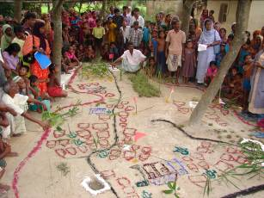
Photograph 1. Situation analysis by community people

Source: WaterAid Bangladesh
- After the community situation analysis, people were motivated about WaSH, and form a community group to solve the identified problems. This community group, however, evolved as community based organization. They prepared their own community action plan in a participatory manner based on identified problems during situation analysis, where they put hand washing as one of the main behaviours whereas other important issues were scope of income generating activities, availability of safe drinking water, hygienic latrine and so on.
- Then, based on the community need and demand, hygiene education was given to the community people through households, community groups (like mother group, children group, adolescent group, and so on) in communities, and also in schools and public places. Children at schools and community had given high priority to adopt proper hand washing practice, as they were the potential change agent in society and there had also long term effect of behaviour change. This hygiene education, especially on hand washing, was conducted through courtyard meetings, tea stall sessions, household visits, street dramas, rhymes and story competitions and mass campaigns. Pictorial flash card and flip chart, rhyme and story books, hygiene promotion ludo, billboards and stickers used as a means of hygiene education so that the community people could recall the right messages at right time.
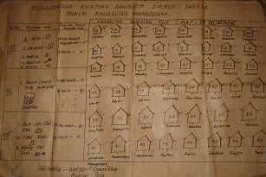
Photograph 2. Participatory monitoring by community having hand washing indicators

Source: WaterAid Bangladesh
- After having education sessions, community people updated their community action plan in a participatory approach. For monitoring the activities of action plan, community people formed a participatory monitoring group, especially, to monitor the practice of hand washing at five critical times in an accurate way with cleaning agents. This participatory monitoring group of the community played a vital role to establish as well as sustain the hand washing practice. It is worth to mention that as the community people using the platform of community based organizations delineated the way of monitoring hand washing in a participatory manner, the process differ from one community to other with the facilitation of field staff for validating the information flow. As an example of monitoring hand washing at community people,
- firstly, the committee of community based organization made some clusters having twenty households (that is convenient number of population to observe) in a cluster considering the catchment area of that community based organization;
- secondly, one member from the committee and one member from the cluster were selected to collect observed information through house to house visit;
- thirdly, the collected information presented in a pre-decided format that was done before by engaging the project participants, and this format was filled in through a discussion during the meeting of community based organization where the members/ monitors, household representatives, and field staff participated;
- fourthly, the status was reviewed during the meeting as well as decide the next course of action based on the available information and discussion; and
- finally, the responsible person to collect information conferred as peer pressure group to improve the situation, and thus people motivated spontaneously to change their behaviour in this regard.

7.0 Findings from rural areas

7.1 Knowledge on hand washing

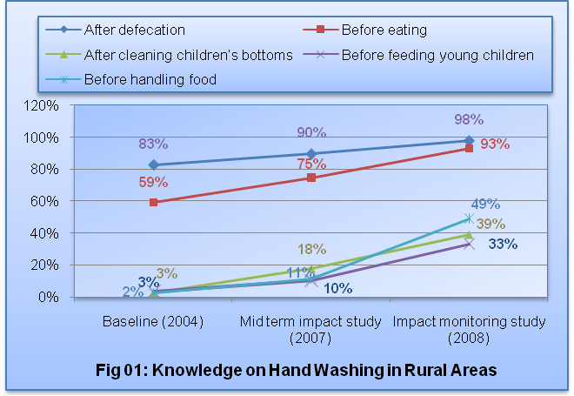
In WaterAid Bangladesh intervention areas, the level of knowledge regarding hand washing at five critical times is increased from the baseline and mid-term impact study (Fig- 01). For three of the practices, the percentage who recalled the critical hand washing times increased with the increasing times periods of project implementation. The exceptions were the two critical times related to children. In these two cases, the percentage of knowledge is more when the implementation period was one to two years, and secondly, this percentage is higher when the implementation period is more than two years than six months to one year. Since, most of the households do not have children (only 27% households have children aged less than 6 years of age), the beneficiaries appear to forget these messages with the passage of time. Again according to the geographical context of ASEH implementation, this percentage of hand washing knowledge at all of the critical times is higher in hilly/ hillock areas where in flood/ char areas have a lot of rooms for further development in this regard; this is because the people of hilly/ hillock areas live in a place for longer period of time whereas the people of flood/ char areas compelled to change their living place due to regular natural calamity. In two areas (arid plains and coastal areas) knowledge levels were similar, and higher than flood/ char areas but still need attention for further improvement to reach the desired results.
The proportion of respondents who could recall all of the five critical hand washing times increased from 43% in the baseline study to 53% during midterm impact study. However the proportion who recalled all 5 times decreased dramatically to only 27% in the present 2008 study.

7.2 Practice hand washing

For hand washing behaviours, the data from the 2008 study were compared only with mid-term impact study, since baseline data was not available. Hand washing practice, as reported by the respondents, increased (Fig- 02) except before feeding young children. Reported practice increased remarkably before eating and before handling food. Only washing hands after defecation is nearly universal whereas washing hands before eating has increased significantly (from 34% to 68%), but washing hands before handling food and before handling young children need special focus to reach the expected result. It can also be revealed that the percentage of practice is increasing over implementation period at all of the critical times of hand washing except one critical time- before handling food.
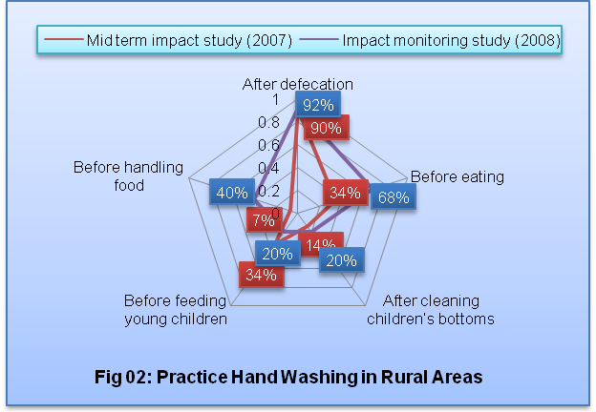
Again, when geographical contexts were considered, only washing hands after defecation at all geographic areas was nearly universal, however, percentage of children related two critical times were too less (only 53%) in flood/ char areas.
It is worth mentioning that 27% people reported washing their hands with cleaning agents at all of the five critical times whereas this data was less than or equal to 6.6% during mid-term impact study.

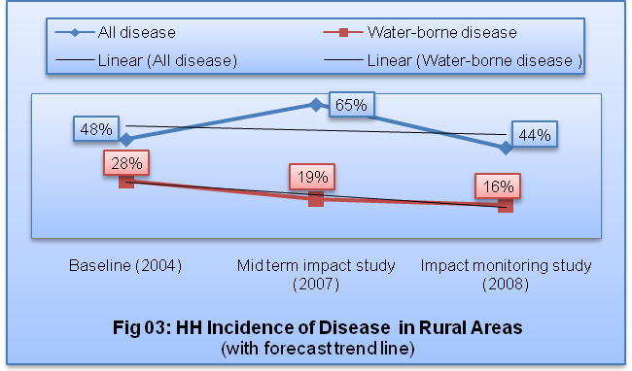
7.3 Disease, medical expenditure and disposable income

7.3.1 Incidence of diseases

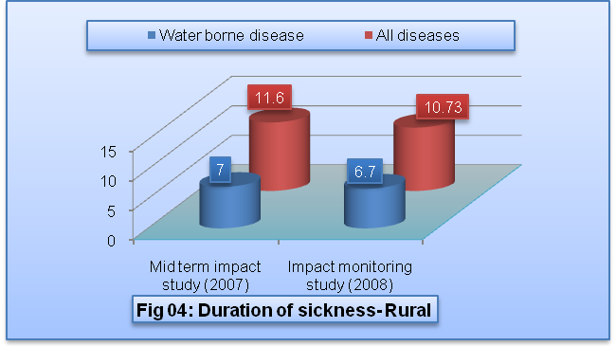
Incidence of diseases decreased from the baseline (Fig- 03) for both of all and waterborne diseases. In this stipulation, as there had data of three periods a forecast trend line was analyzed for all and waterborne diseases and revealed that the rate of incidence is decreasing and this decreasing rate of water borne diseases is more than all diseases, that is expected from ASEH.
Again, duration of sickness of all and water borne diseases were decreased from mid-term impact study, baseline data cannot be compared due to its unavailability (Fig- 04).
It is worth mentioning that people who did not wash their hands properly are affected more (79%) by water-borne diseases than those people who wash their hands properly (23%).

7.3.2 Medical expenditure saving and disposable income gain

Considering 15% flat inflation from 2007 (data collected from HR, WAB) to 2008, it was revealed that from baseline medical expenditure reduced 65% for all kinds of diseases and reduced 64% for specifically water borne diseases. Again this percentage is 46% for all diseases and 10% for water borne diseases with respect to midterm-impact study.
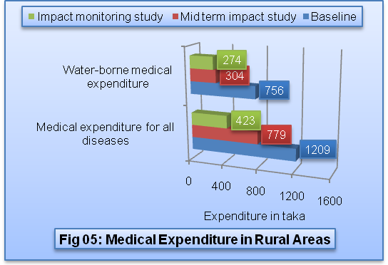
Thus, the savings for only water-borne diseases were Tk. 786/- from baseline, that was equivalent to Tk. 3,144/- per year per household. Hence, considering total rural household of this study total saved amount was Taka 2,012,254,320/- per annum.

7.3.3 Workdays lost

It was revealed that within the ASEH intervention area, workdays lost for water borne diseases were decreased 10% from the mid-term impact study, whereas it was also decreased 31% from midterm study and 79% from baseline for all diseases.

Table 2. Changes in workdays lost for diseases from baseline and midterm study in rural areas
Diseases | Work days lost (in days) |  |  | % of change (2008)
Diseases | Baseline Survey (2004) | Midterm impact study (2007) | Impact monitoring study (2008) | From midterm (2007) | From baseline (2004)
All diseases | 19.7 | 5.9 | 4.08 | -31 | -79
Water-borne disease | No data | 3.5 | 3.69 | -10

8.0 Findings from urban areas

8.1 Knowledge on hand washing

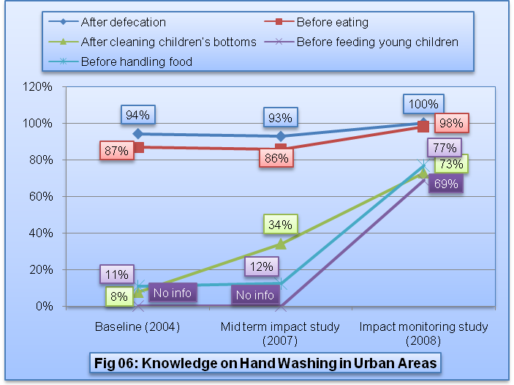
In the WaterAid Bangladesh intervention urban study, the level of knowledge about all critical hand washing times increased from the baseline and mid-term impact study following an upward trend (Fig- 06). In this stipulation, only after defecation reached to its target and before eating was very near to its target, but rest of the three critical times increased due to more concentration and special attention and this attention and concentration is required in future also.
When respondents having knowledge on all of the five critical times was considered, it was observed that this percentage was remarkably increased in this study (63%) from midterm impact study as well as baseline (3% to 1% respectively).

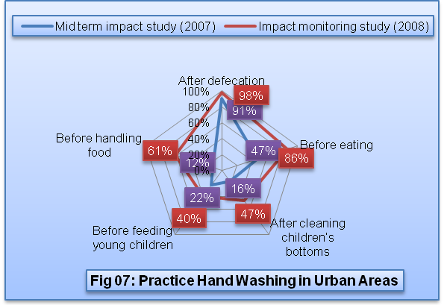
8.2 Practice hand washing

In case of practice hand washing at five critical times, the data were compared with only mid-term impact study, since the data is not available at baseline. It was revealed that reported hand washing increased remarkably increased (Fig- 07) for each critical time. Hands washing after defecation and before eating were above 90%. It can also be revealed that the proportion practicing is increased over the implementation period at all of the critical times of hand washing.
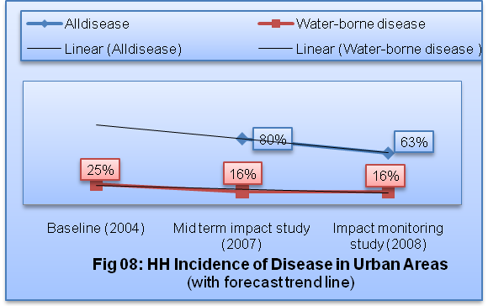
Again, whereas only 5% people wash their hands at all of the five critical times during midterm study, this increased to 32% in 2008

8.3 Medical expenditure and disposable income

8.3.1 Incidence of diseases

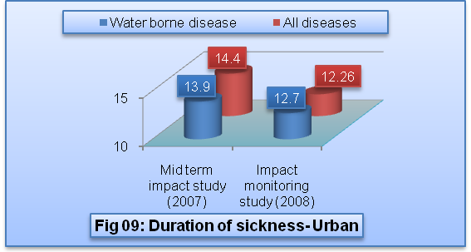
Incidence of diseases decreased from the baseline (Fig- 08). From the figure it can be inferred that the waterborne diseases were same from mid-term to current studies. But it is important to mention here that the data of midterm impact study was collected during dry season whereas data of this study was collected in rainy season. The usual pattern of disease in urban areas of Bangladesh shows that people suffer more in WaSH related diseases in rainy season. Therefore, though both of the midterm impact and this studies’ results shown the same as ‘16%’, in fact it reflects improved situation during this study.
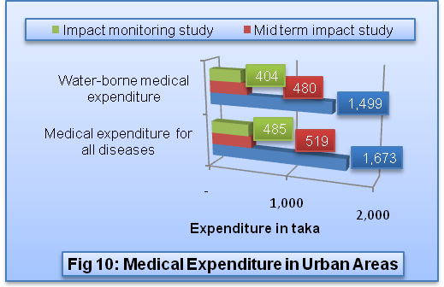
Again duration of sickness of all and water borne diseases decreased slightly over two reporting periods, although the difference is not significant (Fig- 09). Since latest study’s survey was completed on rainy season, the duration of water borne disease was slightly increased, though duration of all diseases was slightly decreased.
It is worth mentioning that people who did not report washing their hands properly were affected more (58%) by water-borne diseases than those people who wash their hands properly (26%).

8.3.2 Medical expenditure saving and disposable income gain

Considering 15% flat inflation from 2007 (data collected from HR, WAB) to 2008, it appears that there was a reduction from the reported baseline medical expenditure of 71% for all kinds of diseases and 73% for specifically water borne diseases. Again, this percentage was 6% for all diseases and 16% for water borne diseases with respect to midterm-impact study. Thus, the savings for only water-borne diseases were Tk. 1,095/- from baseline, that was equivalent to Tk. 4,379/- per year per beneficiary household. Hence, considering total urban household for this study total saving amount was Taka 350,965,232/- per annum.

8.3.3 Work days lost

It was revealed that workdays lost for both all and water borne diseases were decreased. Detailed results are presented at following table.

Table 3. Changes in workdays lost for diseases from baseline and midterm study in urban areas
Diseases | Work days lost (in days) |  |  | % of change (2008)
Diseases | Baseline Survey (2004) | Midterm impact study (2007) | Impact monitoring study (2008) | From midterm (2007) | From baseline (2004)
All diseases | 10.4 | 8.1 | 4.82 | -40 | -54
Water-borne disease | No data | 5.3 | 5 | -6

9.0 Triangulation

To test the results of responses to the structured questionnaire, data from the Ranking and Pocket Chart - one of the participatory group discussion tools - were compared with questionnaire survey. The Ranking and Pocket Chart is a tool in which the respondent remains anonymous, the concept being the people are more likely to respond candidly if their identity remains secret in the ranking process. During the Ranking and Pocket Chart activity, core data was collected on hand washing knowledge and practice in rural and urban areas. The results are compared at the Figures 11, 12, 13, and 14.
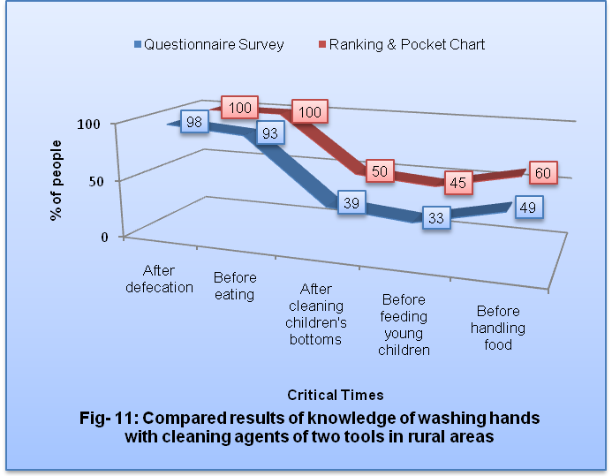
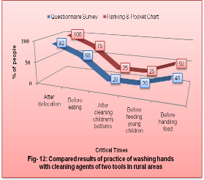
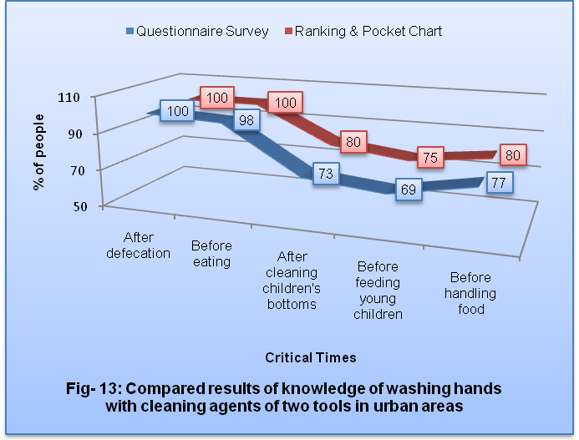
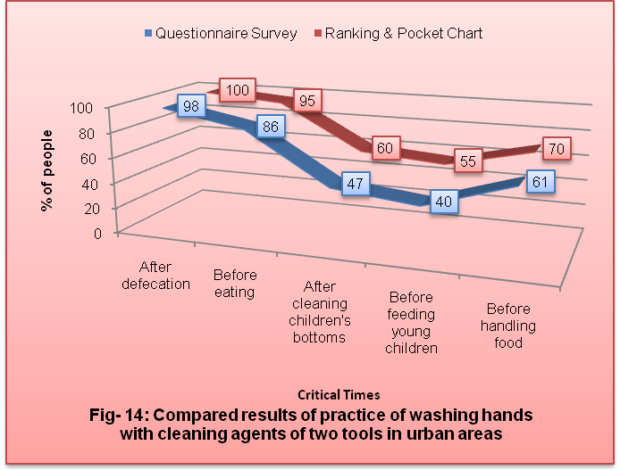
These figures show knowledge and practice of hand washing on critical times with cleaning agents in rural and urban areas. It was observed that the responses to the questionnaire and the pocket voting for each item were not significantly different. However there is a trend in each case, with the pocket voting being uniformly higher than the responses to the structured questionnaire. This tends to lend credence to the questionnaire responses. On the other hand, it would be very surprising if 100% or more than 90% of the respondents always washed hands after defecation and before eating with cleaning agents. These proportions appeared very high. However, the trends noted above suggest that the results of questionnaire survey may be accepted within the range of its statistical limitations for the following reasons:
- results of questionnaire and survey were statistically tested, and
- it was triangulated with another tool named ranking and pocket chart, where the trends of the results were similar.

10.0 Conclusion

Hand washing with cleaning agent is, no doubt, the most effective and inexpensive ways to prevent WaSH related diseases that are responsible for child deaths. Therefore, promoting and practicing hand washing is the most appropriate and effective intervention for hygiene behaviour in the developing countries. It is evident from the study that the project beneficiaries had been benefitted from reducing waterborne diseases, reducing lost workdays, increasing disposable income, and decreasing medical expenditure. These changes may be due in all or in part to hand washing practice properly with appropriate cleaning agent. It was observed that despite its lifesaving effect and increase of disposable income potential, there is room for further improvement, though beneficiaries are changing their behaviours. The challenge is to transform hand washing with cleaning agents at five critical times from knowledge into a spontaneous behaviour performed by individuals in households and communities. The key areas, however, for this success were proper motivation of the community people through risk analysis on WaSH during community situation analysis, and participatory community monitoring on the hand washing practice as a peer education as well as means of evaluation. ASEH had taken over the challenge and successfully improved the worse situation to a moderate one and dreamt to change even better result in future.

Acknowledgements
The authors would like to extend their thanks to Dr. Khairul Islam- Country Representative of WAB to create the scope to reflect the learning of this research. The contribution of all of the staff of Partner NGOs, named UST, GH, PSTC, Shushilan, Zibika, Solidarity, VARD, NGO Forum, ARBAN, DSK, DAM, and VERC, who were involved in data collection process to make the research successful, was also appreciable. The involvement of all of the WAB colleagues, especially Md. Shahjahan Hossain, Sadia Afrin, ASM Shafiqur Rahman, and Bakht Hindole to conduct the study and finalize the main report, was mentionable too. The authors would also like to acknowledge the contribution of those colleagues who reviewed this paper, especially to Hasin Jahan- Program Director of WAB, Kathleen Shordt- the official reviewer for the workshop papers, Rudaba Raihan- spouse of one of the authors. And above all, gratitude of authors to the Almighty Allah, who never cease in loving and also for His continued guidance and protection.

References
Khan, M.H.; Ahmed, S.S.; Nasreen, M.; Karim, F. and Eitu, A.H.K. (2004). Independent Baseline Survey for Advancing Sustainable Environmental Health (ASEH) Programme of WaterAid Bangladesh. Pathway: Dhaka.

Barakat, A.; Mahiyuddin, G.; Poddar, A.; Sabina, N.; Rahman, M.; Zaman, B.; Osman, A. and Khan, S. (2007). Assessment of socio-economic improvement in the life of targeted people with special focus on extreme poor, women, and girls because of water, sanitation, hygiene intervention: an impact study. Human Development Research Centre: Dhaka.

Ahmed, M.I. and Begum, R. (2008). Hand washing practice in ASEH. WaterAid Bangladesh: Dhaka.

Note/s
Three abbreviations were used in this paper, that are (i) WAB stands for WaterAid Bangladesh, (ii) ASEH stands for Advancing Sustainable Environmental Health, and (iii) WaSH stands for Water, Sanitation, and Hygiene.

Keywords
hand washing, disposable income gain, incidence of disease, workday lost, triangulation, monitoring.

Contact details

Name of Principal Author: Md. Iqbal Ahmed,  Program Officer- Monitoring and Evaluation  Address: WaterAid Bangladesh, House # 97/B,  Block # A, Road # 25, Banani,  Dhaka- 1213, Bangladesh  Tel: 880-2-8815757 (extension: 144)  Fax: 880-2-8818521  Email: iqbal.ahmed@wateraidbd.org  www: www.wateraid.org/bangladesh | Name of Second Author: Rozena Begum, Program Coordinator- Monitoring and Evaluation  Address: WaterAid Bangladesh, House # 97/B,  Block # A, Road # 25, Banani,  Dhaka- 1213, Bangladesh  Tel: 880-2-8815757 (extension: 141)  Fax: 880-2-8818521  Email: rozena.begum@wateraidbd.org  www: www.wateraid.org/bangladesh

