Quantifying the Cost of Community Water Supply Services: Case of
Bosomtwe-Atwima-Kwanwoma District (BAKD), Ghana.

Appiah-Effah E, Nyarko K. B., Oduro-Kwarteng, S. and Moriarty, P.
Accessibility to good and adequate water on sustainable basis is a fundamental need and right of the individual for survival. In Ghana, focus of water sector agencies is mainly on investment in new schemes compared to cost of running existing schemes. Availability of funds to cover cost components such as capital maintenance, operation and minor maintenance and support costs is critical for sustainability of the existing schemes. This paper determines the capital maintenance, operation and minor maintenance and support costs of water supply services and the quality delivered to the end-users. The study was conducted on four water supply schemes (one Small Town Water Supply Scheme (STWSS) in Kuntanase and three boreholes with Hand pump in Kuntanase, Abono and Petriensa. Data on costs were provided by the District Assembly, Water Board and WATSAN committees. Customer quality of service was obtained via household questionnaires. Using an average inflation rate of 15%, the results revealed that the cost of providing water from the water scheme range from GH¢ 1.97 to GH¢4.98 per capita per year. The annual capital maintenance, operation and minor maintenance, and support costs was estimated to be 47% of the investment cost of the STWSS. That of the hand pumps range from 17-40% of the investment cost. The paper discusses the relationship between the cost components and the average household expenditure on water.

Key Words: Investment, Capital Maintenance, Operation and Minor Maintenance, Support Cost, Stakeholders

Introduction
The lack of clean drinking water and sanitation is a severe public health concern in Ghana contributing to 70% of diseases in the country (UNDP, 2006). Only 60% of Ghana’s urban population has access to potable water supply. The access to water services is even bad for those in the rural and small towns where coverage is only 54%.

One of the reasons for the poor water services delivery is the lack of financial resources to provide, maintain and extend the water supply schemes (UNDP, 2006). Cost of water supply services such as investment, capital maintenance, operation and minor maintenance, and support costs are thus critical in determining the sustainability of WASH services (IRC, 2008). Understanding and planning for the cost of delivering the water services which is to provide, maintain and extend the water supply scheme is important for addressing the public health concern.

In Ghana, there is the Strategic Investment Program (SIP) for extending water coverage. The government agency, Community Water and Sanitation Agency (CWSA) with responsibility for facilitating rural and small towns water supply lead the process of preparing the SIP. The SIP is focused on providing water infrastructure to meet the needs of unserved population. The SIP is based on unit cost information on the construction of a small town water system. An example is the CWSA estimate of, $45/capita for piped schemes in small towns (hardware) and the cost of community development (software) at $700/community (CWSA, 2007).

However this SIP is focused on only investment for providing water facilities (boreholes, pumps etc) which means that other cost components (replacement/capital maintenance, operation and minor maintenance and support) are not given enough attention, which is a threat to ensure sustainability of the services. This explains the fact that in the SIP sufficient attention is not given to how much it cost to sustain the water supply service which includes capital maintenance, operation and minor maintenance, support (capacity building and skills training) provided at different levels by various key sector stakeholders (CWSA, District Assembly’s (DAs)/District Water and Sanitation Teams (DWSTs), service beneficiaries etc). Ignoring these cost components lead to frequent breakdown of the facility due to lack of proper planning and budgeting.

In spite of the huge investment in the water sector there is still low coverage. There is therefore the need to know how much it cost to operate and maintain, replace parts and support the water supply services in order to inform decision makers to have sustainable service delivery.

The research objectives are to:
(a) Quantify the cost of water supply services into investment, operation and minor maintenance, capital maintenance/replacement and support
(b) Determine the quality of service derived from the water supply services
(c) Determine the linkage between cost and service delivered

Cost of Water Service Delivery
Investment cost is the initial facility cost and it is the outlays incurred prior to putting the facility in service. The investment phase determines the reliability, maintainability and effectiveness of a scheme and its components (Chao and Ishi, 2004). The total investment costs may include items such as borehole works, pipe works, stand pipe, electrical installations for water supply. Operation and minor maintenance cost outlays are future expenses; costs incurred after the project has been placed in service (Mearig, et al., 1999). The operation and minor maintenance cost comprise all expenditures (personnel, energy, minor repairs etc) that are required to keep a system operational and in good condition (maintenance) after its installation is complete. This cost is recurrent in that they are continuous over time. The support cost includes institutional capacity building and skills training at local, regional and national levels. This cost also includes the cost of ensuring that stakeholders within the water sector are well trained and resourced to help communities when schemes breakdown.

Conceptual Framework for Cost of Water Services Delivery
The investment cost was disaggregated into software and hardware costs. The hardware cost comprised the construction cost, which had various units such as the concrete works, hydrogeological works, borehole works, pipe works, electrical installations etc. The software cost comprised community mobilization and sensitization, capacity building and hygiene education and promotion for the beneficiary community (Kuntanase). The capital maintenance cost was the expenditure on major repairs, rehabilitation and extension works that were carried out with regards to the water supply scheme. Operation and minor maintenance cost consisted of expenditure on transportation, water quality test, energy use (electricity), salaries, allowances, stationeries etc. It also included minor repairs and works normally carried out for instance on the pipelines, valves and other worn-out parts. The support cost is the expenditure on continuous institutional capacity building, skills training and monitoring activities at local, regional and national levels. It also includes the cost of ensuring that stakeholders within the WASH sector are well trained and resourced to help communities when schemes breakdown. The disaggregation is as shown in Figure 1.

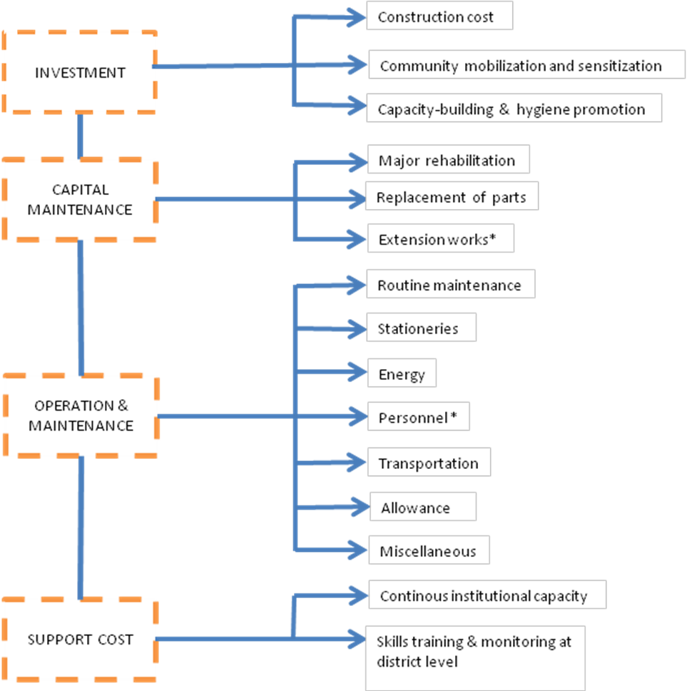

Figure 1. Conceptual Framework for cost data collection

Description of Study Area and WASH Sector Framework
The Bosomtwe Atwima Kwanwoma (BAK) district is located at the eastern part of the Ashanti Region and covers an area of approximately 718 square kilometers and has Kuntanase as its capital. The population of the BAK district in the year 2000 was estimated to be 146,028 comprising 71,904 males and 74,124 females (“ghanadistricts.”). Three communities namely Kuntanase, Abono and Petriensa in the Bosomtwe District in the Ashanti Region were selected (Figure 2). One out of two Small Town Water Supply Schemes (STWSS) was selected for the study in Kuntanase. Also three point sources (Borehole with hand pump) in Kuntanase, Abono and Petriensa were also selected for the study. The sampling method was based on both random and purposive methodologies because of availability of records on the water supply schemes in the selected communities. The characteristics of the selected communities and water supply schemes as shown (Table1).
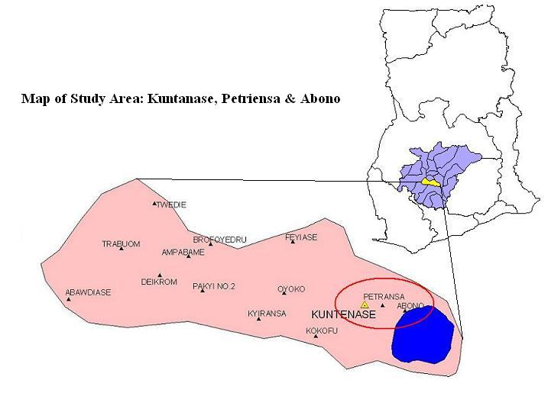
Figure 2: Map of Bosomtwe-Atwima-Kwanwoma District showing selected communities

Table 1: Characteristics of selected communities
Name of community | Projected Population (2008) | Number of houses | Number of households | Sample Size (No. of households)
Kuntanase | 3884 | 273 | 574 | 40
Abono | 1467 | 122 | 245 | 40
Petriensa | 356 | 47 | 150 | 40

Actors for WASH Service Delivery
Water supply services delivery is associated with stakeholders at the national, regional, municipal/district, community and other private levels. With regards to rural water supply, Community Water and Sanitation Agency (CWSA) are the main stakeholders identified at the national level. The stakeholders that exist at the regional level to support water supply delivery are the Regional Coordinating Council (RCC) and Regional Water and Sanitation Team (RWST). Also the Metropolitan/Municipal/District Assembly’s (MMDAs), District Water and Sanitation Team, Water and Sanitation Development Board (WSDB) and Water and Sanitation Committee (WATSAN) exist at the both the MMD and community levels.

Community Water and Sanitation Agency (CWSA)
The Community Water and Sanitation Agency (CWSA) is responsible for facilitating the delivery of water supply to rural communities and small towns in Ghana. CWSA’s main mandate is to support and build the capacity of DAs to implement their water supply programmes. They also facilitate the provision of safe water to rural communities and small towns in Ghana. CWSA help to set appropriate standards and define regulations for the delivery of water supply in small towns and rural communities including hygiene promotion to rural communities and small towns in Ghana.

Regional Coordinating Council (RCC)
The Regional Coordinating Council is responsible for the coordination of all development activities undertaken by the districts at the regional level. The Regional Development Plans are created from the consolidation and harmonization of the various district plans received from the districts. In the water supply sector, the council collaborates with the CWSA regional water and sanitation teams at the regional level.

Regional Water and Sanitation Team (RWST)
The CWSA regional office staffs constitute the Regional Water and Sanitation Team (RWST). The RWST is responsible for facilitating water supply services in the region. They are made up of a Regional Director, two water and sanitation engineers, two extension services specialist, one MIS officer, finance expert and hydrogeologist.

Metropolitan/Municipal/District Assembly (MMDA)
The MMDAs have a significant role to play in rural and small towns’ water service delivery. The MMDAs are responsible for the overall implementation of projects and the development of the communities within their jurisdiction. The District Planning Officer (DPO) serves as the desk officer and Coordinate water supply activities. The District Water and Sanitation Team with the support of the DPO prepare and submit annual work plans and budgets for approval by the DA. The roles and responsibilities of the DAs are as follows;
- Preparation of district water and sanitation plans and budget together with district water and sanitation team
- Hygiene education and enforcement of bye-laws by Environmental Health Assistants
- Contribution to the capital cost of water and sanitation facilities
- Provision of external works e.g. roads, power supply, to complement WASH projects
- Approval of tariff requests submitted by Water and Sanitation Development Boards

District Water and Sanitation Team (DWST)
The District Water and Sanitation Teams (DWSTs) are the focal persons for water supply services at the district level. The DWST is made of three members and has a desk officer who serves as a liaison between the DWST and the Executive Committee of the Assembly. The three-member DWST is made up of technician engineer, health/hygiene education officer/assistance and community development officer.

Water and Sanitation Development Board (WSDB)
Water and Sanitation Development Boards (WSDB) are elected representatives responsible for the mobilization of community members, operation and maintenance of small towns water facilities. The WSDB leads the implementation process. The Water and Sanitation Development Board (WSDB) have in place a strong and effective management system that ensures that the water supply facilities are being run efficiently to avoid the complete breakdown of the installed facility much to the health detriment of the community.

Water and Sanitation Committee (WATSAN)
The Water and Sanitation committee (WATSAN) manages water point sources in the community. There are also unit committees that assist the WATSANs in their activities. The WATSAN conduct community meetings on water supply activities. The WATSAN committee keeps records on meetings, finances, repairs and organizes cleaning of water points. The WATSAN facilitate sanitation and hygiene education to sensitize members on the need to stay healthy.

The Private Sector
The private sector are contracted by the District Assemblies and CWSA (where necessary), to provide works, goods and services. The private sector and relevant stake-holders participate in project evaluation and sector capacity building. Some of the services the private sector provides are consultancy, construction of civil works and management of water supply schemes.

Approach and Methodology
The methodology adopted was a case study based on qualitative and quantitative research method which included;
- Structured interviews conducted with District Water and Sanitation Team (DWST), Water Supply and Sanitation Development Board (WSDB), Water and Sanitation (WATSAN) Committee and other Key Informants (KI) and stakeholders
- Household level survey questionnaire design and administration
- Observational walk within the selected communities to visit the water supply schemes
Data on disaggregated costs were obtained from the DWST, WSDB, WATSAN and other KI and were analyzed. The WSDB and the WATSAN provided data on capital maintenance and operation and minor maintenance. The DWST specifically provided data on the support cost of the water supply schemes. The main components of the disaggregated cost included investment/Capital (CapEx), operation and minor maintenance (OpEx), capital maintenance/replacement (CapManEx) and support costs. For the CapEx, a design life of 20 years was used to bring the onetime payment to its equivalent annual worth using an average inflation rate of 15%. In the case of capital maintenance, operation and minor maintenance and support costs, historical cost data over a five (5) year study period (2003-2007) was used. The costs were converted to their equivalent annual worth and the average cost in each case calculated using an average inflation rate of 15%. All the disaggregated cost components were divided by their design population to get the per capita unit cost. Household level questionnaires were administered to households and were used to assess the service quality derived from the water supply schemes based on performance indicators (water quality, reliability, affordability and quantity of supply). Responses from the household level questionnaires were analyzed using Statistical Package for Social Scientist (SPSS) software and the results were used to provide a basis for the quality of service. Observational walks were made to the various water points to confirm the reliability of water supply from vendors/caretakers.

Results and Discussions

Kuntanase Small Town Water Supply Scheme
The cost of providing water services in the selected communities are shown in Figure 3. The unit cost of investment for the small town water supply was GH¢3.38 per capita per year and represents 68% of the total cost.

The results revealed the CapManEx incurred on rehabilitation works on the pipe lines and rehabilitation of the office of WSDB, cost of servicing of pump and borehole, cost of blowing and cleaning of borehole and the cost of replacement of pump. It also included the cost of extension of water from Kuntanase to Toamfom, a nearby community. The cost of capital maintenance was calculated based on the actual replacements and works that had been carried out over the five (5) year study period. The unit cost of capital maintenance for the small town water supply was GH¢ 0.15 per capita per year (Figure 3) and represents 3% of the total cost. The unit cost of operation and minor maintenance for the small town water supply over the five year study period was GH¢1.32 per capita per year (Figure 3) and represents 26% of the total cost. This study captured mainly the support cost at the District level and this is the support given to the DWSTs by the European Union during the construction of the small town water supply scheme. The support apart from this financial provision also included a computer, printer and other logistics for the smooth operation of the DWST. The Support cost in this study does not include salaries of staff from the District level. The unit cost of support to the small town water supply was estimated as GH¢0.13 per capita per year (Figure 3) and represents 3% of the total cost.

From the Figure 3, it is realized that the capital maintenance and support costs per capita are lower than that of the CapEx and OpEx. OpEx in the small towns setting was generally just enough for small repairs and smooth running of the system. This was obtained from the average tariff after the WSDB broke even in their previous operations. No major allocation is put aside for major rehabilitation and replacement works at the WSBD level. Part of the revenue generated is supposed to be used to train personnel on new management practices and technologies. Since the tariff structure does not meet full cost recovery policy (revenue per capita per year was GH¢ 1.50), little money is available for support as the expenditure has to be prioritized. This could be a justification why most systems break down after few years of operation, and partly due to the fact that members of the board are not well remunerated and soon leave to the big cities for greener pastures.

Point Sources (Borehole with Hand pump)
The investment costs (CapEx) included the software and construction costs. The construction costs were made up of Hydrogeological works (Drilling), borehole development, borehole concrete pad, capping, test pumping, supply and installation of pump. Comparing boreholes from various communities, it was observed that the investment cost were almost the same at an average of GH¢503.86 (Figure 3).

Capital maintenance expenditure (CapManEx) for boreholes with hand pump was mainly the replacement of the PVC riser pipe. Others included the replacement of the PVC brass lined cylinder and the replacement of pipe centralizer. CapEx was highest at Petriensa because the borehole had frequent breakdowns and needed immediate repairs since it was the only source of water to the community. It was lowest in Kuntanase because the community used it as their supplementary source as they often relied on their small town water scheme (Figure 3).

The operation and minor maintenance expenditure (OpEx) of the boreholes with hand pump included minor routine maintenances, greasing and oiling of movable parts, cleaning of the borehole and weeding around borehole area. It also included payments that were given to the vendors selling the water. The high OpEx in Abono can be attributed to the fact that it is the only among the three communities that pays commission to vendors. Petriensa recorded the lowest OpEx because the community does not sell water implying that there is no cost incurred on payment to vendors (Figure 3).

The support cost included allowances that were given to four (4) DWSTs, utilities such as electricity and water bills. It also included communication, fuel and vehicle maintenance costs. The variable costs included capacity building and skills training that were given to two (2) DWSTs and also feedback on reports from both the regional and district levels. Support costs incurred from the national level was money for administrative and other logistics. Support cost for all the three (3) communities were the same. The average support cost was estimated at GH¢ 12.47. The support cost excluded the salaries of District Water and Sanitation Teams (DWSTs), Regional Water and Sanitation Teams (RWSTs) and Ministry of Water Resource Works and Housing (MWRWH). The support costs were estimated on the spending incurred on keeping the facilities working (Figure 3).

The cost of water supply services from the small town water supply schemes was higher at GH¢ 4.98 compared to that of the point sources (borehole with hand pump) at an average of GH¢ 2.19 (Figure 3).
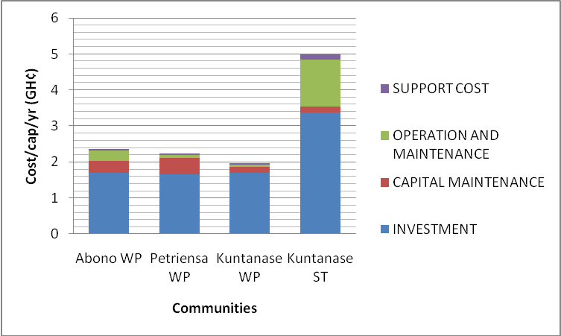

Figure 3. Cost of Water Supply Services
Service quality
The perceptions of the services derived from water supply scheme (Borehole and Small Town Water Supply) by beneficiaries were assessed. The quality of service was determined based on indicators such as water quality, affordability, reliability and quantity of supply (Figure 4). Forty (40) households in each of the selected communities (a total of 120 households) were interviewed. The price of water ranged from 1-2 Gp per 34 size bucket (18 litres). The end-users claimed this was affordable and they were willing and able to pay as and when they needed the water. The water was thought to be of good quality and the quantity was appreciable since they were able to get water from the water scheme always for various domestic and non domestic activities. The service quality derived from the Small Town Water was also good based on the perception of beneficiaries. For the small towns the beneficiaries paid GH¢1.2/m³ for house-to house connection and 2 Gp/18 litres for the pay-as-you-fetch policy fetched from the public standpipe. From the Figure 4 the end-users are generally satisfied with water quality, quantity of water and reliability for all the water schemes.

The satisfaction of the users with the service quality was more or less same irrespective of the cost of the different schemes. In particular user satisfaction levels did not suffer much difference in the cost of water schemes as existing literature would have us believe. All the respondents reported that they are satisfied when the scheme is functioning and the service quality is good.

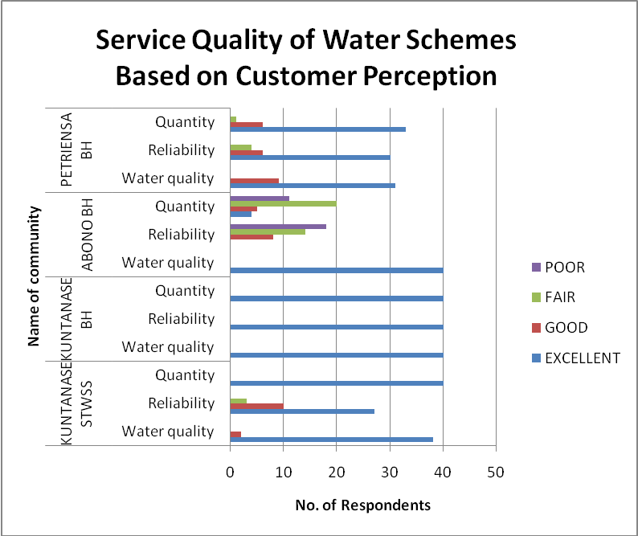
Figure 4: Service Quality of Water Supply Schemes based on customer perception

Cost of water and expenditure on water service
The main sources of household income in the three selected communities comprised of income from employment, agricultural (farming and fishing) and non agricultural activities (trading, rent). The annual average per capita income was estimated at GH¢564 (i.e. 1.6/cap/day). The average water consumption per person per day for those using the STWSS and boreholes were estimated at 36 litres and 18 litres respectively, with the cost of 34 size bucket (18 litres) being 2Gp. It was estimated that customers spent about 1.3% to 2.6% of their income on water. The cost of providing water is less compared to the expenditure on water. It can be seen that the cost of providing water ranges from 27 to 36% of household expenditure.

Table 2: Cost of water to expenditure on water
Scheme | Cost of scheme/cap/yr | Expenditure on water/cap/yr
STWSS  House connection  Public stand pipe | 5.00 | 13.99  14.60
Bore with hand pump | 2.00 | 7.30

Conclusion and Recommendations

Conclusion

From the analysis of the results and discussion the following can be concluded:

Cost per capita (GH¢)
Schemes | Investment | Capital Maintenance | O & M | Support
Kuntanase ST | 3.38 | 0.15 | 1.32 | 0.13
Abono PS | 1.69 | 0.34 | 0.29 | 0.04
Petriensa PS | 1.66 | 0.45 | 0.09 | 0.04
Kuntanase PS | 1.69 | 0.18 | 0.06 | 0.04

- The cost of point sources is 50% of small town water supply scheme (pipe scheme)
- Other cost component( capital maintenance, operation and minor maintenance and support) cost was estimated to be 10% of the investment for the STWSS
- Service beneficiaries were generally satisfied with the quality of service delivered from water sources
- Expenditure on water is dependent on the choice of water supply scheme
- Quality of service delivered is irrespective of the cost of the water supply scheme.

Recommendations
Based on the results and discussion, the following are recommended;
- In providing sustainable WASH services focus should not be on only investment but operation and maintenance, capital maintenance and support costs.
- There should be significant level of awareness and knowledge of the application of unit cost in planning and decision-making by WASH sector actors.
- Further research is recommended in other communities to enable the results and subsequent recommendations to be applied nationally.

Acknowledgements
The authors wish to acknowledge the support of WASHCost Project for funding the field work for the MSc. Research, WASHCost Project Office Staffs, Mr Mark Tachie of the Bosomtwe District Water and Sanitation Sector and Mr Asare, Technical Manager of the Kuntanase Small Town Water and Sanitation Development Board. Sincere thanks to Barbara Gyapong-Korsah for helping in the data entry.

References

Chao, L. P. (2004) Project Quality Function Deployment, International Journal of
Quality & Reliability Management, 21(9), 938-958.

CWSA (2003) Small Town and Sanitation Policy, Community Water and Sanitation
Agency, Ministry of Works and Housing, Government of Ghana.

CWSA (2007) Community Water and Sanitation Agency Strategic Investment Plan, 2007.

DWSP (2008) District Water and Sanitation Plan, Bosomtwe District, Ashanti Region,
Ghana. (Unpublished).

Ghanadistricts: A repository of all districts in the Republic of Ghana [Online].
Available: www.ghanadistricts.com/districts/?news&r=2&_20, [Date accessed 20th July, 2009].

GSS (2000) National Population and Housing Census, Ghana. Ghana Statistical
Service, Accra, Ghana.

GSS (2008) Ghana Living Standard Survey: Report of the fifth Round, Ghana
Statistical Services, Accra, Ghana.

IRC (2008) International Water and Sanitation Centre [Online]. Available:
http://www.irc.nl/content/view/full/3733 [Date accessed 13th October, 2008].

Mearig, T., Coffee, N., and Morgan, M. (1999). Life cycle cost analysis handbook.
Juneau, Alaska: Department of Education & Early Childhood Development Education Support Services/Facilities.

UNDP (2006) ‘Getting Africa on Track to meet MDGs on Water and Sanitation’, A
Status Overview of Sixteen African Countries, United Nations Development Program.

World Bank and UNDP, (2000) Water Supply and Sanitation Program. World Bank
and United Nations Development Programme

Note/s
Small Town: A small town is defined in the CWSA Act as ‘a community that is not rural (more than 5000) but is a small urban community that has decided to manage its own water and sanitation systems’. The CWSA policy defines a small town water system as a piped system serving communities of between two and fifty thousand (2,000 and 50,000) inhabitants who are prepared to manage their water supply systems in an efficient and sustainable manner (CWSA, 2003).
Hardware: Hardware includes all civil works undertaken in providing improved water supply and sanitation facilities. It also includes the procurement and installation of equipment required for improved water supply and sanitation.
Software: Software includes all activities that are undertaken to complement the provision of facilities to the communities and to ensure the successful implementation, management and sustained utilization of the facilities by the communities. It includes activities such as sanitation education, training, development of training materials and short-term consultancy form part of Software.

Appiah-Effah Eugene  WASHCost Project  Civil Engineering Department  KNUST-Ghana  Tel: +233 (0)243o34733  Email: appiaheffah@yahoo.com  Sampson Oduro-Kwarteng  Civil Engineering Department,  KNUST - Ghana  Tel: +233 (0)244598999  Email: sokwarteng@yahoo.com | Dr. Kwabena Biritwum Nyarko  Civil Engineering Department, KNUST - Ghana  Tel: +233 (0)208165515  Email: Nyarko.k.b@gmail.com  Dr. Patrick Moriarty  International Water and Sanitation Centre(IRC), Delft  Netherlands  Email: moriarty@irc.nl
Contact details

