Dhaka, Bangladesh, February 2010

SOUTH ASIA HYGIENE PRACTITIONERS’ WORKSHOP

____________________________________________________________________________

A Study on Personal and Home Hygiene in Flood Prone Communities in the Philippines

by
L. Capistrano
Philippine Center for Water and Sanitation

________________________________________________________________________

This study documents the results of field visits, interactions with household members and focus group discussions with village health workers, municipal health officers and NGOs working in two regions of the Philippines (Bicol and Eastern Visayas). Case studies on personal and home hygiene in flood prone communities were documented by members of the WASH (water, sanitation and hygiene) Philippines Coalition working in the provinces of Western Samar, Northern Samar, Sorsogon and Albay, which are periodically battered by typhoons, floods and volcanic eruptions. These case studies provide insights into personal and household hygienic practices with recommendations about the implications of these for improving sanitation, hygiene and water programmes.

_____________________________________________________________________________

Introduction

The Waray and the Bicol are among the 110 ethnic groups in the Philippines. Living in regions that receive more than 250 centimeters of rain a year, both are hardy peoples who have adjusted well to frequent natural disasters. There, for example, are 5 to 6 typhoons (cyclonic storms) on the average, each year. The Waray region suffers 2 to 3 earthquakes a year.

Of the estimated 90 million population of the Philippines today, the Waray people of Eastern Visayas and the Bicol people at the southern part of Luzon would comprise about 5 million each. The Waray and the Bicol languages are among the most widely spoken of the over 120 languages in the Philippines. Inhabiting the south-eastern part of the Philippines, the Waray and the Bicol reflect the ethnic diversity as well as the archipelagic character of the country.
This study looked into the personal and home hygiene practices of people living in flood prone communities in the Waray provinces of Western and Northern Samar as well as in the Bicol provinces of Albay and Sorsogon. This knowledge management initiative was undertaken by the WASH (water, sanitation and hygiene) Philippines Coalition in support of its three other strategies -- program development and resource mobilization, advocacy and networking, and institutional strengthening -- all aimed at increased access to basic water and sanitation services with emphasis on hygiene promotion. The study is also part of a combination of activities for policy reform, infrastructure, capacity building, awareness raising on WASH, hygiene promotion at household, community and institutional levels. WASH Philippines Coalition has members working in remote island communities and provinces that are among the poorest in the Philippines and have the lowest access to water supply and sanitation services compared to the rest of the nation.

Objectives of the study

- To find out about personal and home hygiene practices of people living in flood prone communities in the Waray provinces of Western and Northern Samar as well as in the Bicol provinces of Albay and Sorsogon in the Philippines.

- To identify specific advocacy efforts as well as immediate actions and recommendations to be communicated to local governments, NGOs, communities and households.

Methodology

This study used various methods of data gathering. These included field visits, observation, and interactions with household members, as well as focus group discussions with village health workers, municipal health officers and NGOs. Separate case studies on personal and home hygiene practices were each conducted on the Bicol and on the Waray in flood prone communities. The data were gathered by the members of the WASH Philippines Coalition in the Waray and Bicol provinces.

Focus group discussions facilitated by 15 to 20 village health workers working in flood prone communities were conducted in four municipalities of Northern Samar: San Jose, Lope de Vega, Allen and Mondragon; four in Western Samar: Paranas, Villareal, Santa Rita and Pinabacdao; three in Albay: Camalig, Daraga and Guinobatan; and two in Sorsogon: Pilar and Barcelona. House visits and observations were undertaken in at least 10 houses in each of these 13 municipalities. Municipal Health Officers, sanitary inspectors and representatives of local NGOs joined some of the focus group discussions.

Results

Waray Case Study

The Waray people associate hygiene with health, well being and cleanliness. Home hygiene was seen in the context of practices in a house as an architectural structure and in relation to the other members of the household. They were mainly practices at home to prevent the spread of diseases, accidents, even misfortune and ill will. Enumerated were practices relating to: hand washing; food handling and preparation; laundry; safe disposal of human and other wastes; cleaning of toilet and bathing area; care of pets and livestock; care of sick family members; control of dust, molds and mildew; mental hygiene and harmonious relationships.

Personal and home hygiene for the Warays are directly affected by the tropical monsoon climate and the change in seasons. The typical temperature is 27 degrees Centigrade. Seasons change from dry to wet and last for months. It is also common that a single day could be both sunny and rainy.

Household hygiene

Home hygiene, as defined by the local people, was observed by the researchers to have a direct link to the local architecture. It was observed that most houses in the flood prone communities have a strong, pyramidal thatched roof that can withstand and deflect the wind and torrential rains. Windows are wide and usually left open all day to allow continuous air flow and thus good ventilation that prevents the growth of molds and mildew, which are common in the humid tropics. Dust build-up inside the house is prevented by the daily sweeping and wiping surfaces with a wet cloth that is washed and re-washed and then hung up to dry under the sun.

Air circulation is regarded as an important aspect of home hygiene. The mere act of keeping the windows open to allow air and sunlight inside the house already helps control molds, mildew and other allergens. It also eliminates any unpleasant odor. Fragrant flowers like sampaguita, jasmine, and camia are planted near windows so that the breeze carries the fragrance inside the house.

Many houses are built on posts and stilts one or two meters above the ground to keep snakes, rats, and other vermin from entering the living areas. The open space between the bamboo floor and the ground or soil, allows flood waters to pass through. People have adapted to the coming and going of floods. Some houses have boats nearby. Others have items which could readily be used or converted into flotation devices. Floors made of split bamboo allow air circulation and also facilitate house cleaning as dirt and dust inside the house could readily be disposed of through the spaces in the bamboo slat flooring. The multi purpose open space beneath the house is often used for storage or as a work place. It safeguards the household against flooding, snakes, and insects.

Made of light local materials like bamboo, nipa, wood, grass, palm leaves, the houses enable its occupants to survive earthquakes and typhoons. Such lightweight houses are said to give only little injuries when toppled by earthquake or typhoon.

Inside a typical house is a multi-use open space that gives the simple dwelling a spacious feel. Some houses have an open front porch used to store jars of water for washing and other purposes. Jars and pots are used for cooking and for storing water and other liquids. The abundance of raw materials from indigenous plants such as buri, palm leaves, tikog, grass, rattan, bamboo, pandanus, encourages the making of mats, baskets and other useful household items. Rice and other food stuffs are stored in baskets. A fruit basket, root basket, vegetable basket and a hanging basket for storing left-over food are commonly found in most houses.

Sunlight is regarded as a good disinfectant – widely abundant and free. A lot of personal and household items such as clothes, beddings, mats, hammocks, utensils, shoes, slippers, are taken out of the house daily to be hung or exposed directly to sunlight and air. People also try to catch the early morning sun and expose themselves to sunlight from early to midmorning. Exposure to the morning sun while working or relaxing is believed to provide energy giving benefits.

In the late afternoon when the sun is down, dried leaves and twigs falling from the trees and other plants in the yard are swept into a heap. These are burned to allow the smoke to move upwards to the trees and towards the house. The smoke controls pests and induce the flowering of fruit trees like mangoes. The smoke that enters the house drives away mosquitoes, which normally swarm during the early evening.

People wear footwear outside the house. Most prefer to walk barefoot inside the house to maintain its cleanliness. The floor has to be kept clean as it is a multipurpose shared social space by day and a sleeping area at night. It was observed that the floor is swept almost daily. The Waray language has a lot of words referring to floor cleaning -- from sweeping it with various types of brooms, to washing the floor with water, to drying it up, to making it shiny by scrubbing banana leaves over it.

The kitchen and the dining areas are cleaned after every meal, which is three times a day. Dishes and cooking utensils are washed after use. Wet surfaces are wiped dry. Drinking water occupies a special place in the house, away from contamination and other disturbances.

Home hygiene takes a family-centered perspective. Caring for the very young and the elderly is given more attention as they are perceived to be the members of the family who are more prone to illnesses. This shows in the aspect of food preparation. For example, in cooking the staple food rice, a family with very young children and elderly members would tend to cook their rice with more water to make it soft. This is to ensure that both the very young and the elderly would be able to eat rice that is soft and easy to chew.

Personal hygiene

Eating food with bare hands is a common practice. Hand washing before and after meals is universal. According to some old folks, hand washing before meals used to be a sacred ritual wherein the oldest member of the family, usually a grandparent, starts it, followed by the next eldest then on to the youngest. It was some sort of manifestation of filial piety or respect for the elders. After meals, hand washing is a natural thing as the typical Waray diet of rice, fish, vegetables, root crops and fruits would leave a messy feeling on the hands if left unwashed. The smell of fish has to be washed off from one’s hands with soap and water. If soap is not available, local sour fruits commonly grown in the backyard garden like limoncito and camias are used as substitute for soap. The juice of limoncito – a small, green, lemon-like fruit commonly used in cooking and as a beverage -- are effective in removing the fishy smell from hands, plates, utensils and kitchen surfaces. In some social gatherings, like returning from a wake or a funeral, a hand washing ritual of lukewarm water boiled with citrus leaves is still practiced. Aside from hygiene aspects, this practice is also a sort of aromatherapy meant to uplift the spirit or relax tired hands.

Home and personal hygiene change in times of calamities such as during floods and typhoons. Adults undertake some form of fasting or reduce food intake as resources typically dwindle during a calamity. Water use in the house is typically reduced during floods. Taking a positive attitude during calamities is regarded as a means of mental hygiene. Conflicts are avoided. Opportunities arise for story telling and learning from the elders some useful knowledge for survival as well as lessons in life. Story telling is also used as a means to prevent children from playing in flooded waters.

The notion is that if one can not have a clean house or a clean body because of a natural calamity, having instead a clean mind or a high spirit must prevail. People also resort to prayers as a form of spiritual hygiene. In fact, several Waray expressions refer to emotional and spiritual strength, conveying the belief that nothing bad can last forever. The Warays try to find something to celebrate in the face of adversities, building confidence as they survive or move on despite difficulties. After each calamity comes the restoration of houses and the communal cleaning up of surroundings.

Personal hygiene is closely linked to home hygiene. An enumeration of personal hygiene practices includes: hand washing; taking a bath daily or a sponge bath if bathing with flowing water is not possible due to circumstances; a change of clothes after each bath or when the clothes get dirty or sweaty; wearing clean clothes; using clean beddings, consuming clean food and water; safe disposal of human waste; brushing the teeth; trimming the nails; rubbing the skin and hair with coconut oil; getting a regular hair cut; having a massage when fatigued; keeping the mind and the emotions clean.

Collectively referred to as a daily cleaning routine or ritual, personal hygiene practices are carried out by both males and females. Women, however, have more diverse and elaborate hygiene practices associated with beautifying or making themselves feel good considering the numerous chores and responsibilities they face in their daily life.

Some women boil water with the leaves of citrus fruits. The resulting fragrant smelling warm water is mixed with their water for bathing. They attest that bathing with the lukewarm fragrant water gives them a feel good effect. Other practices have to do with achieving a clear complexion. Some women use rice washing for facial toning to prevent pimples and blemishes. Grated coconut is used as a body scrub. The application of coconut oil on the hair and scalp prevents dandruff and promotes healthy hair. Coconut oil is also used to moisturize the skin. Women typically resort to a daily change of clothes that are clean and light, suited in style and material for the humid tropics.

The leaves of guava trees which grow abundantly in garden yards are boiled. The infusion is used as mouthwash or as an antiseptic for skin irritations and for washing wounds. Toothpaste is used in dental hygiene. Salt is sometimes used as a substitute for toothpaste.

The Waray view personal hygiene as an investment for health. One has to be in good health for emergency preparedness considering that they live in communities prone to natural disasters brought about by typhoons, floods and earthquakes.

Bicol Case study

Bicol households covered in this study also regard hygiene as a means of keeping clean and as a protection against illnesses. Home hygiene practices enumerated as behavior and activities aimed at keeping the house clean and safe were similar to those mentioned by the Waray. Household and personal hygiene practices were similar as well. People also bask in the morning sun to be energized in body, mind and spirit. Like the Waray, the Bicol hold communal cleaning sessions and reconstruction activities after each flood, earthquake and typhoon. Such activities reinforce their community cohesiveness and enhance the value of social capital.

It was observed that both the Waray and the Bicol have many herbal preparations that are used for personal hygiene and for treating common illnesses. Diuretics like tea made from the leaves of the banaba tree, from ginger, or from corn tassels are some of the popular drinks. Diuretics are resorted to during calamities and in other times when salted dried fish is eaten more often instead of the usual diet of fresh fish and other sea foods.

Majority of the households in both the Bicol and the Waray study areas has a water sealed toilet with a septic tank. Pour flush toilets with soak pits were also observed. Some households do not have toilets due to poverty. Others that do not have toilets have access to the toilets of their relatives who are usually also their neighbors. In both areas, paper is used for anal cleaning, followed by washing with soap and water. When toilet paper is not available, anal cleaning is done by washing with soap and water. The private parts are washed too. It was common for some of the women to wash their private parts after urinating.

No sacred ritual was associated with hand washing before meals in the Bicol area. This could probably be because very few old folks were engaged in conversations during the study period in the Bicol area. Like it was observed in the Waray households, hand washing among the households visited in the Bicol areas was undertaken usually when the hands get dirty or feel sticky and also after using the toilet. Some women and men in both the Bicol and Waray areas mentioned about taking a bath twice a day especially during the summer months and on days when they exert a lot of physical activities.

Like the Waray, the Bicol also highly value personal hygiene as an investment for good health, enabling them to adapt and thrive in communities prone to natural disasters.

Learnings

Home and personal hygiene of the Waray and the Bicol reflect a lifestyle borne out of indigenous knowledge and emergency preparedness acquired over time characterized by a cycle of natural calamities. It could be surmised that they would be able to adapt well to the onslaught of climate change and to real or perceived future difficulties.

Home and personal hygiene are also regarded as forms of social insurance. The human body and its dwelling are strengthened for emergency preparedness when resources and opportunities are lessened as a result of natural calamities.

The case studies remind us that hygiene does not have a fixed definition. In these case studies, hygiene has a spiritual dimension. Spiritual and emotional hygiene are recognized as special components of personal hygiene which provides strength and well being in trying times. A positive outlook that values harmonious relationships help nurture social capital, which promotes community cohesiveness, that, in societies with not much cash, serve as an alternative to financial capital.

Recommendations

On the basis of these case studies of healthy hygiene practices in the Waray and Bicol regions, we have formulated three recommendations.

Firstly, the studies have identified many positive aspects of current hygiene practices. They have shown that such studies can be useful. It is recommended that personal and home hygiene practices be documented among the various other ethnic groups in the Philippines in order to find out about indigenous knowledge that could help enhance and sustain WASH programs.

Secondly, it is known that new hygiene practices are most likely to be sustained when they are related to existing practices. Thus, the recommended strategy is to build upon local capability and indigenous knowledge in promoting healthy hygiene behaviours and in mobilizing resources for safe and sustainable water supply and sanitation systems. This should allow for various options, especially low-cost appropriate technologies that help sustain and promote hygiene behavior.

Thirdly, it is recommended that strong partnerships be initiated between and among communities, local governments, NGOs and the academe in promoting and implementing WASH programs.

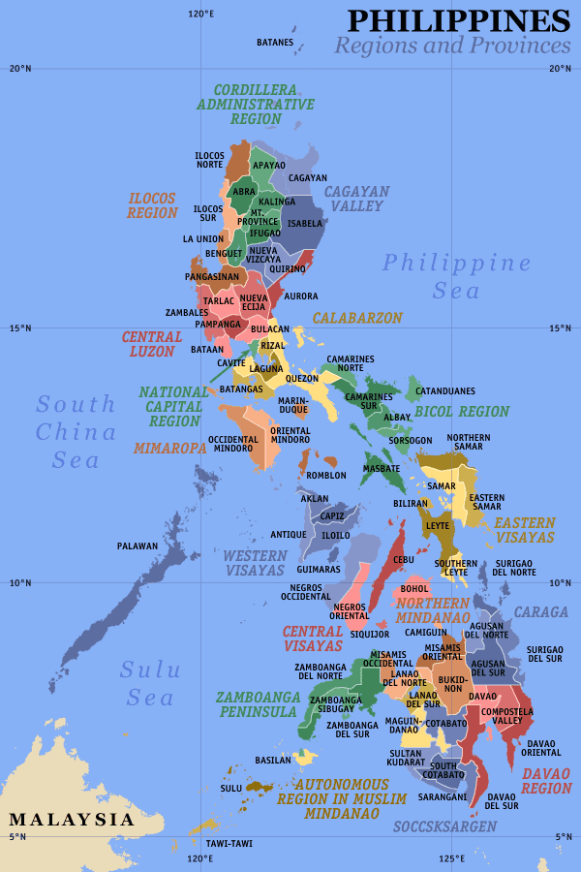

Keywords
Waray, Bicol, indigenous knowledge, social capital
Contact details
Name of Principal Author: Lyn N. Capistrano
Address: PCWS, P3 Minnesota Mansion, 267 Ermin Garcia Street, Cubao, Quezon City, 1102 Philippines
Tel: (632) 9120531
Fax: (632) 9120531
Email: capistranolyn@gmail.com
www: www.itnphil.org.ph

