Dhaka, Bangladesh, 31 January -2 February 2012

Asia Regional Sanitation and Hygiene

Practitioners Workshop

Hygiene and Sanitation Behavior Change Efforts
in Vulnerable Communities of Western Nepal

C. Goudel & M. Tuukkanen, Nepal
Finnish-Nepali government bilateral development co-operation project RWSSP-WN (Rural Water Supply and Sanitation Project in Western Nepal) has been implemented since 2008 in 51 VDC´s (Village Development Committees) of nine districts. Hygiene and sanitation is one of the project components and the project decided to pilot an approach "Community Led Total Behavior Change (TBC) in Hygiene and Sanitation" CLTBCHS in these VDC´s. In this approach local bodies are facilitated and local people are trained to ignite and trigger people to build toilets and change their hygienic behaviour with Small Doable Actions (SDA). Nine Districts, 51 VDCs and 553 community level structures and systems have been mobilized/established for the purpose. In total 6300 triggers (49% female) have been trained out of the population of 330,000 in 56,000 households in the project VDC´s. During the year and a half (January 2010 to June 2011) during which this approach has been implemented, 18,168 households have constructed toilets on their own without subsidy according to their capacity. A total of 66 VDC´s (32 program VDCs plus 34 neighbouring VDCs) were declared Open Defecation Free and started Small Doable Actions in hygienic practices (SDAs) serving 253,794 people. As a result, it is assumed that the hygiene and sanitation situation within the project working area has greatly improved. The lessons learnt from this approach can be replicated in other parts of Nepal to increase sanitation coverage from the current 43% of the 26.6 million people in the nation (MPPW, 2010).

Hygiene and Sanitation situation in Nepal

Diarrhoeal disease due to poor hygiene and sanitation is estimated to cause each year deaths of 10,500 children under five. Of this, 72% is due to unsafe drinking water and poor sanitation (National Living Standard Survey, 2004). The annual cost of the increased morbidity and mortality of sanitation related diseases is conservatively estimated to be USD 8,000, 0000 (Nepal State of sanitation, 2000).

After the declaration of MDG in 2000, sanitation received high priority in the development agenda of Nepal. MDG and national target of universal accessibility by 2017 started the formulation of national plans, policies, strategies, programmes, structures and other changes in the sector. The actors involved in the sector have tried various approaches with different incentive structures and financing models. This sector led by two ministries(Ministry of Physical Planning and Works (MPPW) and Ministry of Local Development (MLD) which is also one of the challenges in the sector.

According to the Local Self Governance Act-1999, the role of service delivery including water and sanitation is devolved to the local government bodies. The District Development Committees (DDCs – local government body at district level), Village Development Committees (VDCs – local government body at village level) and municipalities have great potential to promote sanitation and hygiene in terms of legal authority, local accountability and internal financial resources.

Figure 1. Sanitation – Existing Situation and Targets

Source: Sanitation and Hygiene Master Plan 2010

Water Supply and Sanitation Coverage in Western Nepal

The current situation of Water Supply and Sanitation coverage in the Western Region districts varies a lot. The highest coverage is 100% in one district while the lowest is only 28%, with an average in the Region of 59%. For water supply, coverage varies from 94% to 75% with an average of 86%, but as with sanitation, there is also high variation among the VDC´s of the districts too.

Why the Idea

Various actors have been working in Nepal for many years to improve sanitation and hygiene. Achievements have been made but the progress has been slow and real breakthrough has yet to come. When the RWSSP-WN project started to formulate an approach for hygiene and sanitation, it became evident that something new was needed and project was ready for the challenge. CLTBC in hygiene and sanitation was the chosen for the approach.

Using the new tools

In the CLTBC hygiene and sanitation approach, communities themselves take the lead and change their behaviour. After the ignition and triggering the community people become ignited, firstly to stop open defecation and secondly to change behaviours in hygiene and sanitation.

The process of change happens at district, VDC and community levels. At the district and VDC levels ignition is carried out in order to ensure the required resources and political commitment, whereas at the community level actual physical action takes place. Districts train, (first with the support of the project and then on their own) the Lead TBC Facilitators (LTBCF) who in turn are responsible for training selected community people who are called TBC Triggerers. The trained TBC Triggerers can be natural leaders, female community health volunteers, health workers, teachers, lead mothers and so on. These TBC triggerers apply the triggering tools and starts negotiation for changes in terms of Small Doable Actions in hygiene and sanitation at household level.

ODF Triggering Process
Triggering process starts with district level multi-stakeholder meeting with political parties, government officials, civil society, journalists and INGO´s/NGO´s. After the district level meeting then a meeting is arranged at VDC level. Meetings are organized by local bodies that also formulate policies and strategies regarding WASH. After the decision to proceed with this approach is made, then the training of Lead TBC facilitators takes place. Trained facilitators support the VDC to establish Village WASH coordination committees (VWASHCC). VWASHCC selects persons from their community to be trained as triggers. Once the selection is done, the facilitators train VDC level TBC triggers.

Trained TBC triggers visit every household in VDC to establish baseline data on the existing sanitation and hygiene status. Once baseline data is established then all the people from the community are gathered for the discussion of the current situation. During this gathering triggering tools are used.

The triggering tools include touching open shit by a stick, touching shit with one loose hair and putting that hair into a water glass, shit mapping, shit calculation, shit flow to humans by different methods. All this is aimed to make people realize how much open shit there is in the village. They learn how flies transport shit in their legs to drinking water (hair touching shit and then water in a glass example) and food, counting the transported shit amount and how much shit people are eating and drinking. This triggering makes people feel disgust and they want to stop eating and drinking shit – they want to change their behaviour and start action towards creating Open Defecation Free (ODF) communities/VDCs.

ODF definition
According to the Joint Monitoring Program (JMP) of UNICEF and WHO, an improved sanitation facility is defined as one that hygienically separates human excreta from human contact. The collection of faeces in a direct pit with no lid is also a form of OD but with a fly proof lid it then qualifies for ODF (Nepal Sanitation and Hygiene Master Plan, 2010).

ODF Certification criteria
An ODF VDC should be certified using
set criteria. The following definition of a faecal free VDC/district is proposed:
- All households should have access to toilets with proper use,
- All institutions must have toilets access for males and females
- All schools must have toilets access for males/boys and females/girls
- There is no open defecation found in the respective community/ward/VDC/district.

ODF Verification
Verifying ODF status can be carried out by combinations of: District Development committee representatives, DWASHCC-members (Mandatory), people from neighboring VDCs, staff of District level government offices, general public and TBC triggers of the respective VDC and journalists covering the event.

ODF Declaration Ceremony process
Some useful principles and practices to carry out the declaration ceremony and to test the standards of the declaration and certification are presented below. Participation of as many people as possible from all community/wards/VDC as well as neighboring communities/wards/VDCs/district increases the importance of the ceremony and the ownership.

- The declaration is displayed on a hoarding board (compulsory for VDC level declaration) in the public places to increase the ownership and commitment of the people.
- Organize a walk of pride, rally, singing, dancing and street drama with local musical and cultural program as much as possible.
- Declaration program at local gathering place; speeches, singing and dancing and ODF Oath taking by all the people

Post ODF Rewarding
Once the VDC has been declared ODF, then this approach has provision of rewarding the VDC WASH Coordination Committee (VWASHCC). VWASHCC gets to decide how to use the reward, but they are encouraged to use this reward to support the individuals with unimproved sanitation facilities to upgrade them to improved sanitation facilities.

Post ODF Monitoring
After the VDC has been declared ODF it is time to monitor that the status is maintained. Main responsibility of the monitoring is on the VWASHCC. Also Community level Hygiene and Sanitation Action Committee (CHSAC) monitors the ODF status in their community. So far the project has experience on post ODF monitoring for about one years’ time. This has shown that communities are upgrading their sanitation facilities on their own. More experience on the sustainability of the ODF status will come when time passes.

Key hygiene behaviours and Small Doable Actions
The approach aims to change hygiene and sanitation behaviors at the household and community levels. It aim is to ignite both healthy and sick people to practice five key hygiene behaviors; (1) Hand washing at four critical times with Soap or Cleaning Agent (2) Safe disposal of feces both household and institution (3) Safe handling and treatment of Household Drinking Water and food (4) Regular nail cutting, bathing, cloth washing, daily combing, tooth brushing, menstruation hygiene, home cleanliness (5) Proper solid and liquid waste management in and out of home.

Achievements

In the nine districts (51 VDC´s) where RWSSP-WN has piloted this approach, results have been very good. VDC´s have been able to become open defecation free ODF within 1-3 months after the triggering. In total 206 Lead TBC Facilitators (LTBCF), 977 lead mothers, 878 school teachers, 51 Health promoters and 4,396 sanitation (TBC) triggers have been trained. In all of the nine districts, a WASH Journalist Forum has been established to support this movement.

Many local institutions (like schools, health posts, community/resource buildings, forest users’ group buildings, post offices, police offices, VDC offices) are considered to be within the VDC areas for the sanitation programme. In total, 80 institutions have built the toilets and most of these toilets are child-, gender- and disabled friendly including hand-washing facilities. Among the 80 institutions, 22 are public institutions including police offices, VDC offices, community buildings, public places and 58 are schools. These institutional toilets benefit about 14,401 users (7,346 females and 7,055 males).

Out of the 3913 VDC´s in Nepal, 232 are open defecation free (ODF) (Figure 2.) and in the project districts altogether 66 VDC´s (including 15 non-programme VDC´s where the approach has been replicated) have declared Open Defecation Free (ODF) using CLTBC in hygiene and sanitation approach. In addition to these there are more than 60 VDC´s ready to declare ODF.

The target for the RWSSP-WN sanitation activities was set to 250,000 beneficiaries by the end of July 2012. By July 2011 the triggering action had already resulted that 63,000 households with 366,000 people having their VDC´s declared ODF. So far about 100,000 people are benefitting from their new toilets and more than 250,000 people have started SDA. It is estimated that by the end of July 2012 (end of the project's first phase) more than 500,000 people in the project districts have declared their VDC´s ODF. These achievements imply that this approach is the most successful so far in Nepal to trigger behavioural change in sanitation and hygiene practices.

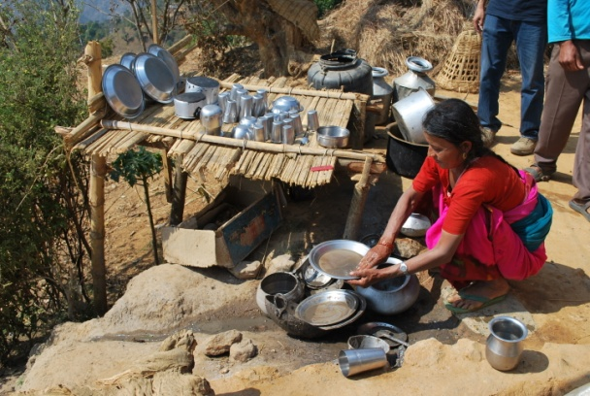  Photograph 1. Small Doable Action – Washing plates etc. |  | 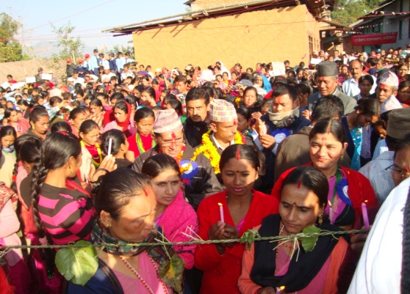  Photograph 2. ODF Oath taking – No more Open Defecation

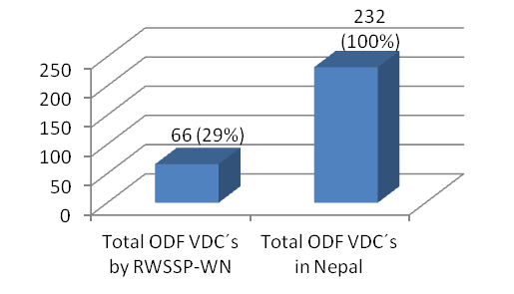
Figure 2. ODF status in Nepal and RWSSP-WN contribution

Learning Points

The experience shows that a VDC can become Open Defecation Free (ODF) within 1-3 months after the right kind of ignition and triggering process. Good results have encouraged the local bodies (DDCs and VDCs) to replicate this approach in other VDC´s aiming to improve the hygiene and sanitation situation.

The ignition and triggering process makes people realize that because of open defecation they are eating their own and their neighbours' shit, people start to think and feel disgust, they say out loud that they do not want to eat shit anymore and take the decision to stop open defecation. This approach has an impact on people's feelings and during triggering nothing is spoken about toilets – people link that in their own heads and start behavioural change. Once people realise to stop open defecation then low cost technological options have been provided.

References
National Living Standard Survey, 2004

Nepal State of sanitation, 2000

Ministry of Physical Planning and Works, Department of Water Supply and Sewerage, 2010

Keywords
Sanitation, hygiene, CLTBC, ODF, Nepal, RWSSP-WN

Contact details

Name of Principal Author: Chhabi Goudel  Address: RWSSP-WN, Pokhara, Nepal  Tel: 00977 61 531883  Fax: 00977 61531879  Email: cgoudel@gmail.com  www: rwsspwn.org.np | Name of Second Author: Markus Tuukkanen  Address: RWSSP-WN, Pokhara, Nepal  Tel: 00977 61 531883  Fax: 00977 61531879  Email: markus.tuukkanen@gmail.com  www: rwsspwn.org.np

A district has several (ranging from 43-69) Village Development Committees (VDCs) which have subdivisions of 9 wards in each VDC. A VDC has population of about 5000.

