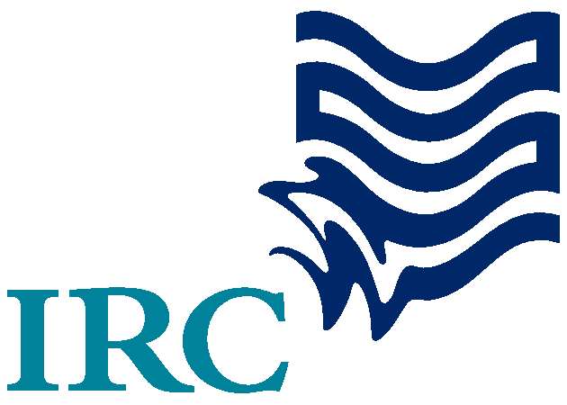
IRC/ WAWI KNOWLEDGE MANAGEMENT RESEARCH

Conversations with Ghana WAWI Partners
Key Findings of Process Documentation Assessment of WAWI I&II Activities
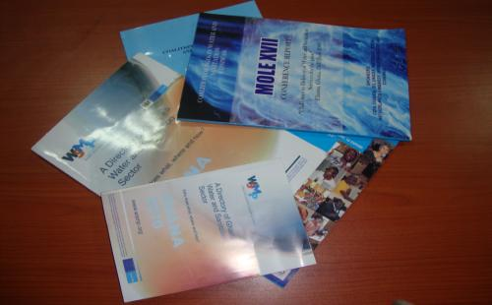


06 August 2010

CAVEAT! This report presents the Researcher’s impressions on issues relating to process documentation of seven development organisations that have been involved in WAWI I and currently with WAWI II activities in Ghana, based on the conversations held with key officials of these organisations. The conversations, which centered mainly on relevant stories and key issues with process documentation of WAWI activities are summarised here in this Document. The full interviews have been captured on CD ROMs in audio/ visual forms, and come as separate addition to this Document. Also included on the CDs are specific outputs developed over the period of project implementation. It is therefore not enough to read this document alone. For a full view of issues, refer to the additions!

CONTENTS

ACRONYMS 3
1.0 INTRODUCTION 4
1.1 Background 4
1.2 Objective 4
1.3 Specific Activities 4

2.0 THE DATA COLLECTION PROCESS 5
2.1 Consultant’s Mobilisation 5

3.0 STUDY METHODOLOGY 6
3.1 Preparing for the Interview 6
3.2 Plotting the Networks 8
3.3 Visiting and Interviewing 8
3.4 Review of Interviews 9

4.0 KEY EMMERGING ISSUES FROM THE INTERVIEWS 10
4.1 Interactions with APDO 10
4.2 Interactions with Church of Christ 11
4.3 Interactions with Rural Aid 12
4.4 Interactions with World Vision International 13
4.5 Interactions with CONIWAS 14
4.6 Interactions with TREND Group 15
4.7 Interactions with Water Aid 16

5.0 ANALYSIS OF PROJECT DOCUMENTATION WITH
THE WAWI PROJECTS 16
5.1 Summary of Key Issues Regarding Partners Involvement 17
5.2 Summary Analysis of Process Documentation issues 19

6.0 CONCLUSION 20

7.0 RECOMMENDATIONS 21
ACRONYMS

APDO Afram Plains Development Organisation
ARD Agricultural Research for Development
AWIS African Water Information System
CLTS Community-led Total Sanitation
CONIWAS Coalition of NGOs in Water and Sanitation
CSC Community Score Card
IEC Information, Education and Communication
IRC IRC International Water and Sanitation Centre
KM Knowledge Management
PD Process Documentation
TREND Training, research and networking for Development
UNICEF United Nations Children’s Fund
WAWI West Africa Water Initiative
WASH Water, Sanitation and Hygiene
WSMP Water and Sanitation Monitoring Platform
WVI World Vision International
1.0 INTRODUCTION

1.1 Background
In Phase I of WAWI, the Partner Organizations worked to institute some level of joint reporting, communications and outreach, with reportedly inconsistent results. Apparently, several attempts had been made to establish mechanisms including common M&E and consistent reporting practices, facilitation of effective internal communications to share information, experiences and accomplishments at the field and HQ level, and development of shared external outreach materials and analyses about the WAWI partnership as a whole. Much of the KM initiatives in WAWI came into play after the main program had been established, and it proved hard to retrofit this in to on-going activities. The lack of a clear mandate among partners for KM initiatives was also a contributing factor in the lack of significant KM outputs.

Moving into Phase II of the Alliance under a different organizational structure, USAID is interested in working with partners to develop a strategic and effective WAWI knowledge management and communications program that will provide technical information, ‘lessons learned’, success stories, and overall WAWI program synthesis for a number of different internal and external audiences. Such efforts will not only benefit WAWI partners and others within the initiative’s focus countries of Mali, Niger and Ghana (with an expansion into Burkina Faso in 2009), but will have a wider relevance to the West Africa region such as the IRC West Africa regional programme, CREPA and AWIS (African Water Information System) and beyond.

In support of this the IRC/ ARD contracted TREND Group to provide assistance in gathering the relevant information from Ghana Partners with regards to process documentation of their activities under WAWI I &II. This information would then form an input in the development of the overall KM strategy. Subsequent to initial discussions in 2009, a contract was signed in March 2010.

1.2 The Objective of the Study
The purpose of the Study was to collect stories on, and explicit knowledge (information) generated during the process over the period from WAWI I till today. It is noteworthy that the study did not have the intention of assessing what has been achieved as against the projected, or monitoring and evaluation of Partners’ activities.

1.3 Specific Activities
The following activities were undertaken by the consultant in the data collection process:
- Preparatory Activities
- Preparing Interviews
- Plotting the Networks
- Visiting/ Interviewing
- Reviewing
- Writing and Reporting

2.0 THE DATA COLLECTION PROCESS

2.1 Consultants Mobilisation
Following the signing of the contract, the consultant commenced preparations towards data gathering. These included the following sub-activities:

Meeting with the Client
The consultant’s meeting with the client (IRC) took the form of a one day training to deliberate on the scope of works and the expectations of the contract. The discussions centered on
- The people to be interviewed
- The type of data to be collected
- The mode of data collection
- Networking and sharing among the consulting stakeholders
- General reporting procedures
- Timelines
The meeting also was intended to build the capacity of the consultant to use the Flip Camera which was supplied by the Client to be used to conduct the interviews. It also deliberated on the use of the WIKI in the data dissemination process. At the end of the exercise, the consultant was conversant with the use of the tools for data collection and the key issues involved in the data collection process.

Desk Study
The mobilisation process also involved the desk study of relevant material and the practice of the use of the WIKI. The consultant commenced the gleaning of materials relating to the specific project and activities the WAWI Partners undertook within the period under WAWI I&II. The essence was to appreciate as much as possible, the nature of the projects that the partners were involved in and whether some of the specific outputs could be found online. The practice of the use of the WIKI also took place during the mobilisation period.

At the end of the mobilisation period, the consultant appreciated the scope of works and the data collection requirements. It also fairly understood the use of the WIKI and with time had an appreciation of it. The key lessons learnt were that the data collection process was a fairly simple one and presented a fine opportunity for learning new things and having more access to information with regards to specific topics and issues relating to the WAWI Projects. It was also realized that not enough information on the projects that the Partners undertook was available online.

3.0 STUDY METHODOLOGY

3.1 Preparing for the Interviews
Preparation for the conduct of the interviews formed a crucial aspect of the Study. The preparations involved the development of a list of key issues and Guide for the interviews. The Guide took a semi-structured form and covered the major points all within the framework of the four WAWI objectives. These objectives included:

- To increase the level of access to sustainable and safe water and environmental sanitation services among poor and vulnerable populations;
- To decrease the prevalence of water-borne diseases including trachoma, guinea worm, and diarrheal diseases;
- To ensure ecologically and financially sustainable management of water quantity and quality; and
- To foster a new model of partnership and institutional synergy to ensure technical excellence, programmatic innovation, and long-term financial, social, and environmental sustainability in water resources management that may be replicable in other parts of the world.

The questions and key issues were presented in such a way that the interviewees would come up with specific stories and main outcomes of their activities in a clear form. The Guide was therefore designed to capture the following broad issues:

- Project Aims and Objectives
- Project Information Management
- Impact of Project/ Material/ Information
- Communication issues
- List and Availability of Material Developed
- Success stories.

In effect, the following table was used as a guide to the collection of information and the conduct of interviews:

Guide for the Conduct of Interviews
- PROJECT AIM, OBJECTIVES AND ACTIVITIES
  - What were the project aims and objectives
  - What specific activities did you undertake
  - To what extent did you cover the requisite activities?
  - What were the key lessons learnt in this area? How have lessons been captured? Verification?
- PROJECT INFORMATION MANAGEMENT
- What outcomes/ information emerged out of each of the activities?
- How were these information/ outputs captured under each activity (means of verifying the information/ Outputs)?
- Where are these knowledge outputs/ information? Who has seen them? Who is using them? How are they using them?
- Have they been updated? How many times? Where are they?
- What lessons did you learn in this area? How have lessons been captured? Verification?
- IMPACT OF PROJECT/ INFORMATION/ MATERIALS/ OUTPUTS
- How many people was the project intended to benefit?
- How many people did the project benefit? How can that be verified?
- Who were the specific outputs/ information intended to benefit?
- How were they supposed to benefit? How many benefitted? What were the lessons learnt?
- Have these lessons been captured? How can they be verified?
- COMMUNICATION
- How have outputs been shared in
- The project region/ area? The country? West Africa?
- Among WAWI partners?
- Who has seen them? Who is using them? Who has but is not using? Why?
- How user-friendly have information/ outputs and materials been? What have been the main complaints/ complements in the use of these outputs/ materials/ information?
- How have outputs been shared in the project country?
- Who has seen them? Who is using them? Who has but is not using? Why?
- How would you advise the next WAWI project.
- Which specific areas are of critical concern by your own assessment?
- LIST OF MATERIALS/ DOCUMENTS COLLECTED
Checked/ verified as right materials?
Checked/ verified for viruses/ defects?
Successfully posted on the WIKI?

3.2 Plotting the Networks
At the initial meeting, the client provided a list of possible personnel to be interviewed. This list included their location, contact numbers and the projects that they were on. The consultant studied the list and plotted the network taking into consideration their locations and convenience of the consultant’s movements. Generally, the locations of the contacts were spread in the northern and southern parts of the country. The consultant therefore grouped the interviewees into Northern and Southern Sectors. The list of specific organisations involved included the following:

Northern Sector
Organisations/ Project | Location
- Rural Aid  - World Vision International  - Afram Plains Development Organisation  - Church of Christ (WATSAN Project) | Zuarungu, Bolgatanga (Upper East)  Savelugu (Northern)  Tamale (Northern)  Yendi (Northern)

Southern Sector
Organisations/ Project | Location
- Water Aid  - CONIWAS  - TREND Group | Accra (Greater Accra)  Accra (Greater Accra)  Accra (Greater Accra)

The consultant first made contacts with the respondents through the email and followed up with telephone calls to schedule interviews. Though the schedules were not convenient for the consultant’s movement, the consultant had to settle for multiple movements to the northern sector which affected the time allotted for the conduct of the interviews

3.3 Visiting and Interviewing
The interviewees were visited and interviews conducted in June and July 2010. This was so because it became necessary that the consultant had to make multiple visits to these locations. The interviewees were sent the list of issues to be discussed during the planning period, well ahead of time so that they would be conversant with them before the interview took place. The objectives and process of the interviews were explained to them and their consent sought before the consultant scheduled the dates for the interviews.

Tools/ Materials for Interviews
The tools and equipment used for the conduct of the interviews included the following:

- Potable Flip Video Camera
- Digital Voice Recorder
- Digital Still Camera
- Interview Guide
- Notebook and Writing Material
- External hard drive (for collecting copies of relevant outputs)

The Interviewees
The interviewees were heads of the respective organisations or their representatives and Specific WAWI project officers. The realization was that, most of them were not readily available and it took sometime before locating them. There were times that the consultant had to trace them in different locations. All the same the interviews were held.

The Conduct of the Interviews
On the days of the interviews, the consultant set up the equipment for the conduct. These interviews were designed to last not more than an hour since the recording equipment worked not more than that period. Almost all the interviews were successfully recorded except one, which was due to battery failure, but that was compensated for with the voice recording. After the conduct of the interviews, the consultant loaded the audio-visual recordings and digital shots onto a laptop to be processed later. Digital copies of the relevant outputs were also collected and loaded onto the laptops. With regards to hard copies of relevant outputs, copies were taken and photographs and then loaded onto laptops to be processed later. After every interview, the recorded interviews were discarded and the recorders freed, batteries replaced and made ready for the next interview.

3.4 Review of Interviews
As part of processing information for the writing of the report, the consultant reviewed each of the conducted interviews. The review process involved the conversion of the video recording into a movie form with specific annotations. After the conversions the consultant listened to each interview all over again and made specific notes. These notes were compared with the ones already taken during the interview and the necessary gaps filled. The voice recordings were also cleaned and saved as back-ups. The information gathered during the specific interviews were drafted into broad draft reports to be summarized into second level reports. These reports were further summarised and the key issues gleaned and posted on the WIKI. Copies of every recording made and outputs collected were saved on a CD ROM and delivered to the client.

4.0 KEY EMERGING ISSUES FROM THE INTERVIEWS
The following describes the emerging issues and summary stories from the conduct of the interviews. They are presented according to the organisations visited.

4.1 Interactions with Afram Plains Development Organisation (APDO)
APDO, The Afram Plains Development Organisation is a local NGO based in the Afram Plains and a Partner to UNICEF. They have a wide range of community-based experiences and implement programmes at the community level. Dominic Dapaah is a Programmes Coordinator and leads the process of working at the community levels in the Northern Sector. He was the respondent for APDO.

Projects Involved
APDO undertook the following activities under WAWI I&II:
- Hygiene promotion conducted (WAWI I)
- Hygiene training kits produced (WAWI I)
- Lessons learnt from UNICEF Ghana Experience written (WAWI I)
- Point of use implementation on Northern Ghana (WAWI II)

Key Issues Regarding Process Documentation with APDO WAWI Activities
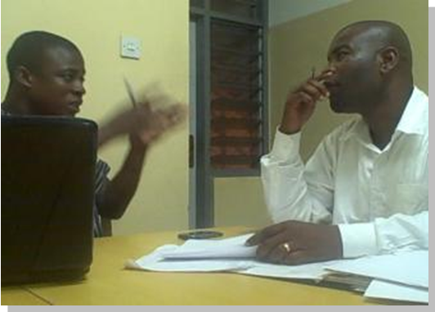
APDO generally has a relatively fair documentation culture. The organisation has made attempts in keeping reports, pictures and material that were general over the period of their involvement in WAWI activities. The main issue with APDO’s documentation is that there is no structured and institutionalized way of documenting activities and outcomes of projects. Documents and material are therefore left on laptops of project staff and their availability meant that the material or information relating to the implementation of the project were not available. Nevertheless, APDO generally makes conscious efforts to record of activities during the implementation of their projects.
Interview with Dominic Dapaah, Northern Sector Programme Director, APDO

The dissemination of their documented outcomes is also an issue. There is not institutionalized way of making their outputs available for use by other organisations or personnel.

STORY 1: Using Video as a Tool for Community Action – An APDO Experience

APDO is a WASH Organisation that has been involved in activities of the WASH sector for many years. It is noted for its community organisation skills, especially the animation of communities in their WASH efforts. Quite recently, they have been keenly involved in engaging communities for their total sanitation efforts and helping them to rid their environments with faecal matter and filth. They provide extension services on many project including CLTS and the I-WASH implementation in northern Ghana and the Afram Plains.

In a conversation with the Northern Sector Programmes Director, he recounts how the use of Video has helped APDO in their mobilisation efforts. He established that, the organisation had acquired an analogue video recorder many years ago but had not utilized it to its fullest and therefore had not really seen the benefits and they role it can play in their process documentation and community mobilisation efforts.

“One day, on our normal visits to our communities with some UNICEF officials”, he recounts “I decided to take the video recorder along, just in case I see something interesting. As usual, I did not take the equipment with documentation in mind per se. We got to one of our communities which had high incidence of Guinea Worm cases and the UNICEF officials wanted to inspect these cases. I therefore thought this was a real opportunity for me to take some shots. I recorded the whole process of the inspection of the cases. It was a pathetic sight and it was not an easy task for me to undertake. As usual when we got back, I just put the video in the collection and forgot about it”. A few months afterwards, one of the UNICEF officials called and asked for the video and I guess I even had difficulty retrieving it from the collection. I gave him the only copy we had and fortunately he kept it well. I think he even made a copy and brought the original back. I was very surprised to realize after a year or so that the video formed the justification and the basis for the development of the I-WASH project which sought to eradicate Guinea Worm in the northern region of Ghana and sponsored by UNICEF. I was thrilled and surprised at the same time that such a simple decision to take along a video camera on our normal routine visits to communities could result in a major project like I-WASH. That is what Process Documentation can do. Later on, I decided to show this particular video to the community where we took the shots because it might be important for them to see what was happening in their locality. To my surprise, after showing the video, it set the community thinking. They asked to see it again and again and I guess it made a lot of impact on them. The impact of the video on the community in their decision making towards the eradication of Guinea Worm was more than the many words and efforts from us. From that time, I decided to rely on the use of video in all my community mobilisation and animation efforts. It is really powerful”.

4.2 Interactions with Church of Christ
Church of Christ is a WASH organisation that is firmly rooted in the Northern Region of Ghana. The organisation mainly makes intervention in the drilling of boreholes and lately has been intensely involved in software activities like community animation and training. It has a strong partnership with UNICEF in the extension of activities especially in hardware. Nathaniel Adams is the Drilling Engineer for church of Christ Water and Sanitation project and was the respondent for the Interview

Projects Involved
- 60 boreholes rehabilitated (WAWI I)
- Pump mechanics trained/ regional pump depot set-up (WAWI I)
- 10 boreholes drilled (WAWI I)

Key Issues Regarding Process Documentation with Church of Christ’s Projects
Association of Area Pump Mechanics in the Northern Region – A WAWI I Output
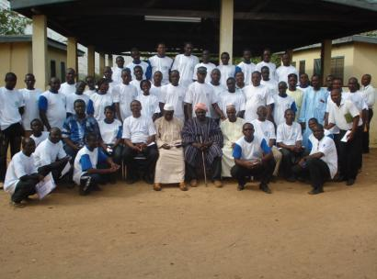
Process documentation is generally not considered in Church of Christ’s Activities. With regards to their involvement with WAWI, the projects required that the partners produced mandatory reports and because of that reports were written but their whereabouts could not be traced. It was also partially because the task officers for the three projects were not at post and different people who were not directly related to the projects were interviewed. The interviewees indicated that, process documentation was an important activity and they do not have the capacity to undertake such a task

STORY 2: Borehole Insurance in Northern Ghana

Church of Christ’s WAWI activities basically was related to the drilling, rehabilitation and maintenance of boreholes spread in the northern region. Support towards the maintenance of the rehabilitated and new boreholes drilled involved the establishment of a Spare parts Depot and the training of Area Pump Mechanics. In addition to the WAWI support, the respective District Assemblies installed new facilities but there were challenges with the communities’ ability to maintain these facilities. Specifically, the communities were not able to afford the cost of maintaining these facilities and this undermined the key issue of sustainability of the facilities. After the support Church of Christ and the respective District Assemblies thought about new ways of dealing with the maintenance issues.

Church of Christ led the way by conceptualising and developing an innovative way of handing the borehole maintenance issues. They termed their new innovation “Borehole Insurance”. Under this arrangement, a partnership arrangement between Beneficiary Communities, Assemblies, Area Mechanics/ contactors and Church of Christ has been reached. the workings of this arrangement and the relationships among the actors are illustrated in the Figure below:

BOREHOLE INSURANCE – Relationship among Key Actors

DISTRICT ASSEMBLY represented by the DWST and Manages proceeds and disbursements
AREA MECHANICS represented by the Area Mechanic Association. They maintain facilities

CHURCH OF CHRIST Facilitator of the Process and Hosts the Spare Parts Depot WATSAN Committee

COMMUNITY represented by the WATSAN Committee

Under this arrangements

COMMUNITIES
- Contribute their premium annually in the form of foodstuffs during the harvest periods of the year to the district assembly. Church of Christ ensures that this is conducted smoothly
- Communities remind AMs about their maintenance schedule
- Make reports to DWST about their non-functioning facilities

DWST in the DISTRICT ASSEMBLIES
- Manages the fund and disburses with Church of Christ
- Appoints contractors to repair major faults
- Reminds AM on schedule maintenance
- Provides technical advice to communities
- Pays for Spare parts at the Depot

AREA MECHANICS/ CONTRACTORS
- Repairs major faults
- Maintains the facilities
- Picks Spare Parts from the Depot
- Provides services reports to the DA and Copies Church of Christ
- Remunerated by the DA from the fund according to the services provided

CHURCH OF CHRIST
- Facilitates the whole process
- Ensures that communities pay their “premium”
- Ensures that DA liquidates proceeds and appropriately manages the funds
- Supplies parts to AMs/ Contractors and Submits invoice to DAs
- Receives Services feedback from communities
- Meets all stakeholder to address pertinent issues
- Manages the Spare parts depot
- Provides training to Pump Area Mechanics

4.3 Interactions with Rural Aid
Rural Aid is a key partner to Water Aid Ghana. It provides extension services mainly through Water Aid’s support to communities in the delivery of WASH services and have comparative strengths in software activities. Currently, it is involved in WAWI in the implementation of CLTS in the Upper East Region of Ghana. Mr. Gani Tijani is the Managing Director of Rural Aid and was the respondent of the interview.

Projects Involved
- CLTS implementation in Ghana (WAWI II)

Key Issues Regarding Process Documentation with Rural Aid’s Project
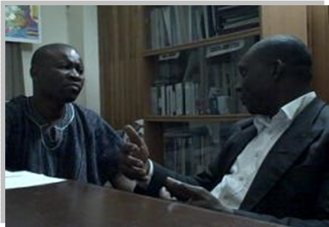
Rural Aid has just commenced a WAWI II activity in the implementation of CLTS in Ghana. Their support is through Water Aid and their main role is to implement the CLTS activities in the Upper region in Ghana. Rural Aid had not been quite mindful about documenting their process activities. In the implementation of their activities, they have written reports, developed materials and taken photographs. All these have been kept on their main computer. They did these because they saw it as a ritual but they have not thought about capturing the process in a systematic manner. They have also have not been mindful and made arrangements about the dissemination of these outputs. Generally, they see a capacity need in this area.

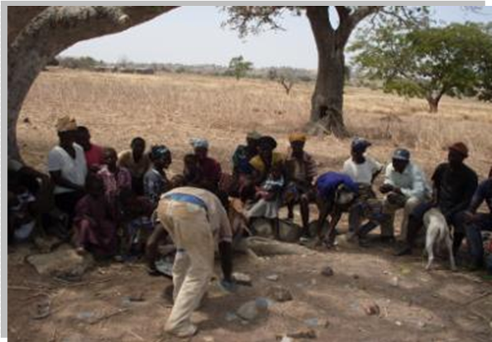
STORY 3: Innovative Ways of Handling Faecal Matter in the Zuarungu Area
– a Rural Aid Experience

Rural Aid has been involved in extension services and rural development activities for a long period of time. In recent years, it operates as a partner to Water Aid in such services and in this case, CLTS implementation in the Upper Region of Ghana, also a WAWI II activity. The crust and success of CLTS implementation is for communities to safely dispose of their faecal matter and to rid their environment of filth. Rural Aid believes that they face a challenge in facilitating this process because they operate in a peculiar environment, where the weather pose a real challenge to the normal implementation of the process – it is dry almost all year round and therefore the ground is hard. This poses a challenge to the communities in the construction of simple latrines to support their newly acquired behaviours. The organisation therefore thought through and designed an innovative way of constructing seasonal latrines. These are 2x2 feet crude latrines which do not necessarily have covers. The sand from the dug-outs is kept by the side of the hole and it is used as top-cover for the faecal matter after every defaecation. This process continues until the pit is full, by which time, due to the intense heat, the faecal matter would have dried up. In the next few months, the hole could be re-dug and used again. All the communities they have engaged in the CLTS process have used this type of latrine though some of them have the intention of upgrading them into permanent latrine.

4.4 Interactions World Vision International
Facilitating CLTS Ignition moments in Pelungu Golingu in the Upper East Region, Ghana

Projects Involved
- Hydro-geo Data Management System Developed (WAWI I)
- Partial construction and equipping of WVI training Centre in Tamale
- Women’s Banking Systems established
- Women’s gardens association created

Key Issues Regarding Process Documentation with WVI’s Projects
Interview with Patrick Apoya, CONIWAS
Generally the interaction with WVI was not satisfactory. The respondents were not willing to release information and material with regards to their involvement in WAWI activities. They were also not willing to allow a video recording of the conversations. Partial voice recording was somehow made and this is attached to the CD ROM.

4.5 Interactions with CONIWAS
CONIWAS is involved in creating the platform and advocating on behalf of all the WASH organisations in Ghana. Patrick Apoya was the then Project Officer in-charge of the organising the MOLE Conference series, the main output of the WAWI support.

Projects Involved
CONIWAS was involved in the Advocacy for NGOs (WAWI II)

Key Issues Regarding Process Documentation with CONIWAS’ Project
CONIWAS is working on Advocacy for NGOs under WAWI II. Their intervention has been quite effective and worthwhile. The main outcome has been the MOLE Conferences and judging from how effective MOLE has been over the years and the impact of its communiqués, the intervention has been effective. Documentation of the process has been a long standing problem and officials of the project have no way of addressing it. This is because the capacity to undertake this task has not been available and to a larger extent, process documentation has not been a main feature of the project. However, many lessons have been learnt from MOLE and some of these have translated into other innovations as elaborated in the story captured below

Lessons Learnt from the Afram “Skuul” of Innovations – an offshoot of a WAWI-Supported CONIWAS Activity

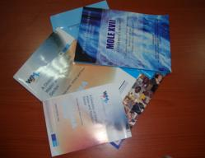
CONIWAS’ involvement in WAWI activities relates basically to Advocacy for NGOs through a platform commonly referred to as the MOLE CONFERENCE. This is an annual conference that has seen twenty six annual meetings of all NGOs in the Water and Sanitation Sector. This is basically an advocacy platform that gives the NGOs an opportunity to deliberate, make decisions and develop communiqués with the intention of affecting policy and by extension making the activities of these organizations much more meaningful. Over the years, many decision and communiqués have been tabled and good outcomes have been seen. One good example is the development of the Water and Sanitation Monitoring Platform (WSMP), sponsored by UNICEF with the sole purpose of monitoring and harmonizing data generated in the WASH sector. This was a direct outcome of a communiqué tabled in one of the MOLE Conferences, a WAWI II activity.

CONNIWAS recently came to the realization that it was important to develop another platform for sharing innovations and skills for the benefit of the NGOs in the sector. The expectation was that, if the process of organizing MOLE brought such encouraging result to the sector NGOs, then this platform, using the same processes, could be viable and would benefit the NGOs immensely. This Learning Platform is intended to run alongside the Advocacy Platform, all to be facilitated by CONIWAS. The first of the innovative sharing platform was held in the Afram Plains of Ghana and hosted by the Afram Plain Development Organisation (APDO), also a WAWI Partner. It was therefore given the name “the Afram “Skuul” of Innovations” because of where it was first hosted, just as its sister platform MOLE, which was also first hosted at the MOLE National park in Damongo, northern Ghana. An appreciable number of the sector NGOs attended this School and learnt many lessons. APDO was motivated to host this School because of the successes it has achieved in its hygiene and sanitation interventions in selected communities. The learning focused on one of the tools developed during one CONIWAS’ WAWI activities – the Community Score Card. This tool enables beneficiaries of projects and services to have access to information on the services and projects they are benefiting from, so they would be in a position to ascertain the performance of all stakeholders in the project by assessing their activities, strengths and weaknesses.. At the Afram School of Innovations, communities who have achieved appreciable levels of successes in their total sanitation efforts were selected for the CSC tool to be used to assess the processes and outcomes.

Lessons Learnt
The main idea was for the participating organizations to assess the function, strengths and weaknesses of the Tool within the community setting and adopt them to their project assessment activities. In fact, hitherto the assessment, the hosting organisation (APDO) had reported of an appreciable level of satisfaction by communities with regards to APDO’s activities. However the outcomes of the use of the Score Cards in the assessments of these communities brought shocking results with regards to the communities’ opinion on their services. In most instances, women and children scored very low whilst men scored high for the facilitator’s relationship with the community. This was a thought-provoking outcome for the participants, especially the hosts. In effect, the participating organisations adopted and adapted the tool for their project assessments. The next Afram School of Innovation learning platform takes place August 2010 in the Ghanaian northern city of Wa for the sector organisations

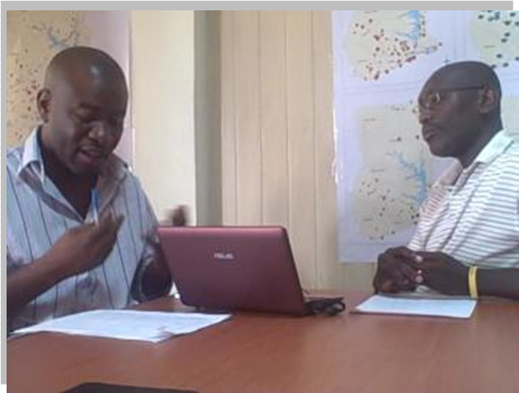
  - Interactions with TREND Group
TREND is involved in facilitating the development of CLTS in Ghana under the USAID Grant provided for such project. It involves the development, dissemination and utilisation of knowledge materials for implementers of the CLTS approach in Ghana
Vincent Tay, CLTS practitioner in the West Africa Sub-region and the officer responsible for the project was the respondent.

Key Issues Regarding Process Documentation with TREND’s Project
The Grant for the development of CLTS in Ghana is a WAWI II activity. This is currently being facilitated by TREND and is still in progress. There is every indication from the conversation that TREND sees documentation as a key component of the assignment. TREND has been able to document the project's activities from its inception up to the second quarter.
Interview with Vincent Tay, TREND Group
In recent times, TREND's role in the documentation of best practices in the sector has clearly put the organisation in the right stead to properly undertake process documentation activities on the project. Already, TREND is playing a lead role in the effort of a resource centre network to transform the water and sanitation sector into a learning and knowledge driven sector. TREND is leading the effort to develop capacity for
- Assessing knowledge requirements,
- Documentation of sector learning events and case studies and development of information products/services,
- Encouraging the dynamic sharing and utilisation of information resources with a view to improving investments in the Ghanaian Sector.
- Serving as a key sector memory base where documentation of sector experience including unpublished literature will be safely kept.
- Facilitating networking with other key knowledge institutions in pursuit of knowledge development and sharing.

The organisation played a key role in establishing and currently hosts the Secretariat of the Resource Centres Network which serves as a hub for Sector Learning and sharing in Ghana.

4.7 Interactions with WATERAID
Projects Involved
- 6 Water Systems constructed
- Community Hygiene Improvement
- Peri-urban Water Supply and Sanitation in Tamale

Water Aid was a key WAWI partner and was involved in three WAWI projects through other partners. It also partnered WVI in the execution of some of the projects. All the projects were completed and specific outputs were developed. Process documentation is a major issue though the organisation has the capacity to institute PD structures and implement them. It has capacity needs in this area.

    - ANALYSIS OF PROCESS DOCUMENTATION OF THE RESPECTIVE WAWI PROJECTS

5.1 Summary of Key Issues Regarding Partners’ Involvement

Organisation / Issue | Projects Involved | Project Information Management | Specific Outputs and Impact | Communication | Key PD issues
Afram Plains Development Organisation (APDO) | - Hygiene promotion conducted (WAWI I)  - Hygiene training kits produced (WAWI I)  - Lessons learnt from UNICEF Ghana Experience written (WAWI I)  - Point of use implementation on Northern Ghana (WAWI II) | - All WAWI I projects activities were conducted and completed. WAWI II activities are still in progress  - Information were generated on all project activities  - No structured and institutionalized way of keeping the information generated and sharing them | - Reports  - Guides  - Manuals  - Photographs  - IEC materials  Most of these were made available to the Consultant | - General poor communication of information and materials  - Have made attempts to make information available through lessons learnt workshops  - Made hygiene education materials available for use by other agencies | - Organisation does not have a thorough understanding of what PD entails  - Have been innovative in developing new concepts out of WAWI activities  - Have made conscious efforts to develop outputs and capture information during the project lifetime  - Sharing of information has generally been poor  - Have capacity needs in PD
Church of Christ | - 60 boreholes rehabilitated  - Pump mechanics trained/ Regional pump-depot set-up  - 10 boreholes drilled | - All projects activities were conducted and completed  - Not much information were generated on project activities  No structured and institutionalized way of keeping the information generated and sharing them | - Reports  - Guides  - Manuals  - Photographs  Most of these were not available | - General poor communication of information and materials | - Organisation does not have a thorough understanding of what PD entails  - Have been innovative in developing new concepts out of WAWI activities  - Sharing of information has generally been poor  - Have capacity needs in PD
Rural Aid | CLTS Implementation in Ghana | - WAWI II. Activities are still in progress  - A lot of information has been generated  - Keeps information satisfactorily | - Reports  - Guides  - Manuals  - Photographs  - IEC materials  Most of these were made available to the Consultant | - General poor communication of information and materials | - Organisation does not have a thorough understanding of what PD entails  - Have been innovative in developing new concepts  - Have made conscious efforts to develop outputs and capture information during the project lifetime  - Sharing of information has generally been poor  - Have capacity needs in PD
World Vision International | Non-responsive

Organisation / Issue | Projects Involved | Project Information Management | Specific Outputs and Impact | Communication | Key PD issues
CONIWAS | Advocacy for NGOs WAWI II | - Activities are still in progress  - Information are being generated  - No structured and institutionalized way of keeping the information generated and sharing them | - Reports  - Guides  - Manuals  - Photographs  - IEC materials  Most of these were made available to the Consultant | - Makes good attempt to communicate information  - Have made attempts to make information available through the RCN | - Organisation does not have a thorough understanding of what PD entails  - Have been innovative in developing new concepts out of WAWI activities  - Have made conscious efforts to develop outputs and capture information during the project lifetime  - Have a close partnership with RCN and sharing of information has generally been good through the utilisation of the RCN Ghana  - Have capacity needs in PD
TREND Group | Grant for CLTS Development in Ghana | - Activities are still in progress  - Information are being generated  - Has a structured and institutionalized way of keeping the information generated and sharing them | - Reports  Most of these were made available to the Consultant | - Host the RCN and organizes the monthly learning alliances  - Makes good attempt to keep and communicate information  - Have made attempts to make information available through the RCN | - Organisation has a thorough understanding of what PD entails  - Have made conscious efforts to develop outputs and capture information during the project lifetime  - Hosts the RCN and sharing of information  - Have capacity needs in PD
Water Aid | - water systems constructed  - Community hygiene improvements  - Peri-urban water supply and sanitation in Tamale | - All projects activities were conducted and completed.  - Information were generated on all project activities  - No structured and institutionalized way of keeping the information generated and sharing them | - Reports  Most of these were made available to the Consultant | - Makes good attempt to communicate information, most of the time through their partners  - Links up closely with sector agencies through CONIWAS and RCN | - Organisation has a fair understanding of what PD entails  - Have made conscious efforts to develop outputs and capture information during the project lifetime  - Utilizes the RCN and sharing of information  - Have capacity needs in PD

5.2 Summary Analysis of Key Process Documentation Issues
General and Partners’ Understanding of Process Documentation
Process documentation is a technique of concisely capturing and sharing critical project concepts, plans and information as they are developed, so that impacted parties can share this information, make informed decisions, and keep the project moving forward without having to revisit old discussions. The basic aim of process documentation is to learn from implementation experience and in the light of this adapt the strategy and ultimately, policy of a program, project or organization. Documentation of processes helps in creating systematic information to articulate the intervention strategies and develop the flow chart of a program. This helps the project or organization to find out more about the needed field intervention methods, coordination, management requirements, financial management and human resource development policies. Not only the project conducting process documentation takes benefit from this but also other similar projects and agencies can use the outcome as a model in their formulation and implementation methods. In relation to the WAWI experience, generally a fair picture of adequate process documentation is not presented. Discussions with respondents indicate that they did not have or had less appreciation of the concept of Process Documentation. Their understanding was rather narrowed to the capturing of specific activities and issues during the projects’ implementation.

Key Issues Regarding Partners’ Development of Concepts and Plans
Conversations with respondents revealed that during the projects’ implementation, Partners learnt a lot to develop new concepts and plans that sought to give new dimensions to their activities. An example can be cited of CONIWAS, who developed a new but related concept to the MOLE Conference Series, which was supported by WAWI. This concept was the Afram Skuul of Innovations, which sought to also create another forum for new innovations to be shared among interested stakeholders. Another good example is Church of Christ’s concept of the institution of a Borehole Insurance system among beneficiary communities in the maintenance and expansion of their facilities, where the project constructed a central spare parts depot and trained Area Mechanics towards the maintenance of water facilities.

Key Issues Regarding Partners’ Development of Outputs and Capturing of Information
During the projects’ implementation the organisations generated more information and further developed outputs. These information were basically captured from baseline activities and researches and observations made during the implementation of the projects. Some of them were in the form of photographs and videos. In most instances, the capturing of the information was mandatory, as required by the project and therefore it was not too clear as to whether they would have been captured or not if they were not mandatory. In the processes, reports were written, forms were filled, manuals and IEC materials were developed. All these were attempts to capture the happenings in the projects’ processes and to ensure that outputs were available for projects objectives to be realised. In all cases, these were conducted, except in the cases of World Vision International that was not ready to divulge information.

Key Issues Regarding Partners’ Sharing of Plans, Information and Outputs
The storage of these information seems to have been an outstanding issue for the Partners. Many reports could not be traced at the time of the visits as well as many of the outputs. Also individual officers keeping outputs on their personal laptops were indications that there were no systems for storing outputs. This trend was translated into the sharing of information. Some of the organisations were simply not willing to share and those who were did not have immediate access to the materials developed. This approach seemed to have affected the system for disseminating and sharing the outputs for other users. In all, the Partners implied the fact that generally the outputs were developed not with other users in mind. This was clear, even in their presentations and captions.

6.0 CONCLUSION
The following observation could be drawn from the conversations and interactions with the WAWI partners with regards to their involvement of WAWI activities within the framework of process documentation:

- Process documentation presents a key issue in the project implementation
- Partners see process documentation as a crucial activity in their knowledge management drive, especially those organisations who are interested in exploring the subject of Knowledge Management.
- Generally, there is no special effort by organisations to establish process documentation and knowledge management systems, though some of them have the capacity to do so
- All the organisations have capacity needs in process documentation and readily welcome any project or activity that would address this issue. Areas that could readily be identified include
  - Partners’ understanding of the concept of process documentation
  - The capturing and storage of information
  - Utilisation of information to impact the project and others
  - Dissemination and sharing of project lessons learnt

7.0 RECOMMENDATION

The consultant recommends that the client further explores the existing Knowledge Management capacities of the partners and build upon it. The partners have seen the importance of process documentation and by extension Knowledge Management in their project activities and are ready to lend support to any initiative to augment this. The client and / or a WAWI successor should take advantage of that.

The various organisations in the Water and Sanitation sector generate diverse knowledge and materials through their individual activities in the sector. Altogether, a lot of knowledge and materials are generated but are not known to the sector agencies. The RCN therefore creates the platform for the individual organisations and persons in the sector to have access to these knowledge and materials for the benefit of the sector as a whole,

