Children With Camera: Knowledge Sharing For Changing Sanitation Of Society

Mr Nam Raj Khatri, NPO, WHO Nepal(Email: namrajk@gmail.com)
Mr Shreerendra Pokhrel, Darechowk, Chitwan Nepal (Email: shreendrapokhrel@gmail.com)

Abstract:

This is the story of Darechowk village (with a population above 8,000) of Chitawan District in Nepal. Mr Shreerendra Pokhrel, Headmaster of Majhgawn high school attended a training on ecological sanitation in 2007. He was determined to make his village into an ecosan village and he did. This village is known as an ecosan village and a resource center and visiting place.

Shreenredra came out with the idea of making children as change agents for sanitation promotion in line with the school sanitation movement of his district. He formed the Bal Club and divided children into 9 groups. He wanted students to write short reports on sanitation with photos. Han Heijnen of WHO liked the idea and provided one digital camera for the school.

With the camera, students happily visited their community in teams and captured different scenes related to sanitation and environment. Students took the photos and discussed each scene in their teams. They prepared a half page report on each scene as key messages. The photographs with their interpretations were displayed in a photo exhibition during the ceremony to declare their school ODF (open defecation free) in 2009. This photo essay is based on the photos displayed in the exhibition.

Key Words:

Children with camera, Sanitation, Change agent, Sanitation scenario, Open Defecation Free, Ecological Sanitation

Acknowledgement:

We would like to express our sincere thanks to all the children who participated in promoting sanitation in Darechhowk and took part in photography and photo exhibition which ultimately changed Darechowk in to open defecation free and Ecological Sanitation Village.
Essay:
No | Photograph | Message
1 | 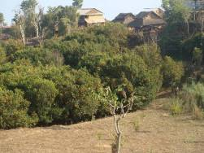  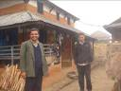  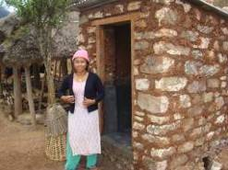 | Mr Shreendra was headmaster in Majgaun high school of Darechowk where he worked 10 years. In 2007, he attended a school sanitation training which had a focus on ecological sanitation. The training program was organized by the district water supply. He then decided to make his village an eco-village and an open defecation free village in line with the district-wide movement. This succeeded in 2010. Now he has left the school and is working fully for the promotion of ecological sanitation.
2 | 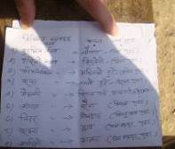  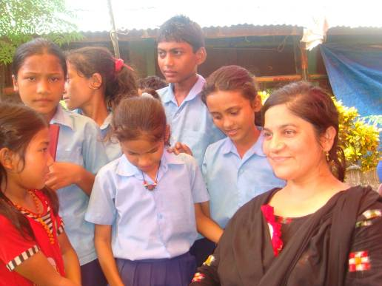 | A Bal (Children) club with 9 teams was formed among students aged 12 years to 16 years from grades 6 to 10 for sanitation activities. Each Bal club worked between the school and community for awareness raising. When students move around the community and speak about sanitation, their parents become very proud and tend to follow them. Hence children becomes change agents for the community
3 | 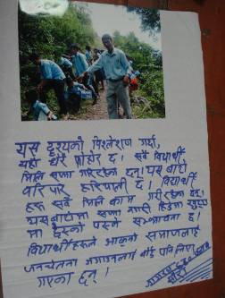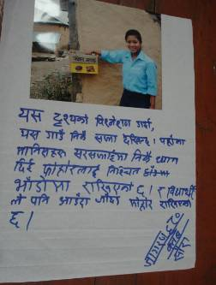 | The children and the written text under it. Children collected pictures, analyzed them and wrote comments on a chart paper. Children were happy to move about to take photographs and discuss in a team the local sanitation situation and how to improve it. Mr Han Heijnen, technical officer of WHO, provided one camera to the school for this purpose.
4 | 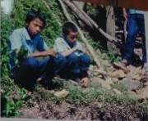 | For this picture, the children write: This place is not clean. There are stones everywhere on the way. These sharp stones may cause injury while walking. One should be careful while walking from this place. Stones needs to be sifted to safe place and roads should be cleaned
5 | 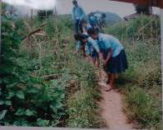 | For this picture, children write: In this view students are working together for sanitation because the path is very dirty. If we take care of sanitation we can live a healthy life.
6 | 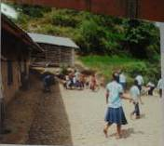 | For this picture, children write: What we can analyze in this picture is that students are working together to clean school surroundings. Here stones, leaves and pieces of woods are seen on the ground, We need to make our school clean and surrounding green.
7 | 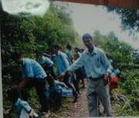 | For this picture, children write: Analyzing this view, we can say that the place is much dirty. Students are working together for sanitation. Both sides of roads are green. If we do not clean the road there is chance that sharp objects may cause injury. Students are carrying flash cards to make people aware.
8 | 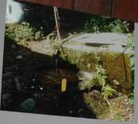 | Children write: This view is very dirty. The water tank and tap are there. We all need to clean this place. Otherwise we will suffer from various communicable diseases.
9 | 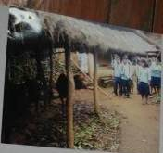 | For this picture children write: In this view, students are making teams for sanitation activities. There is dirty place near by the home. Near the home we can see garbage everywhere. Because of this dirty environment, there is chance of infection from various communicable diseases which can cause death
10 | 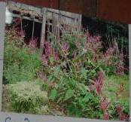 | Children write: This view indicates that the environment is well maintained. People have made their surroundings beautiful by planting various types of flowers. Flowers have increased beauty of households. In addition environment is also clean and green. Hence we must plant various flower in our surroundings.
11 | 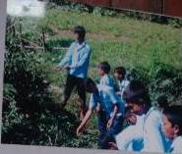 | For this picture children write: It appears that surroundings are very dirty and children are participating in the sanitation program. Only students are working. It seems that the students are supporting the principle of "clean environment and live safe life"
12 | 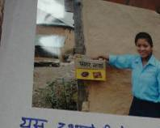 | Children write: Analyzing this view we can say that this village is very clean. Here people are conscious of cleanliness. They have put waste in fixed places. Student also keeps waste in a fix place.  Note: This picture got first prize in the exhibition.
13 | 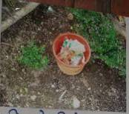 | For this picture children write: This environment is very poor. To keep the environment neat and clean, a dust bin has been brought in to practice. If this place remains clean, this place can be tourist place.
14 | 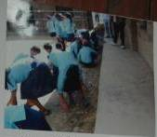 | Children write: we can see the following information in this picture.  Student are actively participating in the school sanitation program  If the school is clean, the health of students remains safe  Sanitation program has been completed under the leadership and action of the teacher and students.
15 | 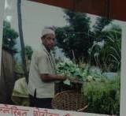 | Children write: The following information is shown in this photo  Using an ecosan toilet, farmers have grown more vegetables than the previous year. Using urine we can grow cauliflower and other vegetables which are more nutritious.
16 | 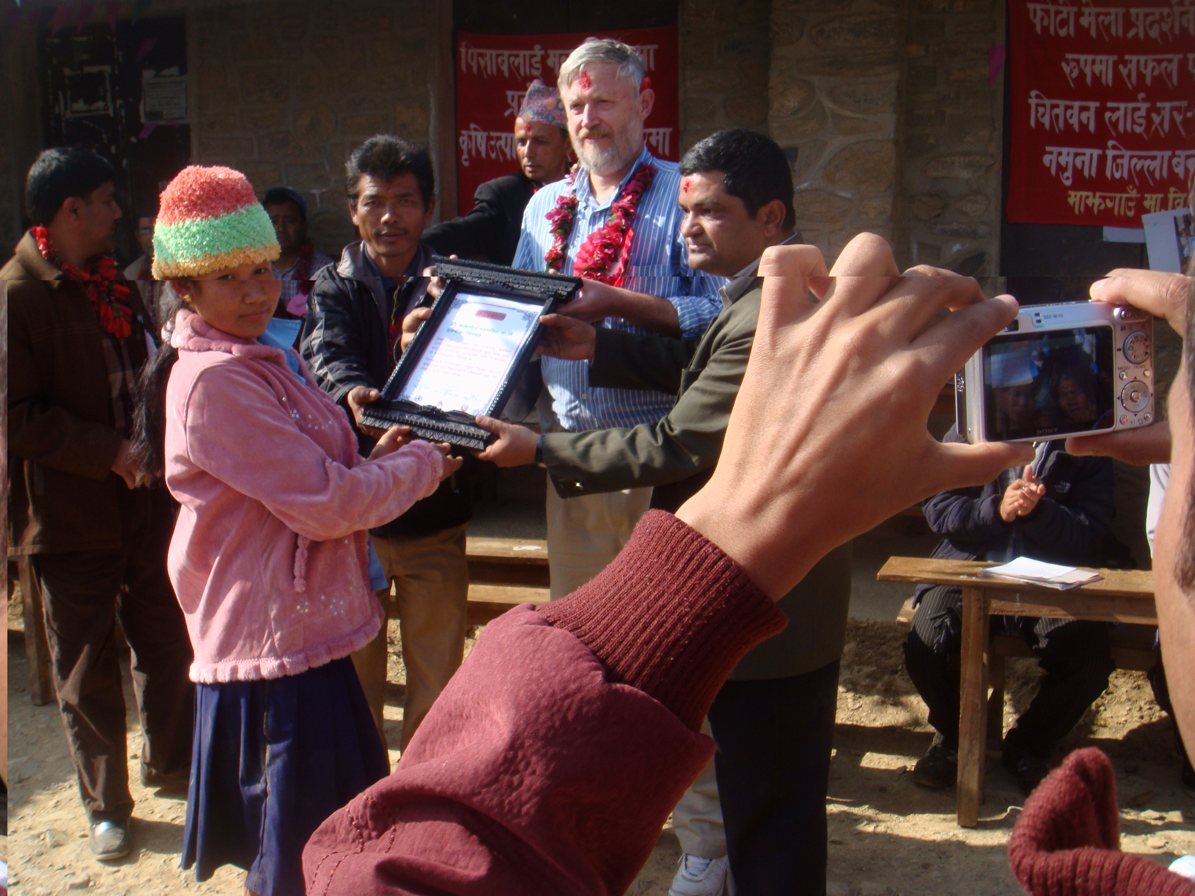  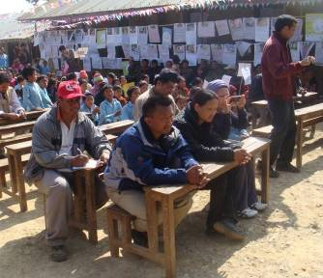 | Photo exhibition was organized in Majgawn school of Darechowk under occasion of school catchment area ODF in 2009. More than 200 photographs with analyses were displayed. Villagers and key stakeholders participated in the exhibition. The best three photographs were selected and given a prize.

