Dhaka, Bangladesh, February 2010

ASIA HYGIENE PRACTITIONERS' WORKSHOP

Hygiene promotion for men -
Challenges and experiences from Nepal

Ingeborg Krukkert [The Netherlands], Carmen da Silva Wells [The Netherlands], Yubraj Shrestha [Nepal] & Mangal Dash Duwal [Nepal]

Effective hygiene promotion reduces the main risky hygiene practices and conditions for women, children and men. To be effective, each member in the community should be involved. Everyone working on hygiene promotion will agree with this. Inclusive hygiene promotion is recognized widely: all gender groups, women, children and men have to be included in hygiene promotion activities. However, most hygiene promotion programmes focus on women only. Specific examples on how men are targeted are difficult to find. Involving men and encouraging their responsibility in hygiene and sanitation improvements is important for many reasons. For example, men have a key role in decision making; often control finances; have an important role to play in family and community health improvement; can help reduce the burdens borne by women; and men can be role models to others in the community. Men who are well informed on the benefits of hygiene improvement for their family are more likely to support their wives and children and to change their own behaviors. In this paper we use the experience of NEWAH, a national NGO based in Nepal, as a case to describe the challenges, but also the benefits and the lessons learned while focusing hygiene promotion on men.

Background and context

The behaviour of women and men, girls and boys impact on community development. Identifying key risk behaviours, priorities, roles and responsibilities can help field staff to understand how to target their hygiene promotion activities more effectively. Doing this in a participatory way helps community members understand key risks and possible corrective actions to be taken. Although this has been recognized for many years, (see, for example, Wijk-Sijbesma, 1995) few programmes have approaches and tools to target men specifically. Many donors want to see impact on women and children; however, they are less interested in how to involve men in hygiene promotion, so it is often also not taken up actively by NGOs or other implementers. An EU-funded programme called “Assistance to Vulnerable Groups and Communities Most Affected by the Internal Conflict (VCP-EU)” has provided an opportunity to address this issue; and, NEWAH is one of the first organizations to take up this challenge.

Two years have passed of this three-year project which includes three major components: (rehabilitate) access to basic services; rebuild livelihoods for the poor; and strengthening community based organisations. Hygiene promotion for men was a small but important element in the overall water and sanitation intervention. Health and sanitation facilitators are members of the community, hired for the project to carry out hygiene promotion activities and support the rehabilitation of basic services. The project covered four districts: Doti and Achham of Far West region and Dailekh and Surkhet of Mid West region.

For many years, the Mid and Far West regions of Nepal were not priorities of development initiatives due to geographical features and the low level of awareness of the developmental challenges in the region. It is an area that is challenging to work in because of the rough terrain, limited infrastructure and scattered habitation as well as the effects of the government -Maoist conflict in the past. Compared to more accessible areas, there is lack of transportation, infrastructure and access, which are significant barriers for development. Many inhabitants, mostly men, are involved in seasonal work, which often means working abroad in India for about six months a year, which is one of the barriers the village health and sanitation facilitators faced as we will see later in this paper.

Health education or hygiene promotion
Many organisations include health education for community members in their water and sanitation projects. However, health education is not the same as hygiene promotion. Health education often implies instruction: telling people what to do or what not to do. We believe that successful programmes do not instruct people, but instead interact with people to jointly find solutions. (See Appleton, 2005). In this paper we deal with hygiene promotion.

What is hygiene promotion for men?
Effective hygiene promotion reduces the main risky hygiene practices and conditions for women, children and men. To be effective, each member in the community should be involved. Everyone working on hygiene promotion will agree with this. Inclusive hygiene promotion is recognized widely: all groups, women, children and men have to be included in hygiene promotion activities. However, most of the hygiene promotion programmes focus on women only. Specific examples on how men are targeted are difficult to find.

This may have to do with the way hygiene promotion activities are set up. First, hygiene and sanitation behaviours that form a risk for health are identified within the community. Secondly, the groups most at risk are identified. In most of the communities these are the mothers. Often they are the ones preparing the food, cleaning the children after defecation, feeding the children. In addition, it is assumed that if you reach the women you will reach the whole family. This appears to make it less urgent to target men.
Hygiene promotion for men means that men are explicitly targeted in hygiene promotion activities; however, it does not mean that other groups are excluded. We will use the experience of NEWAH, a national NGO based in Nepal, as a case to describe the challenges, but also the benefits and the lessons learned while focusing hygiene promotion on men.

Why is it important?
It has been recognized for years that women and men have different roles, responsibilities and interests in hygiene and sanitation. Involving men and encouraging their responsibility in hygiene and sanitation improvements is important for many reasons. For example, men
- have key roles in decision making within the family and community
- often control finances
- have an important role to play in family and community health improvement
- can help reduce the excessive burdens of women
Man Bahadur Bhujel, a male community worker in the village of Phaperthum, reported that since the men in the community have started receiving health education they have become aware of its importance and no longer need convincing from their wives. (NEWAH (2003[?]).
- can be role models to others in the community

Men who are well informed on the benefits of hygiene improvement for their family are more likely to support their wives and children and to change their own behavior. “Exclusion of husbands and fathers from hygiene education programmes also does not take into account their feelings of responsibility and pride in their families and children.” (Burgers et al., p.19, 1988)

Until two years ago, NEWAH’s hygiene education activities were mainly targeted at women and children through community meetings and household visits. NEWAH staff indicated that men are often not present during the household visits. Why target men when they are not around? That was not only stated by the local health and sanitation facilitators, but also by other Nepal-based organisations with whom the experiences were shared during the project.

This triggered something at NEWAH. Their extensive experience with their gender and poverty approaches convinced them of the importance to explicitly target a group if you want to be sure to achieve the goal of hygiene for all, not only for women and children. Targeting men does not mean that you should not target women anymore, as they remains a very important target group.

Explicitly targeting men, however, appeared to be difficult to carry out in reality, in the family and community. The health workers at the community level as well as the regional staff at the district level faced many challenges.

Challenges

Turn theory into practice

In phase one of the EC project there were seventeen health workers hired: thirteen women and four men. In phase two there were eleven health workers: seven women and four men. All of them received a small salary during 12 months. These health workers were hired to act as hygiene promoters in the villages. They were called Health and Sanitation Facilitators (HSFs). Before they started their work on hygiene promotion in the villages, the HSFs had an elaborate training by NEWAH on 18 health issues, all of them equally important. These issues ranged from faecal-oral diseases, transmission routes, safe handling of water, family health and practical use of teaching materials to monitoring and supervision and hygiene promotion key components. The information overload was big and it was difficult for the HSFs to translate this course into practical action at the village level.

The regional support staff of NEWAH also face difficulties in implementing the adapted approach on the ground. They receive questions from HSFs on how to incorporate this specific focus on men in their regular activities. How to translate the training on hygiene for men into practical guidance they can use in their daily work? As the focus on men is new to the regional staff, this is not something for which they have ready-made answers.

Get in contact with men: location and time
The female HSFs emphasized that it is possible to reach men, but that it is not as easy as reaching the women. For example, if there are male and senior relatives of the female HSF in the village, such as a father or brother in law, then the HSF cannot directly talk to them. One of the HSFs also mentioned that she felt intimidated by (elderly) men while doing her job.

The HSFs found it difficult to encourage men, adolescent boys, elderly men and elderly women to attend hygiene promotion meetings. Many community members are busy with farm work or are abroad for seasonal work which makes it difficult to include them in regular hygiene promotion activities. A specific challenge they faced in this programme is that the time of the community members is already consumed by the water construction activities of the programme. So attending hygiene promotion activities is experienced as an additional burden and is given less priority.

Knowing what motivates men
Initial reactions of men towards the attempts of the HSFs to include them in hygiene promotion activities range from indifference to aggression. The HSFs found it difficult to identify what would motivate men to change behaviour for improved sanitation and hygiene and, therefore, also which tools to use to convey their messages.

Support
Some of the HSFs said they felt demotivated because of the lack of interest among community members. They had many roles to perform within the project; and, support from the regional office was irregular due to the large distances to cover, frequent road blocks and high fuel prices. Some HSFs in very remote areas were never visited in their own community. Lack of support seems a structural challenge. A few years ago, male community health workers also indicated that they “face problems in trying to gather other men (given their time constraints) and to overcome the resistance they face from these other men in the community.” (James et al. p.11, 2003).

At the regional level, NEWAH staff supports the HSFs in reaching community members. However, the Health and Sanitation Facilitators face challenges that are common in other countries too. In Ethiopia for example, WaterAid states that the role of the health facilitator is “hard for many reasons: it can be lonely, involves walking long distances in all conditions, and can involve coming into direct daily contact with many of life’s harshest realities.” (Matthewson et al., 2005). The HSFs of NEWAH also have a high work-load, since they work on the implementation of water supply structures too. Linked to the fact that NEWAH staff also work in many projects concurrently, the time left for support is very limited.

Possible improvements

From theory to practice
To bridge the gap between theory and practice, the HSFs were introduced to six steps of hygiene promotion using participatory methods with community members:
- identify the key risk behaviours in your community;
- link risky behaviours to groups of people within the community, that is, identify the target groups;
- find out the reasons for their current practices,, that is, what is their motivation;
- identify the benefits they see in changing their behaviour;
- formulate messages for the target group(s) AND decide which ones to use. It is important to limit the number of messages to one or two;
Table 1: Getting men involved

Some suggestions on how to involve community members, especially men, in hygiene promotion

- Inform men (and women/children) about the benefits for whole household: sanitation and hygiene is not just for women!
- Focus on technical aspects of sanitation.
- Involve men in construction.
- Give a specific role: information sharing; leadership role.
- Focus on economic benefits: reuse of manure and wastewater for kitchen gardening, health savings from improved hygiene and sanitation.
- Choose suitable times: evening, specific day, season, festival.
- Choose suitable locations: go to where the men already are (tea stall, market, household compound).
- Use short messages: focus on part of a tool (like one part of the F diagram, 1 or 2 flashcards), or on one risk behaviour.
- Focus on small, achievable steps: stepwise improvement to existing practice or to existing sanitation facility.
- Involve key opinion leaders: health workers, tea stall owners, religious leaders, teachers, story tellers.
- Involve village leader(s), WSUC, caretakers, CBO, youths.
- select and/or adapt tools to use and people to support.

This training helped the HSFs improve their field work. They started targeting the different groups within the village but realized that they did not reach the adult men and the elderly (men and women). Knowing the importance of including all community members in hygiene promotion, this motivated them to actively focus on men in their activities. However, it did not solve the problem of how to reach them. From their experience with the Gender and Poverty Approach, NEWAH recognized that it is sometimes difficult for women to involve men. For this reason they have also recruited some male community health facilitators.

As early as 1985 men were involved in sanitation training in Nepal: “Water technicians were trained in disease transmission [and] personal and home hygiene […]. The initial resistance to the new training changed. […] By appealing to their interest in improving their own health, they saw greater relevance for the project and its integrated approaches.”(Burgers et al., p.21, 1988)

According to the male HSFs, it is indeed easier for a man to reach the men in the community. Hygiene and sanitation issues can openly be shared among men. This was also concluded from an assessment of the NEWAH gender and poverty approach in 2003: “Male community health workers can be extremely effective in fostering change with men where female CHVs cannot make any headway.” (James et al., p.11, 2003).

Reaching men: location and time
In order to reach the men, the HSFs started to choose new, different locations of public places for their hygiene promotion activities, such as tea stalls, the community building, and areas where work takes place for the rehabilitation of water supply. Timing of the hygiene promotion activities was adapted to the availability of the community members at the public places.

Motivation
Having more possibilities to reach men leads to the next challenge to be addressed: which issues interest men? How to motivate them? How to stimulate behaviour change for improved sanitation and hygiene? Men may often be motivated by other factors than women. The HSFs found for example that men can be attracted towards hygiene promotion activities by being given specific roles. Men do not prefer to be just members of the audience, so it would be good to explore possibility of giving men an information sharing role, or some sort of leadership role.

Support of HSFs
Equally important for involving men in hygiene and sanitation improvement is to find people or organisations able to help to change the attitude and behaviour of men. The HSFs found that it helps if hygiene issues are discussed in the Water and Sanitation User Committee meetings before reaching out to men. With the help of the chairperson and active members of the committee it was easier to get the message across. These are a few things found out by a couple of HSFs in remote areas of Nepal. Are these strategies equally relevant everywhere in Nepal or only for the remote areas? At least some of the methods listed in Table 1 should be relevant within and perhaps outside Nepal as well. In any case, including men in hygiene promotion in a systematic and effective manner is an issue that needs more attention at the levels where planning and strategy are developed.

Staff from the regional office tries to support the HSFs by more frequent contact by telephone or in person and by stimulating closer cooperation between technical and health field staff. Having limited time to actually be around made the regional staff develop alternatives. For example: support from NEWAH regional staff and/ or District Development Committee staff in targeting influential men in the community. These men may pave the way for better involvement of men in sanitation and hygiene improvement.

Two key issues are addressed to improve effectiveness and sustainability of WASH activities after project completion. One is to strengthen the involvement of community structures such as the Water and Sanitation User Committees in sanitation and hygiene promotion as well as in monitoring progress and outputs. Second is to provide practical support and motivate project staff, especially the HSFs. Training is provided for facilitation skills by social section staff of NEWAH, focusing on the six-step approach and a limited number of hygiene issues. According to the HSFs, they could better reach men in at least three project villages: Mathillo Ganma, Jumla Kafal and Dhipintada of the Dailekh district, one of the four districts covered by the project. The HSFs felt empowered by sharing experiences among project staff; mutual field support for each other; and by the the more intensive monitoring and support from regional staff in the form of field visits and joint planning.

Tools used in the communities
To involve men in hygiene and sanitation improvement, they also needed to think about which hygiene promotion tools they could use. A tool such as body mapping for awareness raising on personal hygiene did not work very well with the elderly people, for example.
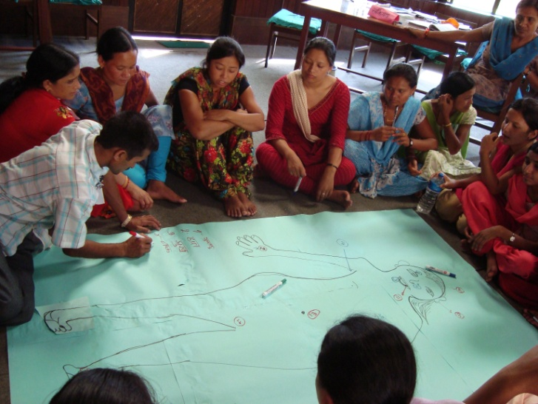
Elderly people are not used to these ‘new’ ways of looking at your body, especially the private parts, according to the HSFs.

Photo: NEWAH-CWRO, body mapping exercise.

Some of the tools that do seem to work are the F-diagram, a tool for raising awareness on transmission routes of oral-faecal diseases, and drama.

The F-diagram was adapted from an education tool to a promotion tool. Thus, instead of showing people the F-diagram and explaining the transmission routes of faecal matter, community members were encouraged to find out for themselves which were the risks they face.

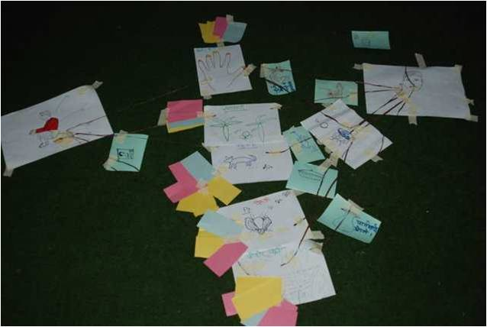
The HSFs started by asking community members to tell a story: how can stool from a person with diarrhoea get into your mouth? They asked them to draw things, for example a plate of food to show contamination by food, or a water pot, or flies. Then the community members were asked to show how faeces can come into the mouth by placing strings from one drawing to another, for example from flies to food. By doing this they showed the link between risky behaviour and faecal-oral illness. Through the exercise, participants became aware of the transmission route; and, this makes it easier to see where the risky behaviour should be blocked in order to block the transmission of faecal-oral diseases, one of them being washing hands after defecation.

After this participatory exercise participants discussed who in their community were the groups most at risk. Even in the training session for the HSFs this worked very well. One of the HSFs said that he only now clearly saw and understood the importance of using a latrine.

Photo: IRC, F-diagram made by HSFs in a training on hygiene promotion for men.

Using drama
HSFs covering three villages work together to convey their hygiene promotion messages. They started touring a play from village to village to convince men that hygiene is an essential part of the drama of family life. In many districts, men go to India for six months at a time for work. When they come home, they often do not attend meetings organised by the health workers. Theatre is an innovative way of getting the hygiene message across to men who are not easy to target. So, the HSFs wrote a play in collaboration with the project staff responsible for technical support. The health workers go from village to village performing a play which shows the importance of having and using a latrine. The moral of the story is that men will not get a wife if they do not have a toilet. These shows are highly popular and attract many villagers, including men. It is hoped they will encourage men to display sustained hygienic behaviour. Of course, getting men to change their behaviour may need more than a play, but it’s an excellent first step.

Integrating new approaches in existing strategy

The hygiene promotion for men approach is seen as a valuable add-on to the existing NEWAH approach on hygiene promotion. NEWAH has integrated hygiene promotion for men in their hygiene promotion strategy guidelines as well as in the existing project cycle. The adapted inclusive hygiene promotion approach is being mainstreamed in all NEWAH projects funded by donors. The training to new HSFs follows the new approach; in fact the entire existing project cycle has been revisited. Learning and sharing of experiences takes place from regional level to head quarter level and vice versa.

Acknowledgements
The author/s would like to extend thanks to the HSFs as well as to the regional NEWAH staff of the Far and Mid Western Region of Nepal for their constructive input and support.

References

Appleton, B. and Sijbesma, C. (2005). Hygiene promotion. (Thematic overview paper / IRC). Delft, The Netherlands, IRC International Water and Sanitation Centre. Available at http://www.irc.nl/page/27611

Burgers, L.; Boot, M.T. and Wijk-Sijbesma, C.A. van (1988). Hygiene education in water supply and sanitation programmes : literature review with selected and annotated bibliography. (Technical paper series / IRC; no. 27). The Hague, The Netherlands, IRC International Water and Sanitation Centre. Available at: http://www.irc.nl/docsearch/title/109555

James, A., Khadka, R., Shahi, D. and Appave, J. (2003). Evaluating the impact of NEWAH's gender and poverty approach using the NEWAH participatory assessment : a report of the assessment of 15 communities in 5 development regions. Kathmandu, Nepal, NEWAH

Matthewson, P. and Ayele, M. (2005). A healthy debate : A discussion paper around sanitation and hygiene promotion, focusing on a WSSHP project in Tigray, Ethiopia – 2005. Addis Ababa, Ethiopia, WaterAid Ethiopia.
Available at: http://www.wateraid.net/penweb/docs/WA_Eth_healthy_debate_05.pdf

NEWAH (2003[?]). NEWAH’s gender and poverty approach : findings from the communities. Kathmandu, Nepal, NEWAH. Available at: http://www.newah.org.np/pdf-file/findings.pdf

Wijk-Sijbesma, C.A. van (1995). Gender in community water supply, sanitation and water resource protection : a guide to methods and techniques. (Occasional paper series / IRC; no. 23). The Hague, The Netherlands, IRC International Water and Sanitation Centre. Available at http://www.irc.nl/page/1856

Keywords
Hygiene promotion, gender roles, participatory methodology

Contact details

Ingeborg Krukkert  IRC International Water  and Sanitation Centre  The Hague, The Netherlands  Email: krukkert@irc.nl  Tel: +31 (0)70 3044023  www: www.irc.nl  Yubraj Shrestha  NEWAH-CWRO  Chitawan, Nepal  Email: yubraj_cwro@wlink.com.np  Tel: 977-056-525833  www: http://www.newah.org.np/ | Carmen da Silva Wells  IRC International Water  and Sanitation Centre  The Hague, The Netherlands  Email: dasilvawells@irc.nl  Tel: +31 (0)70 3044008  www: www.irc.nl  Mangal Dash Duwal  NEWAH-MFWRO  Nepalgunj, Nepal  Email: mangalduwal@newah.org.np  Tel: 977-081-521261  www: http://www.newah.org.np/

