Dhaka, Bangladesh, 31 January -2 February 2012

Asia Regional Sanitation and Hygiene

Practitioners Workshop

Eco-toilet- An Ecological Sanitation Option for Difficult Areas of Bangladesh (Practice)

A. S. A. Abdullah Al Mamun (Bhutan) B. Monirul Alam (Bangladesh)

Bangladesh has made significant progress in sanitation under the programme Sanitation for All by 2013. Coverage and sustainability, however, still remain major challenges. The problems related to sanitation vary between urban and rural areas and among different geographical regions of Bangladesh.

Considering the drawbacks of current sanitation technologies (with respect to varying local conditions), Practical Action Bangladesh has started working on eco-toilet and piloting beginning in 2006. With financial support from UNICEF and DPHE, Practical Action Bangladesh and its partner NGOs implemented an action research project on ecological sanitation in difficult areas (urban slums, Hoar, hilly, Barind track and flood prone) of Bangladesh.

The cost of the technology is another challenge for scaling-up. The average cost of the conventional eco-san option is relatively expensive for the poorer sections of the population. In this regard the current action research adopted a variety of options to bring down the cost. A number of design problems of the traditional eco-toilet and several modifications in the design have been made in order to improve the quality of compost and end uses. The research has also attempted to address another challenge of bringing about behaviour changes with respect to the use of eco- toilet.

Because of the short duration of the project, it was not possible to demonstrate all the design options in particular for urban slums and areas with a high water table. The project attracted considerable attention among sanitation practitioners in order to address the ecological sanitation solutions for the difficult areas of Bangladesh.

Introduction:
The Sanitation, Hygiene Education and Water Supply in Bangladesh (SHEWAB), a GoB-UNICEF-DFID Project, and the Department of Public Health Engineering (DPHE) undertook a 16-month action research called “Ecological Alternatives in Sanitation in Difficult Areas of Bangladesh”. Practical Action Bangladesh and its partner NGOs were engaged as the technical agency for implementation of the project. The major objective of the action research was to try out innovative eco-toilet options appropriate for difficult geo-hydrological, physical and socio-economic and cultural contexts of Bangladesh. The project was implemented in 16 clusters of four geo-hydrological difficult areas (namely, urban slums, Hoar, hilly, Barind track and flood prone) in seven districts, Rangpur, Gaibandha, Chapai Nawabgonj, Bandarban, Sunamganj, Moulavibazar and Narsinghdi.

- Activities and outcomes
The action research was comprised of five stages: (1) Inception, (2) Planning and design (3) Implementation/construction of toilets (4) Post-construction stage and (5) Documentation and knowledge dissemination.

  - Inception stage:
- Cluster Selection: The 16 clusters in the GoB-UNICEF project areas were selected through series of field visits and meetings with local communities, Local Government Bodies (Union Parished, Pourashava and DPHE) considering the various socio-economic and geo-hydrological contexts.
- Baseline survey: A detailed baseline survey was conducted regarding the present sanitation situation and the knowledge and attitudes of the community people to the eco toilet as well as their interest and willingness to pay for eco-toilet construction; and
- Stakeholder’s feedback (local & national): Several meetings were held with relevant stakeholders and individuals (DPHE, UNICEF, WSP-WB, UPPR project, NGO-Forum, DSK, DISHARI project, Plan Bangladesh, ITN etc.) with the objective of informing them about the project, and to seek their suggestions and cooperation for strengthening the expected and effective implementation of the project.

  - Planning and Designing stage
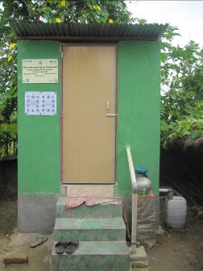
The approach to developing eco-toilet designs has been undertaken by Participatory Technology Development (PTD). The project developed the following eleven (11) prototype engineering designs through reviewing the existing designs available at home and abroad including physical investigations of other Ecosan project areas in Bangladesh and consultative meetings with the beneficiaries and stakeholders to improve the understanding of local conditions and preferences of the potential users. All the toilets have double vaults (2 compartments other than option 8) to enable composting of one while the other is being used. The designs were:
option 1: fixed chamber system using plastic fiber pan
option 2: movable drum system using plastic fibre pan (single pan)
option 3: movable drum system using high commode
option 4: fixed chamber system using modified traditional eco pan
option 5: fixed chamber system using traditional eco pan
option 6: movable drum system using traditional eco pan
option 7: elevated movable drum system with RCC column
option 8: single pit urine diversion toilet
option 9: twin pit urine diversion toilet using urine diversion pan
option 10: waste concern model using urine diversion pan
option 11: community based urine diversion

Users had the freedom to choose an option considering its affordability. Users did not choose option 3 as high commode system is not a culturally preferred option for the poor and lower income groups of Bangladesh. Option 6 was not liked due to the larger space required. For option 10, construction is technically complicated. Option 11 was designed for urban slums/congested settlement but space was a major constraint for the intervention area to promote such kind of toilet option.

The major innovations in the design options are:
- The same pan is used for urination and defecation, to avoid pan switching for anal cleansing as in the conventional eco-san options;
- Plastic fiber pans were used, an innovation in Bangladesh;
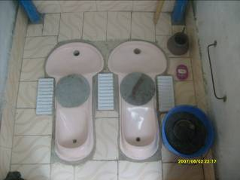
- Due to cultural and religious stigma, the plastic eco-pan and footrests were redesigned to divert urine into an evaporation bed during menstruation periods, without additional cost in construction;
- Address the special needs of women (pregnant), children, elderly and differently abled people by providing handle and railing inside and outside of the toilet;
- Provision of two windows for better ventilation and sunlight and a ventilation pipe of 3 inches in diameter going up 3 ft. above the roof to reduce bad smell as well as expedite the drying process;
- Provide pictorial O & M guidelines on the wall to guide the proper use of the toilet;
- Provision of hand-washing facility with low cost hand washing device and soap stand;
- Improved design of faeces hole cover to avoid fingers coming in direct contact with the pan cover;
- Design faeces chambers based on the number of family members, in order to reduce the construction cost;
- A light bulb (use toilet at night) or using lighter colour roof helped to improve visibility inside without electric lighting
- Provision of a bucket to store ash along with a scoop to use to spread the ash on faeces.
- Reduction in construction cost using different construction materials (low cost materials versus conventional brick/RCC) for each option ranging from Tk. 17,000 ($ 243)—UDD model to Tk. 5000 ($ 70) for the urine diversion model.

Construction cost of different ecosan options
Option No | Total cost for Sub-structure  ($US) | Total Cost -Super-structure made with brick walls) ($US) | Total Cost -Super-structure made with G.I. Sheets ($US) | Total Cost -super-structure made with bamboo ($US) | Total Cost -Super-structure made with mud ($US)
1 | 113 | 173 | 188 | 152 | 147
2 | 105 | 164 | 180 | 143 | 139
3 | 118 | 178 | 193 | 156 | 151
4 | 98 | 158 | 173 | 136 | 131
5 | 105 | 166 | 180 | 144 | 139
6 | 107 | 168 | 182 | 146 | 141
7 | 177 | 236 | 252 | 216 | 211
8 |  | 73
9 | 103 | 151 | 151 | 155 | 0
10 | 0 | 337 | 0 | 0 | 0
11 |  | 1206

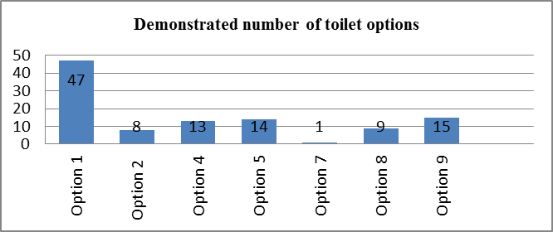
  - Implementation/construction stage:

The 11 designs have been endorsed by the DPHE and 107 toilets were constructed of seven different designs as mentioned in the graph.

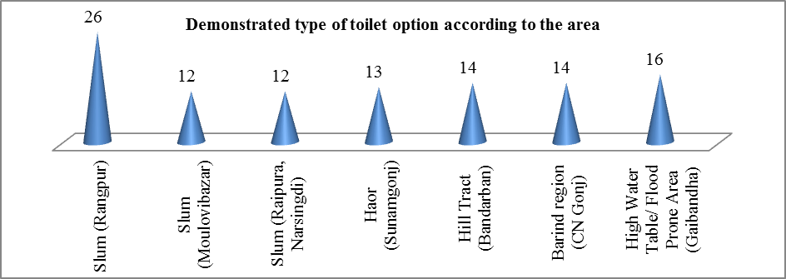

The implementation modality of the action research:
Rapport Building
Community Found Ignited
Capacity Building

Monitoring:
Users, CL, DPHE, PS, PNGOs
Base line Survey
Primary Beneficiaries selection
CBO/Cluster Committee formation
Objective sharing
CAP Development/ Review
Options selection
Option construction, use, O & M and products use
Secondary data, Transect walk, mapping, GD/FGD, interview & pictorial presentation
Mass gathering, court yard session, child to child approach, popular theatre/cultural events, rally & school session, exposure visit, HHs visit etc.
Review of toilet options & selection
Participatory site selection/ design/costing
Discussion on cost sharing
Formation of Purchase Committee
Construction/ installation

Feasibility Study
Participatory monitoring for quality control
Installment recovery, Monitoring
Capacity building of users /committee
Sharing & Decision
Demand to Service provider
Handover and phase out
Coordination with UP/PS/DPHE

Fig 1: Social mobilization process Fig 2: Hardware implementation process

Considerable emphasis was given to:
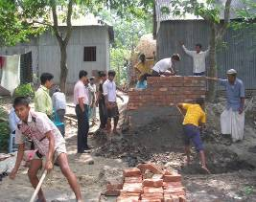
- Capacity building: The users, local masons, community leaders (PS & DPHE) were trained about construction, use and O & M.
- Choice of technology/materials: Users had freedom to choose the toilet option considering its affordability. A technology matrix of toilet options with pictorial view and detailed costing was made available to the community to make their choice.
- Quality of Workmanship: First, one toilet option was built in each cluster to create a demonstration effect and to provide hands-on training to the local mason and community people. The Project Engineer and Engineers (DPHE/PS) ensured quality of construction works and its workmanship.
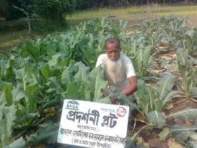
- Cost sharing: Families paid from 15% to 40% of the total cost of the toilet, depending on their income level.
- O&M of facilities: A pictorial chart on toilet use and maintenance is set in front of the toilet wall. A participatory monitoring system has been established to ensure proper use and cleanness. A pictorial monitoring format is used by neighbours or adolescent girls groups during visits to monitor cleanliness, whether water/soap/ash are in place and so on. Monthly feedback sessions were held in the presence of the project field worker to discus these findings and other problems encountered.
- Use of Ecosan products in agriculture: User’s started using the urine for fruit trees, that is, coconut, jackfruit, mango and banana. This was difficult in urban slums, and therefore the project tried to establish a link between users in urban slums and neighboring farmers for use of the Ecosan products.

  - Post implementation/construction stage:
At this stage the project performed two major activities:

      - Collected community feedback (acceptability & sustainability)
After six month of toilet use, a feedback survey was conducted using a questionnaire and FGD among users and local stakeholders. It is found that people have accepted this technology and they are already habituated to the eco-toilet. Major feedback was:
- 74% of the family members used the eco-toilet, whilst 89% of the users are satisfied with using it and 85% of the owners are already using the urine as fertilizer.
- Toilet structure is good, durable and climate resilient. The research continued through one rainy season during in which the toilets continued to be used, being unaffected by the rains. Beneficiaries had difficulties with anal washing at the beginning of use; children need more time to become habituated with the use of eco-toilet.
- 19% of the users identified high construction cost and 77% of the users, who are mainly from urban low income settlements, identified land scarcity as challenges.
- 92% masons and Sub-Assistant Engineers thought that Eco-toilet might be more sustainable than traditional toilets and would support the promotion of eco-toilets;
- 94% of the community leaders found no problem with using and promoting eco-toilet. Moreover, they will assist in promoting the eco toilet and use of urine and composted faeces. By the time the 16-month project ended, the toilets were in use 6 to 7 months, which is insufficient time for the decomposition and reuse of faecal matter. However, information has subsequently been received indicating that a significant proportion of the households used the composted faeces.

      - Conducted pathogen test of composted faces and nutrient analysis of urine.
The recommendations from Institute of Epidemiology, Disease Control & Research (IEDCR) for faeces are:
- The colour and odour of the compost are more or less acceptable;
- Ensure use of ash after each defecation for attaining alkaline (pH) level
- The compost has to be dried (moisture level less than 15%, basically similar to use of cow dung) before use
- Storage of the compost for at least one month in airtight container may reduce the pathogenic load of parasites.

The test resuts from the Department of Soil, Water and Environment of Dhaka University for urine are:
- Urine is sterilized and contains N (0.733%), P (89.3%) and K (0.39%) in sufficient amount so that it could be used in agriculture, while urine does not have arsenic at harmful levels.
- Arsenic and cadmium in composted excreta are not at harmful levels and lead content was found below the detection level (re: Organic Carbon 6.47%, N 0.80%, P 0.563%, K 1.227%, Ca 262.5 mg/kg, and Mg 10.89 g/kg) and could use in farming to increase the soil fertility.

  - Documentation, knowledge dissemination & networking
The research project has also developed a user manual, construction manual for masons and engineers in both languages (Bengali & English), eco-toilet catalogue and a brochure highlighting the project implementation approach and its outcomes. Through implementation of this project, Practical Action has extended its network with all relevant stakeholders working in WASH sectors, donors and also the organic fertilizer sellers and disseminated these experiences through a national workshop at DPHE Bhaban in Dhaka.

Major Challenges
- Selection of beneficiaries (frequently mind changed);
- High construction cost/cost sharing/contribution collection (Re: urban slums);
- Construction was difficult due to heavy rainfall and floods during the project;
- Land scarcity/ tenureship at urban slums;
- Negative attitudes towards eco-toilets, as the technology was not known in these areas;
- Promoting local available materials such as mud/bamboo wall etc;
- Ensuring optimum use of urine in agriculture in urban slums;
- Marketing of urine and eco-compost produced;
- Ensuring menstrual hygiene and consistent use of ecosan latrines by all women who, during time of menstruation must shift their position for urination in addition to which the height of the evaporation beds were raised.
- At the end of the project, meet the increasing demands of Eco toilet.

Lessons Learnt
- Beneficiaries’ freedom for choosing toilet options made them proactive and created ownership as well;
- Critical awareness is important to mobilize all stakeholders for eco-toilets;
- People are interested to have a good looking & long-lasting toilet and are also willing to invest for the same; Particularly the people in remote areas are more interested in constructing a brick-made superstructure;
- More time is required to change people’s attitudes and behaviour toward the eco-toilet. But they are reluctant to go back to traditional toilets, once they are habituated;
- Sanitation link with income generating activities (re: vermi composting) could be more sustainable.

Scaling-up of eco-san initiative:
- The 11 ecosan options got provisional approval from the Design Division of DPHE. It was mentioned in the provisional approval that successful piloting would be essential for formal approval. A formal approval by GOB would be critical for scaling up the technology. Then it can be advocated at the Ministry of Local Government, Rural Development and Cooperative for incorporation of ecological sanitation options as a part of GOB ongoing sanitation promotion campaign strategy. However, LGRD&C Ministry already interested about Ecosan initiatives as they have tried some out earlier in each Union.
- Costing of the technology is another barrier for scaling up. The traditional hard-core engineering solutions do not allow for low cost options. As a result the eco toilet cannot compete with mass sanitation options. However, this project first time tried out low cost option at $70 for the single-pit urine diversion model.
- Numbers of knowledge products (toilet catalogues/manuals) were distributed to all local DPHE offices and PS at SHEWA-B project areas so that it can be used for future promotional activities and SHEWA-B project could be a platform for scaling up. The current 7 piloting areas could be used as demonstration centres and knowledge hubs for replication of Ecosan initiatives.

Acknowledgements
We hereby expressed our gratitude and thank to DPHE and UNICEF for financial support for implementation this project. Our sincere thank is to Veena Khaleque, Country Director and Dr. Afroza Ahmed, Team Leader, IPA 3 of Practical Action Bangladesh for giving us opportunity to submit this paper. We also pay heartiest thank to Mr. Azahar Ali, ED, SPACE, Mr. Monirul Alam Chy. Managing Partner of CC, Mr. Rafiqul Islam, BASA and the colleagues from Practical Action Bangladesh Mr. Rafiul Islam, Raju Basak, Fariduzzaman and Piarul Islam for their direct involvement to implement this project.

Note/s
Practical Action Bangladesh’s partner NGOs are SPACE, BASA and Commitment Consultant
Keywords
Action Research, Ecological Sanitation, Community Mobilization and Participatory Technology Development

Contact details
S. A. Abdullah Al Mamun  Technology Specialist (WES)  Skill Exchange Programme in South Asia  & Project Manager, Practical Action Bangladesh  Address: Tarayana Centre, Thimpu, Bhutan  Tel: +975 16917701  Fax: + 975 2 331433  Email: abdullah.mamun@practicalaction.org.bd  www: practicalaction.org.bd | Md. Monirul Alam  WES Officer (Urban)  Water & Environmental Sanitation Section  UNICEF Bangladesh  Address: BSL Office complex, 1 Minto RD, Dhaka Tel: 880-2 8852266 ext. 7188  Fax: 880-2 9335641-2  Email: malam@unicef.org  www: unicef.org/bangladesh

