Study of different modalities of public toilets in Kathmandu Metropolitan City

Basnet Manish & Bajimaya Shreya, Nepal

In the capital city Kathmandu, one of the neglected aspects of urban sanitation is ‘Public Latrines’. There are different modalities for operating public latrines in the city. However, this study focuses on a new concept, the ‘City Service Center (CSC)’ and mobile toilets operating under a Public Private Partnership (PPP) modality. CSCs include public latrines with added services of showers, lockers and other utility shops such as café, restaurant and hair salon, under one roof. An agreement between the municipality and private companies to operate CSCs and mobile toilets has paved the way for private sector involvement in the public toilet sector. The responsibility of investment, operation and management is given to the private companies while land provision and monitoring is done by the municipality. The public toilets were constructed with a core motive of maintaining sanitation and hygiene and attaining a better standard for facilities, but high profit margin is also a dominant factor for private sector involvement. Therefore, compared to other modalities, public toilets under CSC have upheld adequate hygiene and sanitation status, user’s satisfaction and sustained operation profitably and successfully. However, the sustainability of mobile toilets is questionable due to lack of proper coordination among stakeholders and non-compliance with accords. Having said this, there is room to make further improvements to upgrade the toilets and improve the service. This will help to ensure sustainable sanitation services catering not only Kathmandu’s citizens but also visitors, domestic and foreign alike.

Background

Municipalities of Nepal are characterized by rapid urbanization, sharp population growth and unplanned settlements. And, one of the neglected aspects of urban sanitation is ‘Public Latrines’. Public latrines are essential in places of the cities that see high movements of commuters, shoppers and witness large influx of visitors. Kathmandu Metropolitan City (KMC) is responsible for construction and operation of public toilets in the capital city, Kathmandu. However, not enough public toilets exist in key tourist destinations, shopping and businesses’ hubs and entertainment nucleuses of the municipalities and the existing ones do not comply with the basic hygiene and sanitation standards. Currently, only around 32 public latrines are operating in different parts of the city catering to about 2.3 million populations.

These toilets are predominantly operating under two modalities: They are either leased through wards/municipality by calling for tenders or are operated under Public Private Partnership (PPP) agreements between KMC and the private company. These two modalities account for 64% of the total public toilets operating in KMC. Similarly, the remaining public toilets are being run or leased through by Pashupati Area Development Trust (PADT) and NGOs.

The Kathmandu Metropolitan City (KMC) introduced ‘City Service Centers (CSC)’ under Public Private Partnership (PPP) modality in 2003 to provide public toilet service to city residents. These centers, beside public restrooms, have bathing and locker facilities, restaurants, saloons and other shops under one roof. Similarly, the concept of mobile toilets was introduced by KMC in 2009 citing lack of free space to construct permanent toilets in the busiest places of Kathmandu city. This study will focus on the status of CSCs and mobile toilets on the basis of sanitation and hygiene, financially sustainability and management modality.

Methodology

To carry out the research, initial review was done of secondary sources of information such as published reports, newspaper articles and PPP agreements of concerned agencies. Based on the literature review and the objectives of the study, different questionnaires and checklists were prepared to gain an understanding of functionality, operation and maintenance, finance, service, user satisfaction, hygiene and the aesthetic condition of the CSCs and mobile toilets as well as the opinion of key stakeholders based on these indicators. Afterward, field observation was done and a questionnaire survey was pre-tested in these public latrines to ensure that the questions and indicators covered the scope of the study. A few modifications were made to the initial draft and the final versions of the questionnaires and indicators were used for detailed study of the public toilets. The study team also met with the concerned officials of Kathmandu Metropolitan City (KMC), public toilet operators and the experts in the field of sanitation to learn about the current practices and problems in public toilet sector. Then, data analysis was mainly carried out in context of 3 public toilets operating under CSC and 2 mobile toilets, comparing and analyzing them in terms of different indicators identified. This information was further compared with the other public toilets running under different modalities in Kathmandu valley. However, other public toilets have been generalized in the study which is one of its limitations. The data analyzed was further interpreted to determine the functionality and sustainability of public toilets running under CSCs and mobile toilets.

Overview of public toilets in Kathmandu Metropolitan City

City Service Centre (CSC)

City Service Centre was developed to provide public latrines with added services of hot and cold showers, lockers and other utility shops such as cafés, restaurants, hair salons, etc. under one roof. The agreement between Kathmandu Metropolitan City (KMC) and the private companies in 2003 led to the establishment of 3 CSCs in KMC. CSCs have been established with the view that housing shops and cafes along with public latrines under one roof will lead to properly managed public latrines and that greater effort will be expended to maintain the hygiene, sanitation and an aesthetic standard. In general, the public latrine of CSC intends to serve pedestrians and street hawkers operating in the proximity.

According to the agreement, KMC would allot 10 places to each company within KMC to construct CSCs. However, only three CSCs have been constructed in Ratnapark, Bhotahity and Chabahil. Private companies should bear all the investment during the construction and pay revenue of NRs.50,000 (roughly US$635) to KMC on yearly basis for the first 5 years. After the first 5 years, the revenue will be increased by additional 10% every 3 years. The responsibility for operation and management of the CSCs is with the private companies. After 10 years of operation, CSC should be handed over to KMC. Basically, we can conclude that CSCs are operating under Build, Operate, Own and Transfer (BOOT) mechanism under a PP modality. Furthermore, the private companies have leased out the public latrines and other shops within City Service Centers to sub-lease holders.

City Service Center (CSC) in Ratnapark

Located in front of Bhotahity at the heart of bustling Kathmandu metropolis, Ratnapark CSC provides public latrine service to daily commuters, pedestrians, street hawker, shoppers and alike. Besides the public latrine service, the CSC provides bathing facilities and houses a restaurant, a sweet confectionary and a retail shop. The capital cost of the construction of CSC was NRs. 2,200,000 (stated in the agreement, equivalent to about US$ 28,000). The operator charges users NRs. 5 for defecation and NRs. 3 for urination. Public latrines of CSC are further leased from the private company, Kanchan Trade Limited (KTL) to a sub-lease holder who pays NRs. 25,000 (about US$318) per month to KTL for the lease. Three staff have been hired to clean the toilets and collect tariffs from customers. They are paid monthly salary of NRs. 5000 (US$64) each. After all the expenditures, the monthly net profit from public toilet alone is NRs. 18,000 (US$ 230) on average, excluding the profit from other CSC services.

City Service Center in Khulamanch

Khulamanch CSC, in front of Old Bus Park, was built by Arati and Company in agreement with KMC in 2006. It provides public latrines and a bathing facility and also has a hair salon, a restaurant and a stationary shop in its premises. Construction cost of Khulamanch CSC was NRs. 1,700,000 (about US$ 22,000) stated in the agreement. Roughly, the monthly income from rents from all the shops of CSC amounts to around NRs. 100,000 (about US$ 1,275). From the survey, it was found that the public latrine is operated by the shareholders of Arati and Company on a yearly rotational basis. Every shareholder’s lease time ends with the end of the running fiscal year. The shareholder pays NRs. 30,000 (about US$ 380) per month as lease amount to the company. Two staff have been hired to clean the toilets and collect tariffs from the customers and monthly salary of NRs. 3,250 (US$ 41) is paid to each. After all the expenditures, the monthly net profit of public toilets alone stands at NRs. 7,500 (US$ 96).

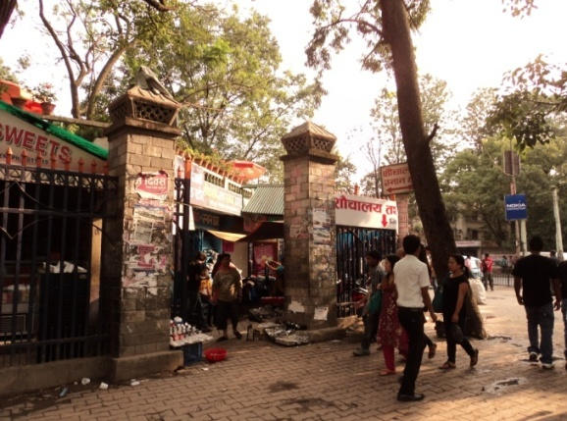  Figure 1 CSC of Ratnapark | 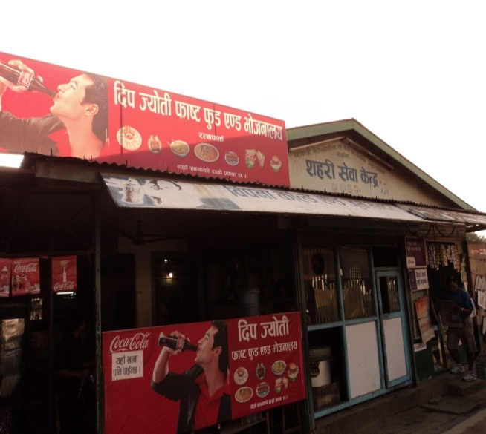  Figure 2 CSC of Khulamanch

City Service Center in Chabahil

Chabahil CSC houses public latrines, a hair salon, a café, a retail shop and a bus ticket counter. The construction cost of this CSC was NRs. 1,700,000 (US$ 22,000). The questionnaire survey and interaction with the staff of the toilets revealed the approximate monthly income and expenditures for the toilets. The operator charges users NRs. 5 for defecation and NRs. 3 for urination. Arati and Company itself runs the toilet and has hired staff for daily operation of the toilets. Daily income amounts to NRs. 2250 (US$ 29) on average, and thus the monthly income of the Chabahil CSC is NRs. 67,500 (US$ 860). There are 5 staff hired, of which 2 are responsible for collecting tariffs, 2 for cleaning toilets and 1 is the guard. Monthly salary of the guard and tariff collectors is NRs. 5000 (US$ 64) per person while of cleaning staffs is NRs. 3,700 (US$ 47) per person. They use groundwater and buy water daily to fulfill water requirements. They spend NRs. 10,000 (US$ 127) on average to buy water. Further expenses are incurred on electricity and purchase of cleansing materials. After all the expenditures, the company’s monthly profit is NRs. 31,100 (about US$ 400), implying that about 4 ½ years are required to pay back the construction costs based on the profit of the toilets alone.

Mobile Toilets

The name itself connotes that mobile toilets are moveable and flexible public toilets that can be placed at different places as needed. Mobile toilets are basically toilets constructed in a large truck where there are separate tanks for urine and excreta collection. These toilets occupy less space and require less water in comparison to permanent toilets as less water is used to clean toilets due to the limited holding capacity of the tanks. Mobile toilet services began in 2009 in Kathmandu with the agreement between Kathmandu Solid Waste Management Center (KSWMC) and KMC. KSWMC designed and installed mobile toilets with its own finance. The PPP agreement allowed the center to operate mobile toilets in places designated by KMC. In turn, KSWMC has to pay monthly revenue of NRs 2,100 (US$27) per unit mobile toilet operated.

Mobile toilets were initially constructed in coordination with the KMC with an agreement for installing 10 such toilets, but only two are operating to date. Moreover, KMC has not issued a “work permit order” to the mobile toilet operators, thus flouting the agreement. And, to add to this discrepancy, mobile toilet operators do not pay any revenue to KMC and are still operating the toilets. Further, the mobile toilet placed in Kathmandu Durbar Square was removed after repeated protests from the locals. They complained that the mobile toilet was a scenic blight in the site. The Kathmandu Durbar Square is a UNESCO world heritage site and according to the UNESCO agreement for world heritage sites, no objects can be placed or constructed within the area that may diminish the traditional, cultural and aesthetic values of the site.

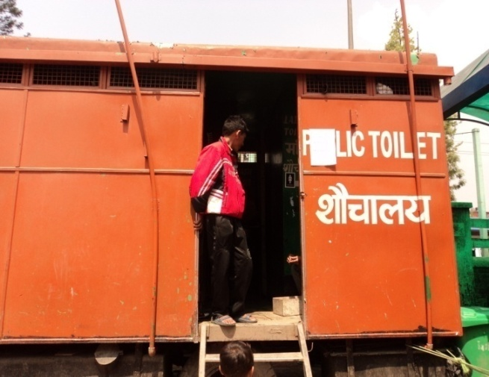
The initial investment cost of each mobile toilet was approximately NRs. 800,000 (about US$ 10,200). The operators do not pay the monthly charges but continue operating the toilets although they did not receive a work order. They charge NRs. 3 for urination and NRs. 5 for defection to the users. These mobile toilets are also sent on hire to the public for crowded events with a charge of NRs. 6,000 (US$ 76) per day. Six staff have been recruited for daily cleaning and tariff collection; and two drivers for the two mobile toilets. The daily average income is approximately NRs.1,750 (US$ 22) in each mobile toilet and the total expenditure amounts to NRs. 35,000 per month inclusive of operation and maintenance, fuel and staff’s salary. In average, the net profit of each mobile toilet is around NRs. 17,500 (US$ 223) per month. The mobile toilet is a boon at crowded places and for occasional use, but its major drawback for continuous daily use is the small holding capacity of the storage tanks.
Figure 3 Mobile Toilet

Others

In addition to the CSCs and mobile toilets, there are other public toilets in the Kathmandu valley functioning under different management modalities. These other modalities are management: by lease through wards/municipalities, by individuals through lease with the Pashupati Area Development Trust (PADT), directly by the PADT, directly by KMC, by an NGO or by individuals through lease with KMC. All these toilets are constructed by the KMC (Kathmandu Metropolitan City) or the PADT.

Analysis of public toilets in Kathmandu City

Sanitation and Hygiene

City Service Centers have provided better service in comparison to other public toilets. During the survey, it was found that the CSCs of Chabahil and Khulamanch were cleaner, provided better basic sanitation facilities and were equipped with adequate water supply. However, foul odors permeated from toilets of CSCs.

Mobile toilets have limited holding capacity. Thus, operators have limited the use of water to avoid over-flow of holding tank. Hence, the toilets were not cleaned frequently. As a result, foul odor was observed in mobile toilets as well. Buckets are provided but they are not clean. Though soap was provided, stagnation of water in the wash basins was observed and stops users from washing their hands. Water was inadequate and intermittent and no towels were provided.

The toilets operating under the modalities other than CSC and mobile toilets have degenerated and are in an abysmal state. They do not provide the basic sanitation facilities at all. Though toilets had dug-wells to provide water, none of the pumps were functioning thus water supply was intermittent in many toilets. Further, stagnation in defecation pans was observed in some of them. Taps in the individual rooms did not work and no buckets or only filthy buckets were provided. Most of the toilets were not cleaned and, a foul and pungent odor emanated from the toilets. Detergents or sanitary cleansing materials were rarely used to clean the toilets.

The survey shows that private sector involvement has helped to maintain better hygiene and sanitation standard in public latrines of CSCs at least in comparison to other modalities of public toilets. Unlike the other public sanitation facilities, these centers were constructed by the private companies apparently resulting in a strong sense of ownership to maintain the toilets. In order to recover the initial investment and to make profit within 10 years, private operators have maintained cleanliness and tried to draw more users into public latrines. The presence of other shops within the vicinity of public latrines in CSCs has also ensured that toilets are kept clean and odor-free. Without a hygienic environment, customers won’t go to cafés, restaurants and shops in the CSCs. Hence, this modality has helped to keep the public latrines relatively cleaner and hygienic. Having said this, there is still room to make further improvement to better the service and upgrade the toilets.

Similarly, mobile toilets are also privately operated. Cost recovery and profit motive have led to better maintenance but hygiene and sanitation are not up to the mark. The limited holding capacity of mobile toilets means they are not frequently cleaned and thus this has compromised the cleanliness and sanitation standard. Added to this, the agreement between KMC and the private company has not been strictly followed. However, their benefit is their mobility. They can be deployed at places where there are no permanent public toilets. As such, one mobile toilet is placed at Narayanhiti on the request of Ministry of Foreign Affairs to cater to the public visiting the ministry.

In stark contrast, other toilets except those of CSCs and mobile toilets are in a dilapidated condition. Since these toilets were constructed by KMC, the study found that operators running the toilets in lease lacked the feeling of ownership and the responsibility for the toilets. They were indifferent to maintenance of the toilets. The quality services and number of customers are inter-related; but no significant steps have been taken by the operator or KMC to repair and maintain the toilets. Thus, with passing years, the toilet services have degraded and as a result, the number of users has also dwindled. As a result, operators do not have any incentive to clean the toilets.

User-friendly

City Service Centers’ public latrines are neither child-friendly nor disabled-friendly. But, they have separate rooms for male and female users. So, they are relatively gender-friendly. Mobile toilets and other public toilets are neither gender-friendly nor child friendly nor disabled-friendly. Even though the other public toilets have separate male and female sections, the absence of proper partitions and poor state of door latches mean women face difficulty using the toilets.

The views of all the stakeholders and users are similar when it comes to the preferred modality of public toilet. Overwhelmingly, 65% of the 25 respondents prefer CSC for better quality of service in comparison to other public latrines. Another good aspect of CSC is that it provides subsidy to nearby located street hawkers and shoppers who have to use public toilet frequently. These vendors pay on monthly basis at highly subsidized rate. These are low-income people who sell small products for their living and are vending near CSC because of high movement of commuters. According to the survey, they are highly satisfied with the service of CSC. So, CSC attempts to address the need of urban poor as well to some extent. However, some of the users who use public toilet not so often feel that the price is not reasonable. While, only 6 % of the users prefer the mobile toilet because they are compact in size and flexible where free space is unavailable for permanent public latrines. And, 29% of the users weren’t aware of different types of public latrines existing in KMC and thus they couldn’t say which they preferred.

Cleanliness and hygiene is the primary component users will look for in public toilets as shown from the survey. As stated earlier, the hygiene and sanitation status of public latrines in CSCs are not excellent but are better in comparison to that of toilets of other modalities. Also, public latrines of CSCs are gender-friendly in comparison to mobile toilets and tender-run toilets. Female users preferred using CSC over other public toilets on a security basis as well. Thus, CSC seems to fulfill people’s need for public toilets given that the quality of service is sustained.

Disposal

Public toilets of CSCs are directly connected to the municipal sewer line. Mobile toilets’ waste is also disposed in the municipal sewer line. Though the mobile toilets had earlier collected the urine in coordination with a leading organization to aid in research and generation of struvite (a type of fertilizer generated from urine), they stopped collecting the urine after the research was completed. This was mainly because of financial constraints and other reasons which were not clear.

Financial Sustainability

Several shareholders have invested their shares in the public toilets of CSCs through Arati and Company and Kanchan Trade Link. These companies have sub-leased the public latrines of Ratnapark and Khulamanch CSCs to the operators while Arati and Company itself is running the public latrine of Chabahil CSC. In addition, private investors have added benefits by leasing the spaces of CSCs to shops, cafes, restaurants and alike. Present CSCs are also strategically constructed in one of the busiest places of Kathmandu City. Ratnapark and Khulamanch are strategically located as they are near to popular shopping centers and they are also major hub of Kathmandu’s public transportation network. Consequently, these toilets witness large movement of commuters and shoppers alike. This has also contributed to high number of users and significant profit of CSCs’ public latrines.

Further, operators themselves have tried to attract and retain public toilet users by satisfactorily maintaining the cleanliness and hygiene to generate more profit. For this, full-time staff are hired to clean the toilets and to collect the tariffs from users. Operators have provided competitive salaries to the staffs. This has motivated staff to regularly clean the toilets. As a result, use of public latrines in CSCs is high. High profit has helped to sustain the public latrines in a hygienic manner. In this context, the CSC is the better-suited modality.

In similar fashion, mobile toilets are also deployed at the busiest places lacking permanent public toilets. They have become ubiquitous at street festivals, concerts and large open-air gatherings. Thus they earn significant revenue and make healthy profit. Good profit has helped to sustain the mobile toilets to date.
Other public toilets fine it hard to make significant profit. In almost all other toilets visited, operators themselves and their family members look after daily operation of the toilets. They make barely enough earnings to pay the monthly lease and the profit, if any, is very small. This is also the reason for their indifference to maintaining and cleaning the toilets. As stated earlier, many toilets’ structure are in poor condition and in need of renovation. Clearly, these public toilets are not as profitable as CSCs and mobile toilets and cannot sustain themselves in present state.

Management Modality

The official of KMC states that City Service Centres are good options to maintain the standard of public toilets in long term and the public toilets operating under other modalities in KMC should be converted to CSCs eventually. Likewise, the private sector and operators involved in public toilets consider CSC to be sustainable because of availability to house shopping stalls, food stalls and other shops within the centre and its strategic placement in busy hubs of the city. Private companies, KTL and Arati and Co., presently involved in CSCs are more than willing to invest in CSCs provided KMC allocates spaces as stated in the agreement.

In case of mobile toilets, there are hindrances in expanding mobile toilets as the operator complained about KMC not being able to issue ‘work orders’ and comply with the agreement. Mobile toilets are profitable and investors are willing to invest in these toilets. These toilets are suited for the congested city centers of Kathmandu where free spaces in the busiest places are no longer available to construct permanent toilets and during crowded events. A problem exists with the disposal of waste from mobile toilets which can be resolved as the wastes can perhaps be utilized. Further research and study is needed for this purpose. Lack of space is also one of the reasons for lack of expansion of CSCs in Kathmandu. Thus, portable toilets can be complimentary to CSCs as they can be placed in Kathmandu where construction of CSCs is not feasible.

The staff of tender-based toilets still lack incentives to maintain the toilets and therefore, the hygiene and sanitation state of these facilities is extremely poor. But, the staff and caretakers of the public toilets established under CSC have optimal incentives that have upheld the sanitation status, at least to some extent compared to the tender-based toilets. There is frequent monitoring of these toilets and their location is another advantage, resulting in more users.

Conclusions and Recommendations

KMC is all set to construct 30 more public toilets in Kathmandu Metropolitan City and the fact that the toilets will be disability- friendly is welcomed news. However, the study shows that the state of public toilets depends upon its management and operation. Public toilets have degenerated over the period of years due to lack of proper operation and management. The way forward is to identify the gaps, discrepancies in the existing system and rectify the shortcomings and upgrade the services.

Kathmandu Metropolitan needs more public latrines at busiest places, tourist destinations, and heritage sites, major junctions of the street and at areas of informal settlements as well. While analyzing the statement of stakeholders, a questionnaire survey and the literature, it was found that public latrines of CSCs are relatively better than other toilets but the ‘better standard’ is still far below a satisfactory level. New public toilets should be better than CSCs or at least comply with the standard of CSCs. A small step to improve the condition of public latrines can leave a positive impression about the city. This will help to improve the image of Kathmandu and cater not only Kathmandu’s citizens but also to the visitors, domestic and foreign alike. Some of the conclusions and recommendations made are:

- There are currently eight modalities of public toilets operating in the city. However, the PPP approach and BOOT modality of CSC should be followed while constructing new public latrines in KMC because this approach provides service to the public and at the same time generates profit to the investors. It also augments the revenue of the KMC and government. This management modality of public toilets should be expanded in the city. Also, it should be implemented in informal settlements areas; and the fare for using public latrines should be revised so that it addresses people below poverty line as well.

- The private sector is willing to invest and expand CSCs and mobile toilets. KMC should create an enabling environment by providing the land at designated places stated in a prior agreement for CSCs. Also, KMC should issue work orders and allocate definite space to mobile toilets. A strong coordination between KMC and the private operators with clearly defined roles and responsibilities is required for smooth operations of public toilet services and for ensuring compliance to agreements by both parties.

- Public toilets operating under CSCs have provided comparatively better services in terms of sanitation, hygiene and maintenance than the mobile and tender-run public toilets. They have added facilities of bathing and lockers to cater to the customers.
- Still, due importance should be given to maintain sanitation and hygiene in the toilets as this is the dominant factor that motivates the public to use the toilets.
- Posters and pamphlets giving messages about proper practices for personal hygiene and sanitation should be installed in the public latrines.
- CSCs and mobile toilets make a healthy profit so the KMC should ensure that certain percentage of the profit is allocated by operators for the maintenance of the toilets.
- Public latrines in City Service Centers are connected to municipal sewers and the municipal sewer waste is unfortunately directly disposed into the rivers. Hence, proper septic tanks should be constructed in new public toilets. KMC, the organization responsible for keeping the city clean, should set an example to its residents by constructing septic tanks in public toilets. This practice can be utilized to motivate and to make private residences aware about septic tanks.

- Public Toilets’ waste is highly concentrated and mostly fresh faecal sludge (UN-HABITAT, 2011). A High Powered Committee for Integrated Development of Bagmati Civilization (HPCIDBC) is constructing a faecal sludge treatment facility at the Guheswori Waste Water Treatment Plant site in the near future. Waste from public latrines of CSCs and mobile toilet can be treated and disposed of at the facility.

- Public latrines should be upgraded to make them child friendly and disabled friendly.

- Mobile toilets need to be technically upgraded as the waste tanks have holding capacity with insufficient capacity which makes it difficult to frequently clean the toilets. Also, the compartments should be more user friendly as users complained about narrow space in mobile toilets.

Acknowledgements
We would like to extend our greatest thank to UN-HABITAT Nepal for giving us the platform to research on issue of public toilets in Kathmandu City. We are also grateful to everyone who assisted and supported us throughout the study period.

References

NEWAH (2003). Study on Public Latrines in Kathmandu Metropolitan City, NEWAH, Central Region Office, Lhosal, Kathmandu
CIUD (2010). Public Latrines – A study, Centre for Integrated Urban Development (CIUD). Sanepa, Lalitpur.
UN-HABITAT (2011). Status and strategy for Faecal Sludge management in the Kathmandu Valley, UN-HABITAT, Pulchowk.
Keywords
CSC, mobile toilets, KMC, PPP, sanitation

Contact details

Manish Singh Basnet  Battisputali, Kathmandu, Nepal  00977-9841587988  manishsinghbasnet@gmail.com | Shreya Bajimaya  Bijuli Bajar, Kathmandu, Nepal  00977-9841331142  yourshreya@hotmail.com

