Authors: Christine Sijbesma and Ria Mozar  Date: 2009  Domain: Solid Waste Management | Age groups: 8-14 years
Subjects: Organic and Non-organic wastes, dangers and potentials, recycling, productive use, entrepreneurial skill development

solid waste management in school
Learning goals:
Knowledge:
- Children know about the different types of solid waste
- They know how different types of waste can be recycled
- They know how to use it productively for horticulture and to make money
Attitudes:
- Children like to keep the school environment clean and tidy
- They appreciate that waste is wealth
- They are eager to recycle solid waste in school and at home

Practical skills:
- Children can identify and bring to school samples of different types of solid wastes
(A special lesson can be added for them to learn how to make compost from organic waste)

Psychosocial life skills:
- Children can identify different types of risks from solid wastes to themselves, other children/people and the environment
- Children develop analytical skills
- (If working in small groups is included) children learn to cooperate
- Older girls and boys can organize a small recycling business

Participatory methods:
- Collecting and bringing samples of different types of solid waste
- Competition
- Analysis in plenary
- Hands-on practice in making compost
- Planning and implementing a small recycling project

Materials:
Different types of solid waste, blackboard or large paper, cardboard boxes, large plastic bags (e.g. old fertilizer bags), composting bin, compost enhancer (fluid that speeds up the natural composting process), a small prize, e.g. a sweet.

Activities:

- On the day before the lesson, ask each child to collect one example of as many different types of solid waste they can find and bring it to class on the next day. The teacher leaves it too the children to decide what kind of samples of solid waste to bring, only stress that they should be of different kinds of material. The learning element is that the children begin to see that there are different kinds of waste that have different risks and potentials. As a help, the teacher can take the children outside to the rubbish bin and ask them to mention different types of waste. The teacher should, however, not provide a list of items.to bring.

- At the start of the lesson, ask the children to display their samples on their desk.

- Now facilitate a discussion on the different types of solid waste. Invite one boy and one girl volunteer to write two lists on the board, one headed organic waste and one headed non-organic waste. Ask the children to give products for each list, beginning with the samples that they have brought. They may also add new examples.

- A typical overview that may appear on the board or the paper is:

- Organic green waste that is composted: all kinds of naturally degradable waste from plants and plant products, such as vegetables, leaves, flowers, cut grass and leaves, food left-overs and waste from agricultural crops (List 1).
- vegetable and food wastes (including cooking oil)
- fruit waste
- waste of animals (meat, bones, egg scales, animal fat, etc.)
- garden waste
- agricultural crop waste
- animal excreta

and also organic waste that is not composted, but recycled in a different way:
- paper
- cardboard
- wood
- natural textiles (from plants), such as cotton, linen

Although paper, cardboard and wood are organic (they are made from trees or plants), they can be recycled into reusable paper, and should therefore be collected separately from green organic waste. Wood can also be reused in building, furniture making, etc. Textiles made from plants, such as cotton and linen, are also organic, but do not degrade, and can be recycled into paper and other products. Only green organic waste is recycled into compost.

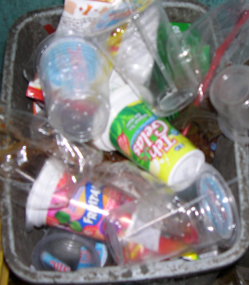
- Non-organic waste.
Fig. 1 Unsorted waste in school
Typical categories are (List 2):
- glass
- various kinds of plastic
- aluminum foil
- tins
- metals
- rubber
- styrofoam
- artificial textiles, such as nylon, acryl, etc.

- Now ask each child to check how many different types of solid wastes s/he has brought. The student that has brought an example of the largest number of different types of solid waste wins the prize.

Analysis:

- Now ask two new students to come and act as reporters.

- Ask the other students to mention the negative and positive sides of solid wastes:

Negative aspects will relate to careless disposal of solid wastes. Think e.g. of risks to health from (a) cuts by glass and sharp metal, (b) attraction of rats, (c) breeding of mosquitoes when empty tins, car tires, etc. fill with (stagnant) water, (d) the diseases spread by rats and mosquitoes, (e) etc.

Positive sides relate to 3R, creating jobs for solid waste collection and recycling, sources of income, providing food for animals, making compost and using compost for agri/horticulture and potted plants, reducing deforestation, reducing pollution by chemicals from decomposition, gas production, etc.

- Explain 3R (reduce, reuse, recycle).

- Ask who among the students and their families already practice 3R at home.

- Ask the reporters to write down a list of names for boys and girls.

- Facilitate older students to calculate the percentages of girl and boy students who already practice 3R at home.

- Explain that this list and these percentages are the baseline: this is the situation now. Ask those who will promote 3R at home to raise hands. Ask students to copy the data in their notebooks, and copy them also yourself.

- In a later lesson, return to the subject and ask which boy and girl students now practice 3R at home, and help them calculate changes.

Alternative 1: Ask the students to split in 2 or more small groups and give each group different types of wastes to list as either organic or non-organic, and to mark which organic wastes can be composted. Groups then present their work in plenary and consolidate their outcomes in two plenary lists. Then do the inventory of who practice 3R at home.

Alternative 2: Form two groups, one on negative aspects and one on positive aspects of waste. Ask each group to write each (dis)advantage in block letters on a separate card or slip of paper. You can reuse these cards/slips later to do a sorting exercise. Mix the cards or slips. How quickly can the class sort them in the two correct lists? You can also write the slips yourself and do the sorting game as a refresher exercise later.

Application:

- Facilitate a discussion on how the class/school can better manage solid waste and use it as a source of income. The school can, for example, enable segregated collection of solid waste by placing in each class, or on the verandah, or in other strategic places:

- a cardboard box for disposal of paper
- a spot for collection of disposed cardboard a
- a bin for disposal of plastic bottles, bags, and straws
- a bin for disposal of glass
- a bin for disposal of metals (cans, tins, aluminum foil, etc.)
- a covered plastic bucket for disposal of organic waste
- a bin for the remaining waste

- Discuss and plan what will be done when bins are full. Is there a TPS (tempat pembuangan sebentara – temporary disposal site) within the school premises? Or can it be kept in other places?

- Discuss what will be done with the waste, e.g. give or sell it to waste collectors from the informal private sector. Plan and implement a project, e.g. a small student enterprise of boys and girls, who organize the end-collection and selling of the waste and manage and account for the use of the funds. Questions to discuss are, for example:

- Can the green waste be composted? How?
- Who will do this? How will it be organized?
- What investments are needed and how will these be financed?
- What will be done with the compost?
- What can be done with the other accumulated and segregated waste? Can it be sold to a waste collector or collectors from the informal sector in the city?
- Who will be responsible for this?
- How will the work be organized?
- Who will control the income?
- How will the finances be managed and accounted for? To whom?
- For what will the net income be used?
Follow-up lesson on composting:

Prepare a special lesson on composting, with if possible a demonstration by or a visit to a local composting project. Assist the organization of a composting project with interested students.
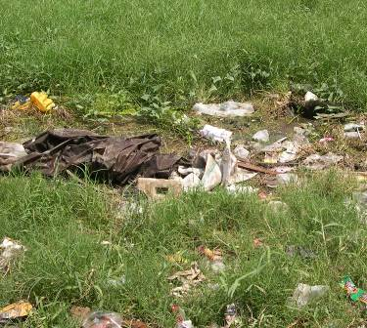
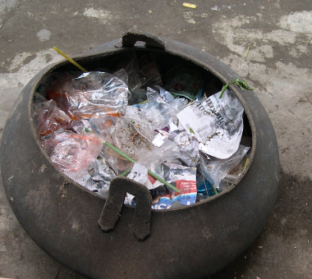
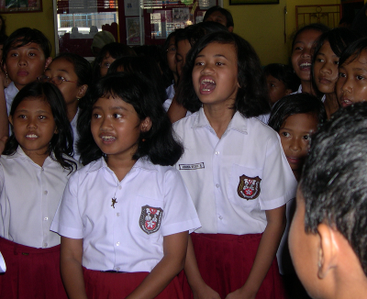
Solid waste deposited in the environment | Schoolgirls and -boys participating in analysis, Tegal | Solid waste bin made from old car tire (school in Tegal)

Competences:

Knowledge, Attitudes and Cooperative Practice on Solid Waste Recycling for Productive Use
(Potential:) Simple entrepreneurial and accounting skills

Sources of information: http://practicalaction.org/docs/technical_information_service/recycling_organic_waste.pdf
http://www.thejakartapost.com/news/2007/04/23/039i-separate-organic-nonorganic-waste039.html
http://www.wasteonline.org.uk/resources/InformationSheets/Compost.htm

This lesson plan was developed by Christine Sijbesma and Ria Mozar following their visit in April 2009 to Kota (and Pokja Sanitasi) Tegal.

