School Washrooms
Should school washrooms be pursued as one of the SWASH+ innovations?

During a meeting held in mid October 2008 between WPI and Emory regarding selecting and finalizing SWASH+ sanitation innovations to be built and studied in the upcoming months, the topic of washrooms as a potential innovation was visited. During the SWASH+ Year 1 (2007) sanitation package construction, SANA International, the then subcontractor of WPI, constructed “washrooms” in two of the SWASH+ Year 1 intervention schools, Chemilil B1 Primary School in Nyando district and Osuri Primary School in Rachuonyo district. These washrooms were built without the knowledge of other SWASH+ partners and deviated from the original sanitation package intervention. Based on a brief conversation between SANA and Emory, SANA explained that the washrooms were built due to the insistence of primary schools girls in the respective schools.

Regardless of the circumstances behind the washroom constructions, Emory and WPI agreed it would be worthwhile conducting a short visit and survey in both Chemilil B1 and Osuri in order to assess the type of washrooms built, the manner in which they may be currently used, and the schools overall impressions of the existing washrooms. Based on the findings, Emory and WPI would assess whether it would be worthwhile to pursue washrooms as a potential innovation.

Emory created a washroom survey (see Appendix A) and a TICH supervisor visited and conducted the survey in both Chemilil B1 and Osuri on Friday, November 14th, 2008. The following gives a brief summary of the results per school:

An unconventional use of mobilets

Chemilil B1 Primary School currently has two washrooms that are essentially mobilets. They are set apart from the latrines in the school. They are approximately 10 meters apart from one another. The only difference between these washrooms and the mobilets used as latrines is the depth of their pits. The washrooms have shallow pits approximately one meter in depth. The pits are connected to a hand dug canal, extending approximately one to two meters outside of the washrooms and less than one meter in depth. The canals do not have a discharge point and water seeps into the surrounding bush.

Both washrooms have doors, but no locks. The upper primary girl interviewed during the survey noted that because the washroom doors currently have no locks, people from the community use the washrooms as latrines over the weekends. The girls subsequently clean the washrooms of any feces or urine on Mondays. In addition, one washroom does not drain water well and often has standing water after washroom use. This washroom is used less frequently than the other washroom and is in need of repair.

The inside of the washroom more frequently used was reported to be “somewhat clean” by the TICH supervisor who directly conducted observations of the washrooms. In addition, the supervisor described seeing some tissue paper on the floor of the washroom as well as a few rags on the door steps of both washrooms. The tissue paper was not soiled and was reported to be used to clean the washroom. The rags were reported to be used by each girl to clean the washroom floor after use. The supervisor did not observe any feces, urine, or blood in either washroom.

The supervisor observed approximately half a liter of standing water in the frequently used washroom directly after use. The supervisor also observed standing water inside the hand dug canals extending outside of the washrooms. The interviewee reported that the standing water was breeding mosquitoes and complained that she and the other girls using the washrooms were getting bitten by mosquitoes while using the washrooms.

The girls use buckets filled with water from the school borehole for bathing use. There was no soap observed in or near the washrooms during the time of visit.

Daily use for bathing

The interviewee reported washrooms being used on a daily basis by predominantly upper primary girls for mainly bathing purposes. The interviewee also reported that washrooms were used to comb hair and apply body oil. The interviewee reported approximately 100 upper primary girls use the washroom each day. The interviewee personally reported using the washroom on a daily basis and reported that she had sufficient water to wash. The interviewee reported being unable to use the washrooms during exam preparation time due to less time allowed for breaks.

The interviewee reported liking the washrooms because it “helps us maintain cleanliness and neatness” and “gives us room for changing clothes.” The supervisor reported to Emory that when probing further, the girl described “changing clothes” as both meaning changing to a clean uniform for some girls and changing sanitary napkins for others. The interviewee also pointed out that some of the girls were saving time in the evenings by taking baths at school since walking to available water sources outside of the school is time consuming.

Suggested improvements

The interviewee suggested improvements be made to the current washrooms. Her suggestions included improving drainage, killing mosquitoes that “bite us while taking bathes”, and providing locks to prevent defecation in the washrooms over the weekends. In addition, the interviewee noted that one of the mobilet washrooms is bent and “straightening it will be nice” and said that the surrounding brush around the washrooms should be cleared.

The supervisor was able to observe washroom use for approximately 30 minutes. In that time, the supervisor reported seeing ten people use the washroom as well as a long line of girls waiting for their turn.

An unusable washroom
Osuri Primary School, Rachuonyo District: This school has one washroom that was built as part of a block of latrines intended for girls. The washroom has a cement foundation and a brick superstructure. The washroom has a door and was unlocked during the time of visit for the supervisor. It is in essence a small cement room the size of the latrines adjoined to it without a pit or any sort of visible drainage system.

The inside of the washroom was observed by the supervisor and reported as “dirty.” The presence of approximately one liter of standing urine was observed without any way for the urine to drain.

The health patron of the school was interviewed and confirmed the washroom has never been used since it has no drainage system. In addition to having no drainage system, the health patron noted that they do not have sufficient soap available for bathing purposes, only handwashing. The supervisor observed a 5,000 liter tank as the school’s primary source of water.

Conclusion

The current washrooms constructed by the SWASH+ project in Chemilil B1 and Osuri are varying in design and use. The washrooms in Chemilil B1 Primary School, although in need of improvements, show that washrooms may be a promising hygiene innovation due to the observed high level of daily use and maintenance by the upper primary school girls. In addition, due to the easy accessibility of water at this school, washroom use can be sustained. In the case of Osuri Primary School, the original poor design of the washroom has made it unusable from the start. However, it is doubtful that the school would have the same level of use as Chemilil B1 given a better design due to their current water source.

Potential Next Steps

Given the positive preliminary results at Chemilil B1, washrooms, when designed properly, may prove to be a highly beneficial improvement to school hygiene. Emory would advise the following next steps:
- Review existing available washroom designs and recommendations from other agencies (i.e. IRC, WEDC, etc.).
- Discuss within SWASH+ partners the potential ways to build and test additional washrooms in a select number of schools.
- Build and test washrooms in a select number of schools as a SWASH+ “hygiene innovation.”
- Share results within the school WASH community and wider WASH sector.

Appendix A

District: _______________________________ Division: ______________________________
Name of Surveyor: ________________________________ Date: ___________________________ Number of WASHROOMS: _______________ If there is more than one washroom in this school, please fill out the “TECHNICAL” portion (questions #1 thru 12) again for the second washroom.

TECHNICAL:
Washroom material / structure / maintenance / water availability:
- Foundation material: __________________________________________________________________

- Superstructure material: _______________________________________________________________

- Does the washroom have a door? 1) Yes 2) No If No, Skip to→ 5

- Was the door locked during time of visit? 1) Yes 2) No

- Is the washroom in need of repair? 1) Yes 2) No If No, Skip to→ 7

- Briefly describe repair needs: __________________________________________________________________________________________________________________________________________________________________________

- Were you able to view the inside of the washroom? 1) Yes 2) No If No, Skip to→ 14

- How would you rate the cleanliness of the washroom:
1. Very Clean 2. Clean 3. Somewhat clean 4. Dirty 5. Very dirty

- Please describe the level of cleanliness in the washroom: ___________________________________________________________________________________________________________________________

- Were there any feces, urine, or blood present in the washroom? 1. Yes 2. No

- Is there a place for water to drain out of the washroom? 1. Yes 2. No If No, Skip to→ 13

- Please describe how the water drains from the washroom and where it discharges: ___________________________________________________________________________________________________________

- At the time of visit, did you observe any discharged water still present inside the washroom?
1. Yes If Yes, approximately how much water____________________ 2. No

- At the time of visit, did you observe any discharged water outside nearby the washrooms?
1. Yes If Yes, approximately how much water____________________ 2. No

- Was there water available in or near the washroom for washroom use during day of visit?
1. Yes 2. No If No, Skip to→ 18

- Describe water facility available for washroom use (i.e. jerrycan filled with water, rain water harvesting tank, etc.):________________________________________________

- Approximately how much water was available for washroom use during time of visit? ___________Litres

- Was there any soap available in or near the washrooms for washroom use during time of visit?
1. Yes 2. No

Please ask to interview in the following preference: (1) an upper primary girl pupil, (2) a female teacher:

- Interviewee: 1) Upper primary girl pupil 2) Female teacher 3) Head teacher 4) Other, specify___________________________

- How often are the washroom(s) used?
1) Daily 2) Specify: ___________________ 3) Never If Never, Skip to→ 40

- Who uses the washroom(s)? Multiple Responses Possible
1. Upper primary girls 2. Lower primary girls 3. Female teachers
4. All pupils 5. All teachers 6. Other, specify: ______________

- Are the washrooms only used for bathing? 1) Yes If Yes, Skip to→ 24 2) No

- What other purposes are the washrooms used for? __________________________________________________________________________________________________________________________________

- Approximately how many people use the washroom(s) each day?
1) # of people________ 2) Don’t know

- Have you used the washroom(s) at this school? 1) Yes 2) No If No, Skip to→ 31

- Were you able to use water while using the washroom? 1) Yes 2) No If No, Skip to→ 28

- Was the water you used sufficient to wash? 1) Yes 2) No All skip to 29

- Why did you not use water while using the washroom? ________________________________________________________________________________________________________________________________

- How often do you use the washroom(s)?
1) Daily 2) Weekly 3) Monthly 4) Specify:___________

- Are there times you are unable to use the washroom when you want to(s)?
1) Yes 2) No If No, Skip to→ 32

- Please describe reasons why you were unable to use the washroom during those times: ______________________________________________________________________________________________________________________________________________________________________________________________

- Do you like the washroom(s)? 1) Yes 2) No If No, Skip to → 34

- Please tell me reasons why you like the washroom(s): ______________________________________________________________________________________________________________________________________________________________________________________________________________Skip to→ 35

- Please tell me reasons why you do NOT like the washrooms(s): _________________________________________________________________________________________________________________________________________________________________________________________________________________

- Are there any improvements that could be made to the washrooms? 1) Yes 2) No Skip to→ 37

- Please describe the improvements: ________________________________________________________________________________________________________________________________________________________________________________________________________________________________________

- Who cleans the washroom(s)? 1) Specify______________________________________ 2) Don’t know

- How often is the washroom(s) cleaned? 1) Specify____________________________ 2) Don’t know

- Any other information you would like to share regarding the washrooms? __________________________________________________________________________________________________________________________________________________________________________________________Skip question 40.

- Why is the washroom(s) never used? ______________________________________________________________________________________________________________________________________________________________________________________________________________________________________

**********************Thank you for participating in this survey.*****************************

- Interviewer: did you have an opportunity to observe whether or not pupils used the washroom(s) during time of interview?
1. Yes 2. No If No, end of survey.

- Approximately how long were you able to observe washroom use? _________________ amount of time

- Approximately how many people did you observe enter / use the washroom during your visit at this school? _____________________ number of people

- Please circle all the various types of people that you observed entering / using the washroom: multiple responses possible:
1. Upper primary girls 2. Lower primary girls 3. Female teachers
4. All pupils 5. All teachers 6. Other, specify: ______________

- Interviewer--- please use the following space for any additional observations / feedback that was not captured in the survey: ______________________________________________________________
____________________________________________________________________________________________________________________________________________________________________________________________________________________________________________________________________________________________________________________________________________________________________________________________________________________________________________________________________________________________________________________________________________________________________________________________________________________________________________________________________________

PHOTOS:

- One of two “washrooms” at Chemilil B1:
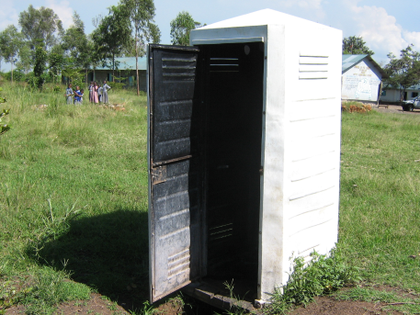

- Inside of one of two washrooms at Chemilil B1 on day of visit:
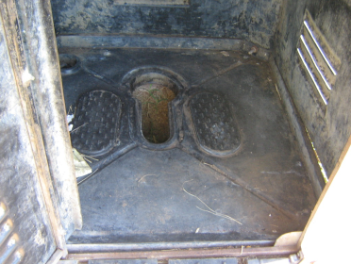

3) One of two hand dug canals with residual washroom water and paper trash at Chemilil B1:
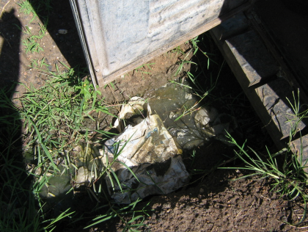

4) Two Chemilil B1 girl pupils standing inside one of the washrooms with a full bucket to demonstrate amount of space available in each mobilet washroom:
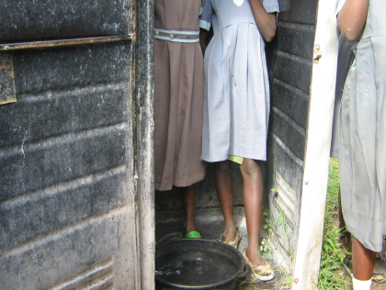

5) Chemilil B1 girl pupils giving showing their enthusiasm for the washrooms in their school:
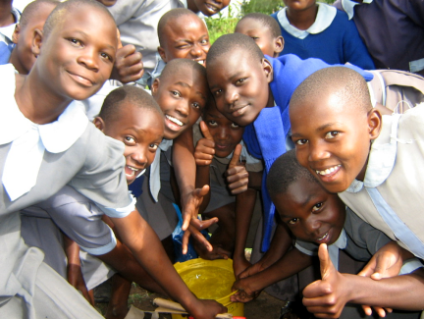

6) A sign at Chemilil B1 encouraging students to bathe:
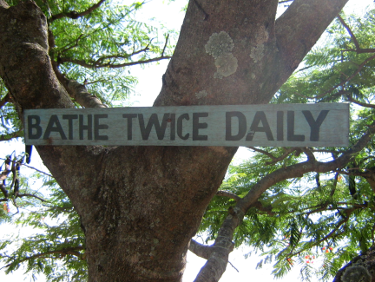

7) A teacher at Osuri showing the “washroom” that was built in their school:
